**AQA**

***A-level Computer Science***

NEA: The Practical Project

**Conway’s Game of Life**

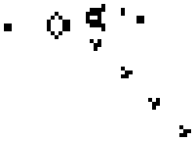

**Candidate Name: Tsz Ying Chow**

**Candidate Number: 4157**

**Centre Number: 64655**

Contents Page

1 Analysis 1

1.1 Introduction 1

1.1.1 Background 1

1.1.2 Initial Research 2

1.2 User Needs and Further Research 6

1.3 DFD 17

1.4 Objectives 18

1.4.1 General Objectives 18

1.4.2 Specific Objectives 18

1.5 How will my program work 20

1.5.1 Grid 20

1.5.2 Control Area 22

1.5.3 Running Information 22

1.6 Justification of chosen solution 23

2 Design 25

2.1 Design Overview 25

2.1.1 Menu Screen 25

2.1.2 The Simulator 26

2.1.3 Editing Screen 26

2.2 Modular Structure of the System 27

2.3 Data Structure in my project 28

2.4 File Structure in My Project 28

2.5 Class Definitions 29

2.6 My Algorithms 33

2.6.1 Change state of cells when clicked 33

2.6.2 Counting the number of live neighbours: 33

2.6.3 Update the Grid to Next Generation 36

2.6.4 Export Pattern 38

2.6.5 Import Pattern 39

2.6.6 Undo Operation 42

2.6.7 Differentiating Clicking, Dragging and Selecting 42

2.6.8 Selecting Cells 43

2.7 User Interface 44

3 Technical solution 50

3.1 Cell Class 50

3.2 Grid Class 52

3.3 GOLGrid Class 53

3.4 Menu Form 60

3.5 Main Form (The Simulator) 62

3.6 Editing Form 76

4 Testing 80

4.1 Menu Form 80

4.2 Main Form (The Simulator) 81

4.3 Editing Form 90

5 Evaluation 92

5.1 Comparison of project performance against general and specific objectives 92

5.2 User feedback 94

5.3 Analysis of feedback 95

5.4 Future development 95

# Analysis

## Introduction

### Background

My project is based on a well-known simulation – Conway's Game of Life.

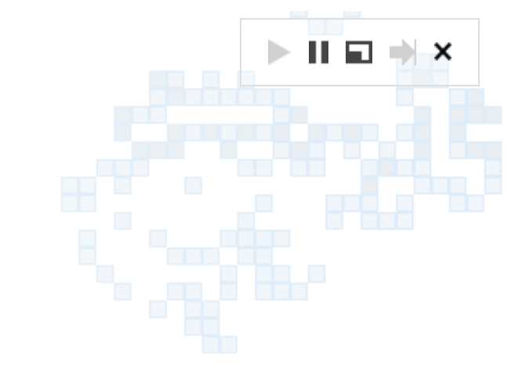Conway’s Game of Life is a cellular automaton invented by the British mathematician John Horton Conway in 1970. It is implemented on an infinite 2-dimensional grid of squared cells. Each cell has two possible states, either dead or alive. Each cell has eight neighbours which are the adjacent cells horizontally, vertically and diagonally. The state of each cell is updated in discrete time steps depending on its current state and the state of its neighbours. Different states of cells together create patterns on the grid. The simulation runs in iterations and shows the evolution of patterns.

In an early stage, Conway’s Game of life was simulated without the use of computers. It was implemented on graph paper or game boards such as Go. However, it is very inefficient and is easy to make errors when working with a large population or generations. With the use of computer programs, a simulator of Conway’s Game of life can be built. Selection and iteration in programming are useful in implementing Game of Life.

I was amazed by the fascinating evolution of patterns created throughout the game with just a simple pattern at the beginning. My curiosity encourages me to investigate the history and logic behind the game. As for computer science, Conway’s Game of Life has the power to implement a universal Turing machine, meaning that it can compute anything that can be computed. For example, it can simulate the behaviours of the three basic logic gates: AND, OR and NOT gates.

I have introduced the universality of Conway’s Game of Life to the tech club of my college, which is a group of students who are interested in investigating problems in computer science. Most of them have not yet heard of Conway’s Game of Life but are also attracted to its unpredictability. I decide to create my own simulator for Conway's Game of Life which would be suitable for both the beginners and advanced players in the tech club to study the behaviour of life.

### Initial Research

I watched a video about the Game of Life. John H Conway was interviewed to talk about his invention. The game was invented based on some real-life situations, for example, cell dies due to over population, as there may be insufficient food. He introduced the four fundamental rules of the simulation as follows:

1. Any live cell with fewer than two live neighbours dies, as if caused by under population.
2. Any live cell with two or three live neighbours lives on to the next generation.
3. Any live cell with more than three live neighbours dies, as if by overpopulation.
4. Any dead cell with exactly three live neighbours becomes a live cell, as if by reproduction.

The following examples shows how the rules can be applied to the cell in the centre.

|  |  |  |  |
| --- | --- | --- | --- |
|  |  |  | The cell is alive and has 0 live neighbours (<2).  According to rule 1, it dies in the next generation. |
|  |  |  |
|  |  |  |

|  |  |  |  |
| --- | --- | --- | --- |
|  |  |  | The cell is alive and has 3 live neighbours (=2 OR =3).  According to rule 2, it lives to the next generation. |
|  |  |  |
|  |  |  |

|  |  |  |  |
| --- | --- | --- | --- |
|  |  |  | The cell is alive and has 4 live neighbours (>3).  According to rule 3, it dies in the next generation. |
|  |  |  |
|  |  |  |

|  |  |  |  |
| --- | --- | --- | --- |
|  |  |  | The cell is dead and it has exactly 3 live neighbours (=3).  According to rule 4, it will be alive in the next generation. |
|  |  |  |
|  |  |  |

(Reference: https://www.youtube.com/watch?v=E8kUJL04ELA&t=11s)

There are plenty of simulators on Conway’s game of life that can be found online. However, I think that more functionalities can be added to make the simulator more user-friendly and entertaining.

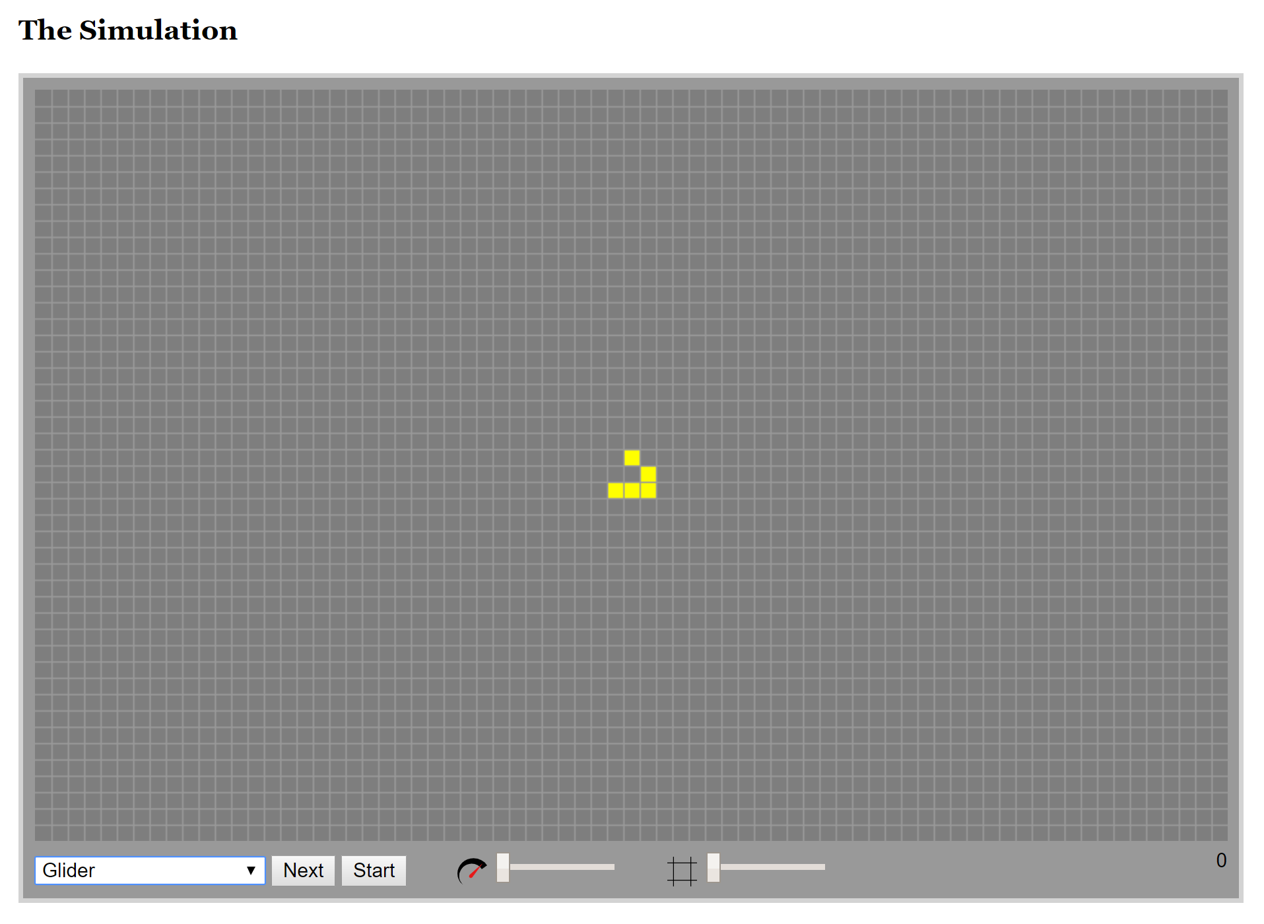

**Figure 1.1.2‑1** Example of an online simulator 1

(Reference: https://bitstorm.org/gameoflife/)

This is an example of a simulator found online. It gives me a basic idea of what a simulator should include. The user can choose a pattern or a clear grid from the pull-down menu or click on a cell to change the state of it. The grid will be updated a generation by clicking the ‘Next’ button. The grid will be updated at a custom speed by clicking the ‘Start’ button. The user can change the speed and the size of the cells with the corresponding track bars. The number at the bottom right corner is the number of generations that it has gone through.

I think that this simulator is simple and easy to use. It includes basic controls which allow users to run the simulation smoothly. However, I think this simulator can be improved to become more user-friendly. Currently, the user can only input patterns by choosing a pattern or clicking on each cell which is quite time-consuming.

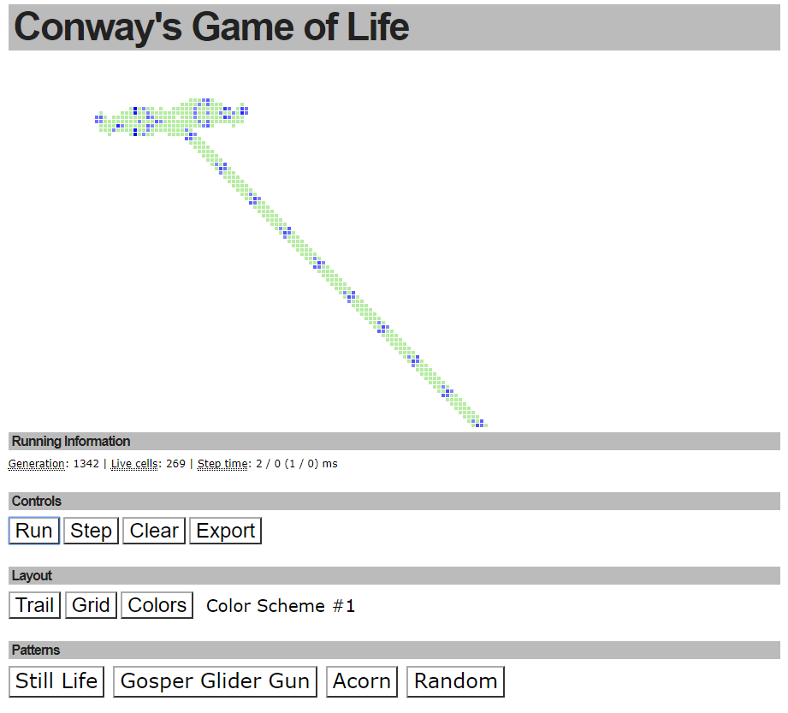

**Figure 1.1.2‑2** Example of an online simulator 2

(Reference: http://pmav.eu/stuff/javascript-game-of-life-v3.1.1/)

This is the second example of an online simulator. Besides the basic controls to run the simulation, there are three colour schemes and grid schemes for the user to choose from to change the colour and border of the cells. The number of generations, population and step time are clearing shown below the grid. The user can also pick a pattern or randomize a pattern. It also allows user to export patterns in the form of URL.

Compared to the previous simulator, this simulator has more options in the design and layout which makes it more appealing. However, it only allows the user to choose a colour scheme but the user cannot pick a custom colour. It does not allow the user to change the scale of the grid which makes inputting small patterns difficult.

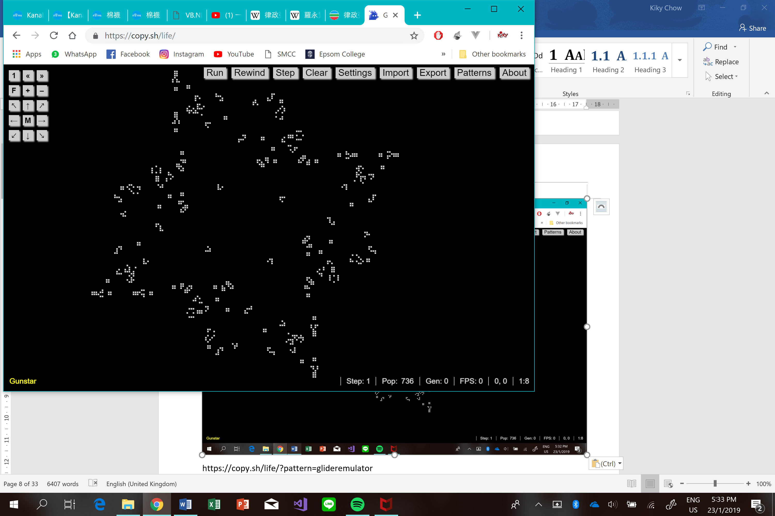

**Figure 1.1.2‑3** Example of an online simulator 3

(Reference: https://copy.sh/life/)

This is the third example of an online simulator. Compared to the previous two simulators, this is a rather complex simulation of Game of Life using the algorithm Hashlife. Hashlife is an algorithm using hash tables to optimise the simulation. It allows computers to compute extremely large patterns and fast generations. Despite the algorithm, this simulator allows user to use arrow keys to navigate the grid.

In my project, on top of the basics, I would like to add more functionalities to make my simulator more user friendly and entertaining. Firstly, I would like to allow users to change the colour of live cells and dead cells to increase their interest in this game. Secondly, I would like to allow users to copy and paste selected patterns on the grid so that input of patterns is more convenient and easier. Thirdly, the users can change the rules of the game to investigate how the same pattern will evolve under different rules. To adapt my program to the needs of users, I will interview potential users of my program and finalise the functionalities in the objectives section.

## User Needs and Further Research

| Date | Comment |
| --- | --- |
| April  (19/04/2018) | **Cellular automaton**  Conway’s Game of Life is a cellular automaton. Cellular automaton is first introduced by John von Neumann. It is a model which consists of a grid of cells. Each cell has a finite number of states. Each cell interacts with a set of cells called its neighbourhood. Each cell is assigned a state at the beginning, known as the initial state. A new generation is created by applying some rules to the whole grid simultaneously. The rules define what the new state of each cell will be based on the current state of the cell and the state of the cells in its neighbourhood.  **Neighbourhood**  The most common types of neighbourhoods for a two-dimensional cellular automaton are the Moore neighbourhood and the von Neumann neighbourhood. The neighbourhood used in Conway’s Game of Life is the Moore neighbourhood.   |  |  |  |  |  |  |  |  |  |  |  | | --- | --- | --- | --- | --- | --- | --- | --- | --- | --- | --- | |  |  |  |  |  |  |  |  |  |  |  | |  | **1** | **2** | **3** |  |  |  | **1** |  |  | |  | **4** |  | **5** |  |  | **2** |  | **3** |  | |  | **6** | **7** | **8** |  |  |  | **4** |  |  | |  |  |  |  |  |  |  |  |  |  | | The Moore neighbourhood | | | | |  | The von Neumann neighbourhood | | | | |   **Life-like cellular automaton**  A cellular automaton is Life-like if it has two dimensions, has two states, uses the Moore neighbourhood and the new state of a cell can be expressed as a function of its current state and the number of living cells in its neighbourhood. Conway’s Game of Life is therefore a Life-like cellular automaton.  (Reference: <http://www.conwaylife.com/wiki/Cellular_automaton>) |
| April  (22/04/2018) | **Interview with a beginner**  In order to design a program that completely meets the requirement of the users, I interviewed a tech club member who has never heard of the Game of Life before. After introducing her about the game and showing her some videos and an online simulator, she started getting interested in it. I asked the following questions:  **What interested you most about Game of Life after the introduction?**  I am especially interested in those complicated patterns, usually with more than 300 population, that will grow over a long period of time. I enjoy watching the revolution of patterns which is unpredictable.  **Did you have any difficulties when using a simple simulator of Game of Life?**  It is quite difficult and time consuming to input a pattern by clicking on the cells one by one. Moreover, I do not know much about the game so I am expecting a larger variety of patterns for beginners to explore.  **Is there anything you would like to add or change to make the simulator more appealing to beginners?**  It would be a great fun to edit the design of the grid. By which I mean that I would like to change the colour of the cells and the border width. It may also be more entertaining if each cell can be in different colours.  **I am planning to add a feature that a user can select an area of cells and copy and paste it on another location. Do you think it is useful?**  Yes, it makes the input much easier. Except copy and paste, it may also be convenient if I can fill the selected cells with a custom colour.  After the chat, I decided to add a range of pre-set patterns (at least 5) for the users to choose from, including oscillators and spaceships. It is also a good idea to allow the users to choose the colour of cells. |
| April  (26/04/2018) | **Interview with a frequent player**  I have another chat with a member who knows Conway’s Game of Life.  **What interested you most about Conway’s Game of Life?**  I am interested in the concept behind the game. It is fascinating to see the explosion of pattern with a small initial configuration. It would be interesting if I could create my own set of rules to simulate life. For instance, it will be interesting to see how the simulation would change if a live cell can live to the next generation when it has exactly 8 live neighbours.  **Are there any features you would find it useful to add into my project?**  I would like to have more information about the life on grid such as the frame per second, the population and the number of generations.  **I am planning to add a range of well-known patterns for user to choose from. Do you think it is useful?**  I think it is a great idea. I suggest adding patterns which takes many generations to stabilise. It may also be a good idea if I could save and load patterns created by myself.  After the chat, I decide to allow the user to change the rules of the simulator to other cellular automaton. I would also include some running information such as the generation and population beside the grid. |
| May  (04/05/2018) | **Research on patterns**  I researched various interesting patterns and I decided to add them to my simulator for the user to select.  Image result for conway's game of life gliderGlider is a pattern discovered by Richard K. Guy in 1970. It is the smallest spaceship. It can travel diagonally across the grid in four directions depending on its initial orientation. It is easily produced from other patterns and can collide with other patterns to produce interesting results.  Figure ‑ Glider  Gosper Glider gun is a pattern which emits gliders every 30 generations. It is the first finite pattern with unbounded growth since it can continually emit gliders.  Figure ‑ Gosper Glider Gun  Related imageR-pentomino is found by John Conway in 1970. It is the most active polyomino. It is the simplest methuselah which takes 1103 generations to stabilise and has a population of 116 that is much larger than its initial configuration. In generation 69, it emits a glider which is the first glider discovered by Richard K. Guy.  Figure ‑ R-Pentomino  https://sites.google.com/site/polyominosconway/pentominoes  Image result for conway's game of life lwssLightweight spaceship (LWSS) is found by John Conway in 1970. It is the smallest orthogonal spaceship and the second most common spaceship after glider.  Figure ‑ Lightweight Spaceship  Image result for conway's game of life pulsar  Pulsar is a larger period 3 oscillator found by John Conway. It means that it repeats itself every 3 generations.  Figure ‑ Pulsar  Image result for Schick engineSchick engine is an orthogonal spaceship found by Paul Schick in 1972. It consists of two LWSS and a tagalong is attached to form a larger spaceship.  Figure ‑ Schick Engine |
| May  (22/05/2018) | **Research on Different Rules**  Despite the Conway’s Game of Life, there are also some other life-like cellular automata. They have different set of rules and the rules can be expressed as rulestrings in S/B notation. The format of this notation is {number list}/{number list}, where the first number list is the number of neighbours that a live cell should have to survive and the second number list is the number of neighbours that a dead cell should have to born. The rules can also be represented by a state transition diagram so that we can visualise the state change. The following are some well-known life-like cellular automata.  **Conway’s Life (23/3)**  This is the rule for Conway’s Game of Life. A cell survives if it has 2 ot 3 neighbours. A cell is born if it has exactly 3 neighbours. It is the most well-studied rule that exhibits complex behaviour.    **Replicator (1357/1357)**  A cell survives or is born if it has an odd number of neighbours. Every pattern self-replicate under this rule.    **Maze (12345/3)**  A cell survives if it has at least 1 and at most 5 neighbours. A cell is born if it has exactly 3 neighbours. Patterns tend to explode in all directions and evolve into maze-like structures under this rule.    **2x2 (125/36)**  A cell survives if it has 1, 2, or 5 neighbours. A cell is born if it has 3 or 6 neighbours. Patterns have a chaotic evolution but die out very quickly under this rule.    **HighLife (23/36)**  A cell survives if it has 2 or 3 neighbours. A cell is born if it has 3 or 6 neighbours. Patterns evolve in similar behaviour under this rule and under Conway’s Game of Life. However, this rule allows a simple replicator.    (Reference: <http://www.conwaylife.com/wiki/List_of_Life-like_cellular_automata>) |
| June  (02/06/2018) | **Logic gates**  Having known the universality of Conway’s Game of Life, we can implement logic gates in Life. To construct logic gates in Life, we can use gliders as input and output signals. Therefore, we first have to investigate the collision of two gliders.  **Glider Collisions**  When two gliders are moving towards each other at the same vertical level and collide, they disappears in 27 generations.  8. Two step process of gliders' disappearance. Â   However, we would like reduce the time needed for the cancelation of gliders. When two gliders are moving towards each other with a one-cell vertical offset in between, they disappears in 5 generations after the collisions.  This indicates that when we place a right gun (a gun that emits gliders rightward) and a left-gun (a gun that emits gliders leftward) side by side with one a cell above the other one, the two streams of gliders will cancel out as a result of glider collisions.  **Eater**  An eater is a pattern that absorbs a glider and can resume its original form afterwards to absorb another glider. The diagram below shows how a glider is absorbed by an eater in 5 generations.  Image result for eater conway's game of life  This eater can be easily destroyed if we make an input to that specific cell shown in the diagram below.    The eater will disappear in 9 generations. This process activates the glider the gun, for instance, the glider gun resume to output a stream of gliders.        **Input**  An input of a logic function can be true or false, which can be represented by with glider or no glider in Life. For example, the binary string ‘110’ can be represented by glider-glider-no glider. A glider gun outputs a glider every 30 generations, representing a stream of true input. To implement a false input, we have to block the output of gliders. This could be done by placing an eater in a specific position below a glider gun as shown in the diagram below.    **Fixed Glider Gun**  Depending on the gate that we are implementing, some glider guns are designed to emit fix streams of gliders to implement collisions and produce the correct output of the gate. To eliminate a stream of gliders where necessary, an eater is placed in the appropriate position.  **NOT Gate**  NOT gate is often called an inverter. It only has a single input. The truth table below shows how a NOT gate behaves.   |  |  | | --- | --- | | INPUT | OUTPUT | | 0 | 1 | | 1 | 0 |   To implement the NOT gate in Life, a right input gun and a left fixed gun is placed side by side.  http://article.sapub.org/image/10.5923.j.ijis.20160601.02_011.gif  INPUT  A=0 🡪 Output=1  The first diagram shows when the input is false, no gliders are emitted from the input gun and there is a stream of gliders from the fixed gun, representing a true output.  A=1 🡪 Output=0  The second diagram shows when the input is true, gliders are emitted from the input gun and the two streams of gliders cancel out. No gliders are emitted, representing a false output.  **AND gate**  AND gate has two inputs. It only outputs true if both of the inputs are true. The truth table below shows how an AND gate behaves.   |  |  |  | | --- | --- | --- | | INPUT A | INPUT B | OUTPUT | | 0 | 0 | 0 | | 0 | 1 | 0 | | 1 | 0 | 0 | | 1 | 1 | 1 |   To implement the AND gate in Life, two right input guns and a left fixed gun is placed side by side. An eater is placed at the end of the fixed glider stream.  http://article.sapub.org/image/10.5923.j.ijis.20160601.02_012.gif  A=0, B=0 🡪 Output=0  The first diagram shows when A and B are both false, no gliders are emitted from the input glider guns and the fixed glider stream is absorbed by the eater, representing a false output.  A=0, B=1 🡪 Output=0  The second diagram shows when A is false and B is true, the glider stream from B cancels out with the fixed glider stream, representing a false output.  A=1, B=0 🡪 Output=0  The third diagram shows when A is true and B is false, the glider stream from A cancels out with the fixed glider stream, representing a false output.  A=1, B=1 🡪 Output=1  The fourth diagram shows when A and B are both true, the glider stream from the input B gun cancels out with the fixed glider stream, leaving the glider stream from the A undestroyed, representing a true output.  **OR gate**  OR gate has two inputs. It outputs true if one or more inputs are true. The truth table below shows how an OR gate behaves.   |  |  |  | | --- | --- | --- | | INPUT A | INPUT B | OUTPUT | | 0 | 0 | 0 | | 0 | 1 | 1 | | 1 | 0 | 1 | | 1 | 1 | 1 |   To implement the OR gate in Life, two right input guns, a right fixed gun and a left fixed gun is placed side by side. An eater is placed at the end of the input A glider stream.  http://article.sapub.org/image/10.5923.j.ijis.20160601.02_013.gif  A=0, B=0 🡪 Output=0  The first diagram shows when A and B are both false, the two fixed glider streams cancel out, representing a false output.  A=0, B=1 🡪 Output=1  The second diagram shows when A is false and B is true, the glider stream from B cancels out with the left fixed gun, leaving the glider stream from the right fixed gun undestroyed, representing a true output.  A=1, B=0 🡪 Output=1  The third diagram shows when A is true and B is false, the glider stream from A cancels out with the left fixed gun, leaving the glider stream from the right fixed gun undestroyed, representing a true output.  A=1, B=1 🡪 Output=1  The fourth diagram shows when A and B are both true, the glider stream from B cancels out with the left fixed gun and the glider stream from A is absorbed by the eater, leaving the glider stream from the right fixed gun undestroyed, representing a true output.  <http://article.sapub.org/10.5923.j.ijis.20160601.02.html>  <https://www.rennard.org/alife/CollisionBasedRennard.pdf> |

After the investigation of the user needs and some further research, I decide to include four main functionalities to my simulator of Conway’s Game of Life. Firstly, the user should be able to select a pre-set pattern. I will include all the patterns I have researched and the logic gates. Secondly, the user should be able to change the rules of the simulator from Conway’s Life to other cellular automaton like replicator of HighLife. Thirdly, the user should be able to select a region on the grid and copy and paste of patterns can be done. Lastly, the user should be able to import and export patterns. These will be finalised in my objectives section (1.4).

## DFD

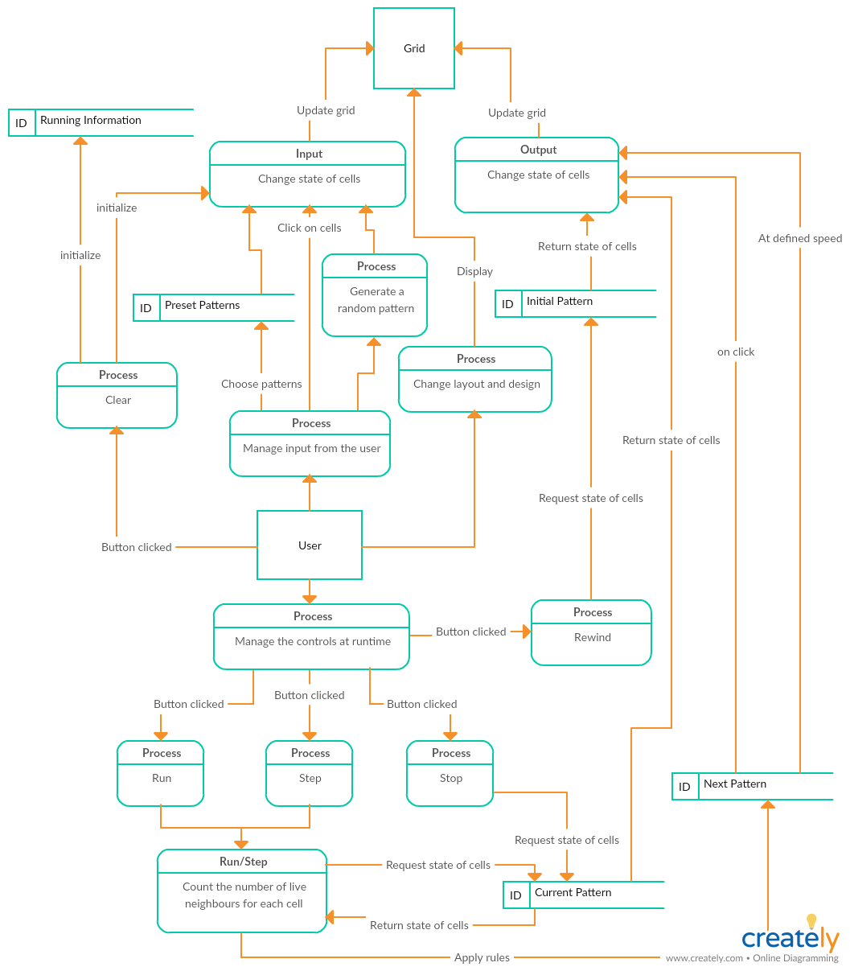

## Objectives

### General Objectives

To simulate cell interactions in Conway's Game of Life on a 2-dimensional grid of squared cells.

### Specific Objectives

1. Grid
   1. The program should allow the user to set the grid size and the grid size should be in the range of 20 to 350
   2. A grid of 2-dimensional squared cells in the correct size should be created when the form loads
   3. The user is able to move the grid by mouse dragging
2. Input and output of patterns
   1. Allow the user to change the state of each cell by clicking the cell. The cell should toggle between live and dead when clicked.
   2. Allow user to load a randomized pattern onto the grid
   3. Provide a range of pre-set patterns, e.g. still life, oscillator and logic gates
   4. Allow the user to import patterns by choosing a file. The program should be able to read the file and load the pattern stored in the file onto the grid. The pattern should be loaded in the centre of the grid despite the grid size.
   5. Allow the user to export patterns. The program should be able to write a file to store the pattern on the grid with a filename entered by the user.
   6. Allow the user to copy and paste patterns in the grid for easier input
      1. The user is able to select a region of cells by pressing and dragging the cursor over a region which will be highlighted
      2. The user is able to preview the selected pattern
      3. The user is able to rotate clockwise or anticlockwise, flip vertically or horizontally the selected pattern
      4. The pattern can be pasted on the grid correctly with the cell selected by the user as the top-left cell of the pattern
3. Simulation
   1. The user is able choose the boundary condition between closed boundaries and toroidal boundaries
   2. The program is able to count the number of live neighbours of each cell depending on the boundary condition
   3. The program is able to update the grid to the next generation using the rules of Conway’s Life (23/3) before any changes to the rules. Each cell is updated to its next state according to its current state and the number of its neighbours
   4. Allows the user to change the rules of the games for investigation. The program is able to update the grid to the next generation using the rules entered by the user.
4. Basic Controls
   1. The user is able to run the simulation at custom speed. The button should be able to toggle between run and stop.
   2. The user is able to stop the simulation
   3. The user is able to move to the next generation only when the step button is clicked
   4. The user is able to clear the cells on the grid. All the cells must be set to dead and all the running information must be reset
   5. The user is able to rewind. The program can store and load the initial pattern back onto the grid. The running information should be reset.
   6. The user is able to undo the pattern. The program can load the pattern of the previous generation onto the grid. The program should undo the running information as well.
   7. The user is able to skip to the specified generation
   8. The user is able to change the speed of the simulation, i.e. the number of generations per second.
   9. The user is able to zoom in and zoom out the grid. When the scale is the smallest, the user is able to see the full size of the grid.
5. The user is able to view running information throughout the simulation. The information should be updated simultaneously with the simulation.
   1. Show the population, i.e. the number of live cells, correctly
   2. Show the number of generations correctly
   3. Show the speed correctly
6. Design and Layout
   1. The user is able to change the colour of the live cells, the dead cells and the gridlines
   2. The user is able to change the width of the gridlines

## How will my program work

I decide to use Windows Forms app in VB.NET in my project since VB.NET is my major programming language. I plan to create four forms in my program:

* Menu Form: The menu screen
* Rules Form: Shows the rules of the game
* Main Form: The simulator
* Editing Form: Edit the selected pattern

When the program starts, a menu form should load. The form should include options to enter the game or to view the rules of the game so that the user can understand the principles behind the simulation.

If the user chooses to enter the game, the main form should load. The form should consist of three main parts: grid, control area and running information. I plan to put the controls and the grid on the same form so that the user can visualise the effect on the simulation simultaneously when the settings are edited.

If the user selects a region on the grid and chooses to copy, an editing form should load. There should be controls that allow the user to close the editing form after editing and pass the edited pattern back to the simulator.

### Grid

To create a grid, I plan to user an object-oriented approach.

I plan to use a built-in Class (PictureBox) and three other user-defined classes (Cell, Grid and GOLGrid) to create a 2-dimensional grid of squared cells. PictureBox is a windows form control used for displaying images. Grid is a class that inherits PictureBox and creates instances of an array of Cell while Cell is a class that stores the properties of each object. The two classes have a composition relation since the cells cannot exist independently without the grid. Grid is simply an image of a grid that does not support any clicking or dragging and is used in the editing form. GOLGrid is the simulation grid that performs the functionality of Conway’s Game of Life. GOLGrid should inherit Grid so specific features can be added to the parent class.

The following is the class diagram of my OOP design.

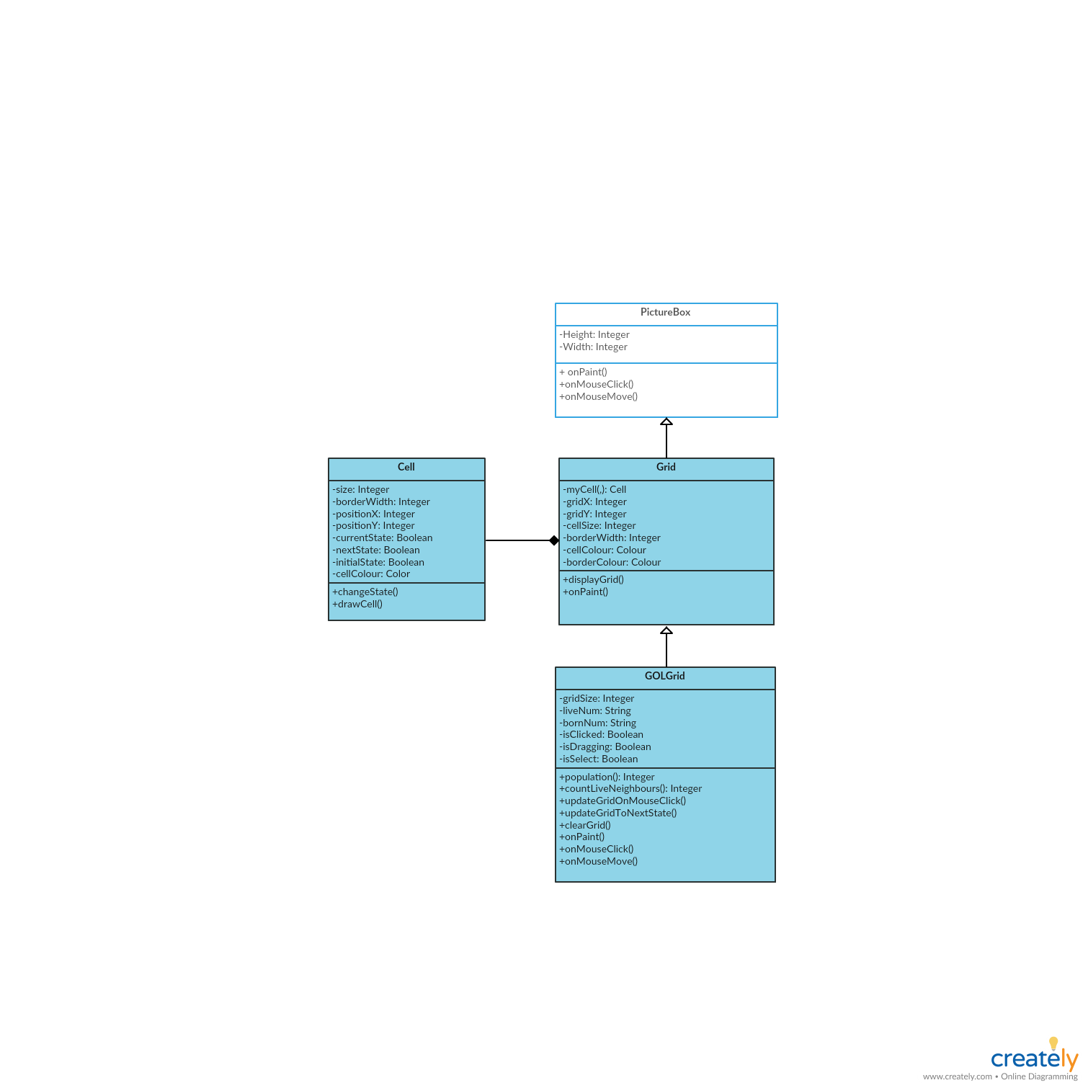

In the Cell Class, positionX and positionY are used to store the point where the cell should be drawn on the form. Size stores the width and height of the cell and borderWidth stores the width of the gridlines. Boolean should be used for the state of cell since a cell will be either dead or alive but nothing else. currentState stores whether the cell is live (represented by true) or dead (represented by false) in the current generation, for instance, the state of cells currently displayed on the screen. nextState stores the state of cell of the next generation after applying the rules. initialState stores the state of cells before running the simulation so that the initial pattern can be returned when the user requests to rewind.

In the Grid Class, instances of the array of Cell are created. Each object represents a cell on the grid. The Class Grid inherits the Class PictureBox. It should override the method OnPaint so that cells can be painted onto the grid.

In the GOLGrid Class, liveNum and bornNum stores the rule of the game. The function population will return the number of live cells of the grid. It should override the method onClick and onMove to detect any mouse clicks and mouse dragging respectively. The procedure updateGridOnMouseClick allows the user to change the state of a cell by clicking and updateGridToNextState runs the simulation.

Each cell on the grid should be a perfect square and is initialised to dead which is represented by the colour white.

On the grid, the user should be allowed to:

* Click: To change the state of the cell
* Drag: To move around the grid like a map
* Select: To Select an area of cells for copy and paste when the checkbox ‘Select’ is checked

### Control Area

In the control area, there should be basic controls to run the simulation such as RUN, STOP and CLEAR. Buttons and track bars should be used for the basic controls. The following is a list of controls I plan to include in the control area:

1. RUN/STOP (Toggle Button): Start the simulation at custom speed/ Stop the simulation
2. STEP (Button): Change the cells into the next state on click
3. CLEAR (Button): Reset the grid and the running information
4. REWIND (Button): Load the initial pattern onto the grid
5. Speed (Track bar): Change the time interval between generations
6. Scale (Track bar): Change the scale of the grid
7. Live cell (Button): Change the colour of the live cells
8. Dead cell (Button): Change the colour of the dead cells
9. Border (Button): Change the colour of the border
10. Border Width (Track bar): Change the border width
11. Export (Button): Save the pattern on the grid by creating a text file
12. Import (Button): Load the selected pattern on grid by reading a text file
13. Random (Button): Generate a random pattern

### Running Information

Running information allows the user to understand and study the behaviour of life. I plan to include the following:

1. Generation: The number of iterations the pattern has gone through
2. Population: The number of live cells on the grid
3. Speed: The number of generations per second

Label control can be used to display the running information as it is only in text form. Three variables are required to store each piece of information. The information should be updated in each generation and initialised when CLEAR or REWIND is clicked.

## Justification of chosen solution

Conway’s Game of Life should be implemented on an infinite grid of squared cells. However, a computer has finite memory. There are various ways in simulating an infinite grid.

The first solution is to treat any cells beyond the grid displayed as dead. The diagram below shows the neighbourhood of a cell at the corner. The red grid lines show the permanently dead neighbours of the shaded cell that are beyond the grid. The advantage of this solution is that it is easy to program and easy for beginners to understand the basic principle of Game of Life. The disadvantage is that this solution has set boundaries and may lead to inaccurate results at the border of the grid. For example, a glider should travel across the grid diagonally and never stop. If this solution is chosen, a glider will stops by the border which is incorrect. However, this is a minor problem given the grid size is large enough.

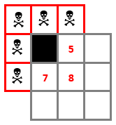

The second solution is to wrap the border of Conway’s Game of Life. It means that the top of the grid is connected to the bottom and the left is connected to the right. In this solution, all cells would have exactly 8 neighbours and the patterns at the edge may reappear at the opposite side again. The diagram below shows the neighbourhood of a cell in the bottom left corner of a 4x4 grid. The advantage of this solution is that the board is a torus (Figure 1.6-1) which simulates an infinite grid that repeats every certain number of cells. The disadvantage of this solution is that the patterns created across the edges may interfere with the original patterns on the board. For example, if this solution is chosen, a glider gun will emit gliders that wrap around the edges and cause destruction of the gun.

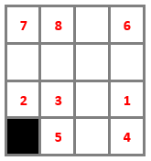

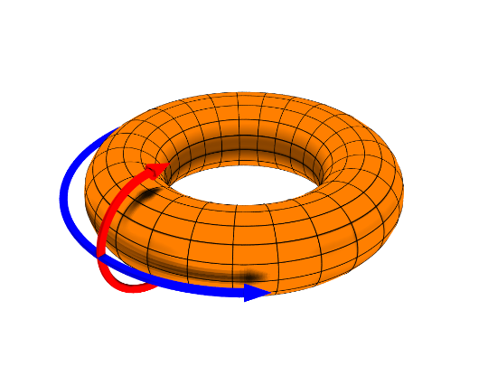

Figure ‑ An example of a torus

Another solution is that the camera will follow the movement of patterns. For example, if the initial pattern is a glider which travels towards the bottom right corner of the grid, the camera will be automatically scrolled down and right to follow the glider as it moves across the grid. Another example is that if the pattern shrinks, the camera will automatically zoom in. This solution best simulate an infinite grid. However, when dealing with explosive patterns, a lot of memory is required and the scale of the grid will turn very small.

The first and second solution can be implemented by using an array to store the state of cells. It is a static data structure which has a fixed maximum size. The third solution can be implemented using a dynamic data structure like arraylist. When a pattern grows, we expand the size of the arraylist so the grid can change according to the movement of the live cells.

Since most members of the tech club are new to Conway’s Game of Life, the ease for the members to understand the basic principles of Life is more important than finding the most accurate representation of Life. The first solution gives the users a better control over the simulator and any inaccurate representation of Life is not significant when dealing with simple patterns like glider guns, while the other two solutions are more complex and may lead to confusion easily for the beginners. Therefore, I chose to implement both the first and second solution using an array with the first solution as the default boundary condition. Since Conway’s Game of Life is implemented on a 2-dimensional grid, a 2-dimensional array provides a compact representation to store a group of variables of the same data type, in this case, Boolean, the state of each cell. I can easily refer to the specific element in the array to change the property of each cell.

# Design

## Design Overview

The aim of my project is to create a user-friendly simulator of Conway’s Game of Life for the members of Tech Club. My program starts with a menu screen which allows the user to enter the game, to view how to use the simulator or to exit the game. If the user chooses to enter the game, the simulator will be created.

The simulator consists of three main parts: the grid, the control area and the running information. The grid, where the simulation takes place, is a two-dimensional grid of squared cells. Each cell has two states which is represented by two distinct colours. The grid is created using object-oriented programming. The user can input the initial state of cells in three ways: clicking the cells, randomising a pattern or importing a pattern. Importing and exporting patterns are achieved using text files. The user can move the grid by dragging it to a new location like using an online map. When the checkbox ‘Select’ is checked, the user can also select cells on the grid to copy and paste. Therefore, algorithms have to be designed so that the grid can listen to and differentiate clicking, dragging and selecting events.

The control area will be on the right of the grid. In the control area, buttons and track bars are created in order to allow the user to control and edit the settings of the simulation. In order to run the simulation smoothly, algorithms have to be designed to count the number of neighbours of each cell and apply the rules to update the grid to the next generation. An editing screen will pop up if the user copies a pattern.

Running information displays the number of generations, population, scale and speed. These are displayed below the grid and will be updated in every generation.

### Menu Screen

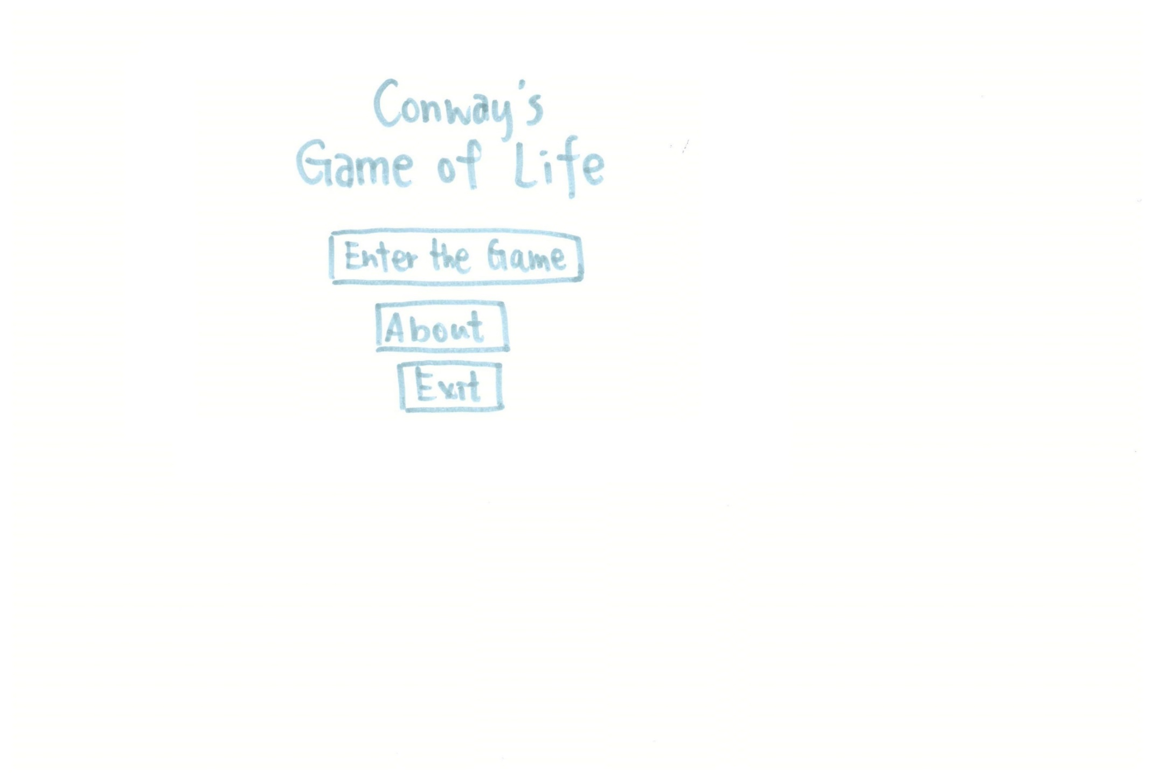

Load the User Guide

Load the simulator

Close the program

(This will be the only way to close the program)

### The Simulator

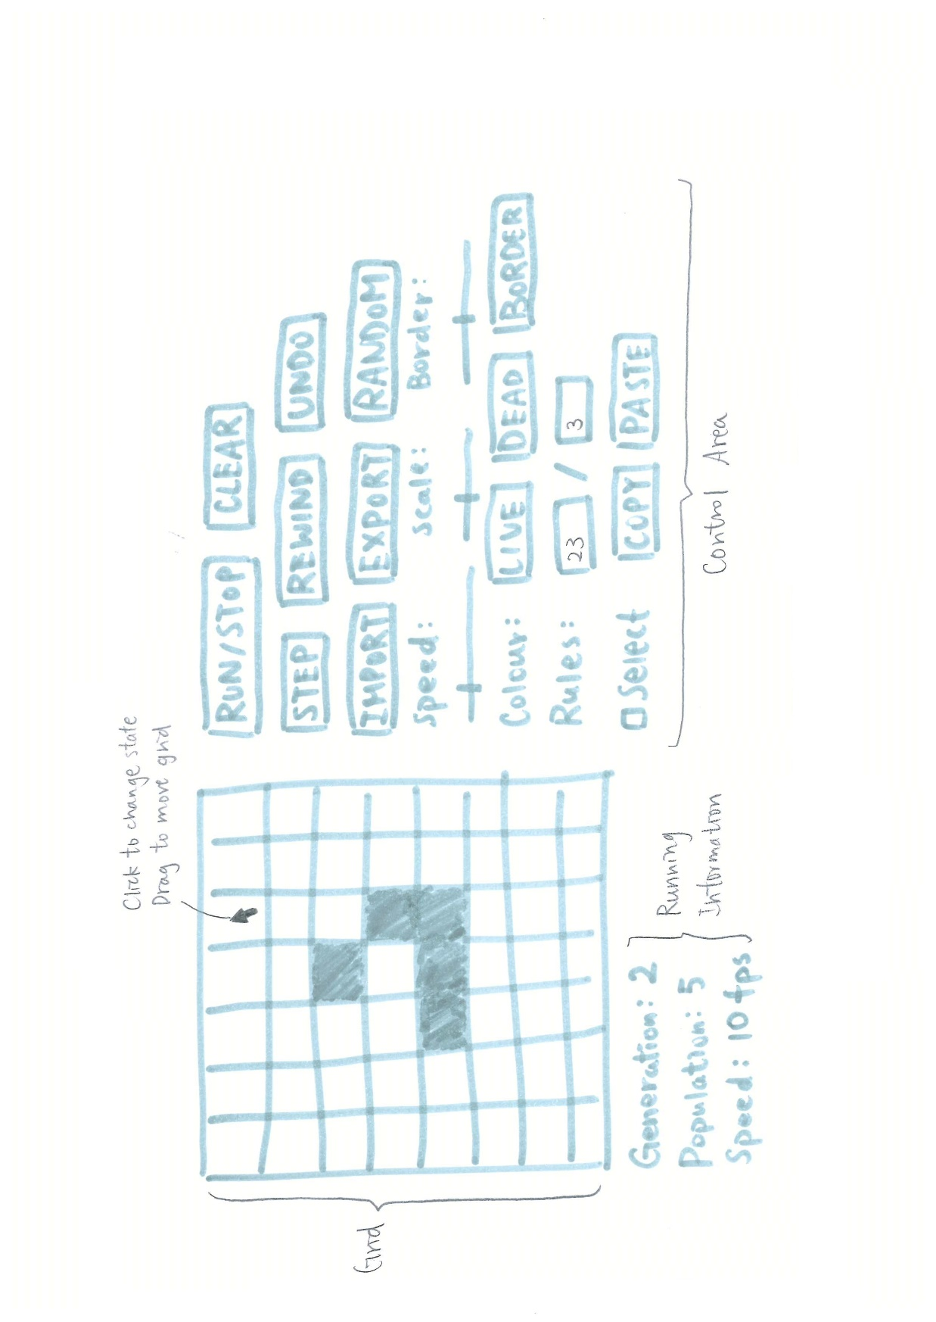

Click and drag the grid to select when cehecked

Load the Editing Screen

(Pass the selected pattern to the editing form)

### Editing Screen

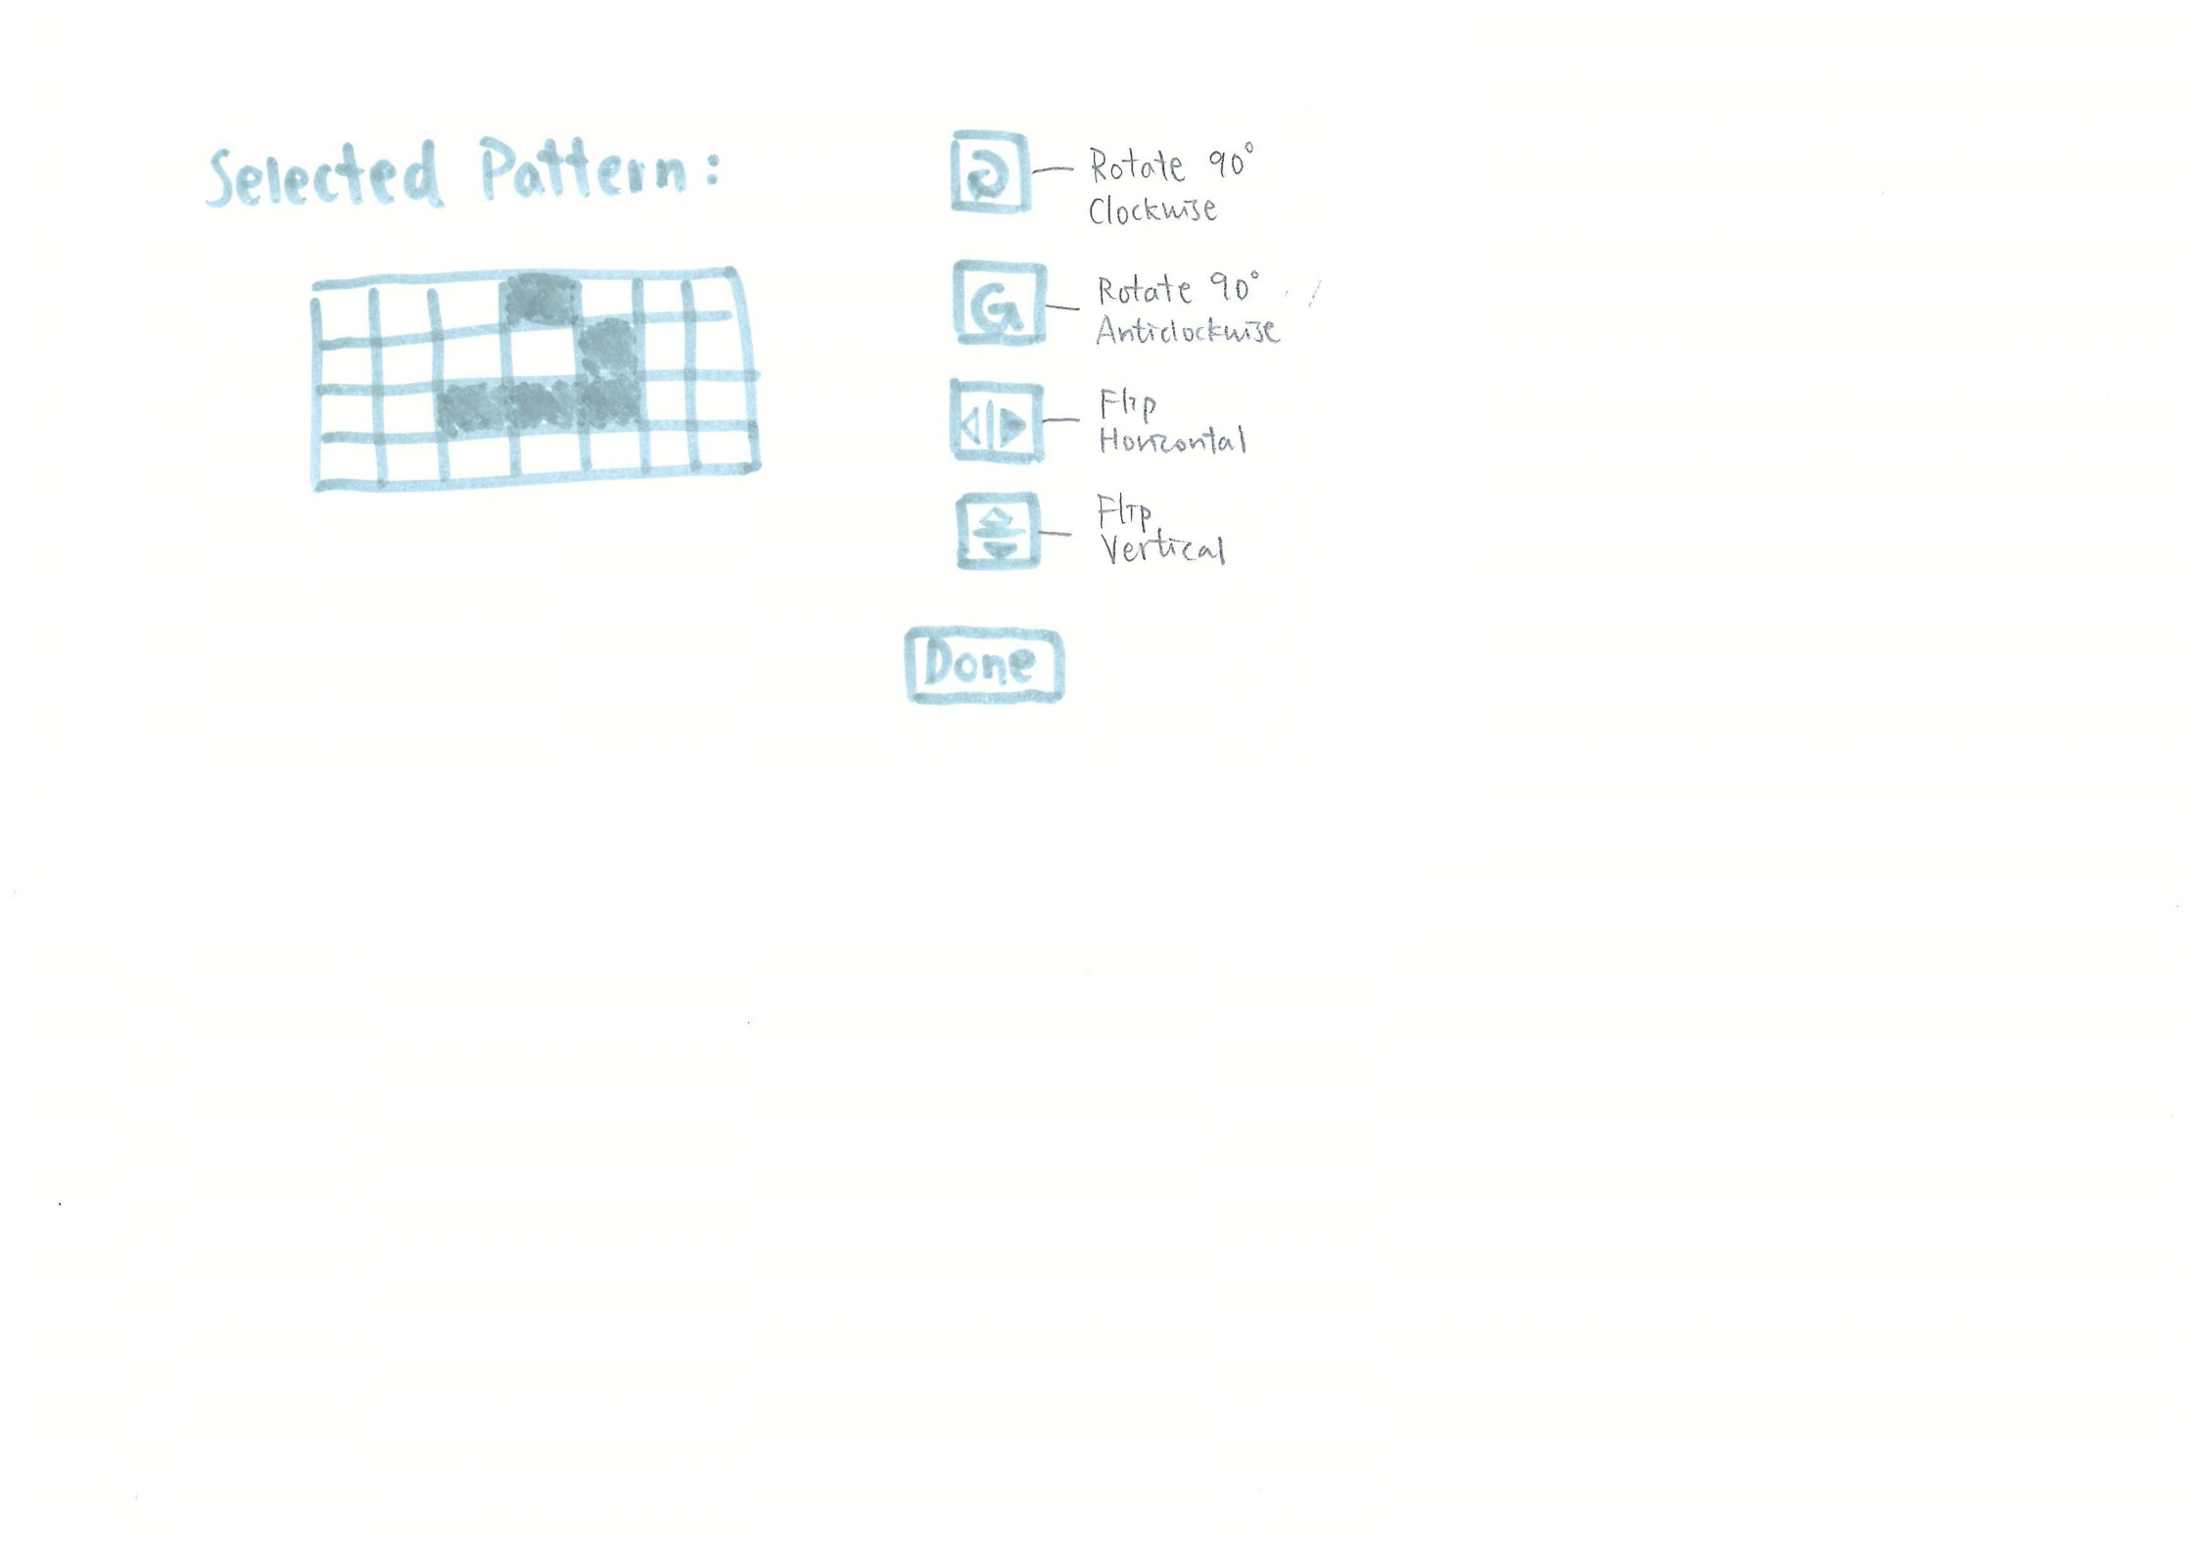

Close the editing screen and return to the simulator

(Pass the edited pattern back to the simulator)

## Modular Structure of the System

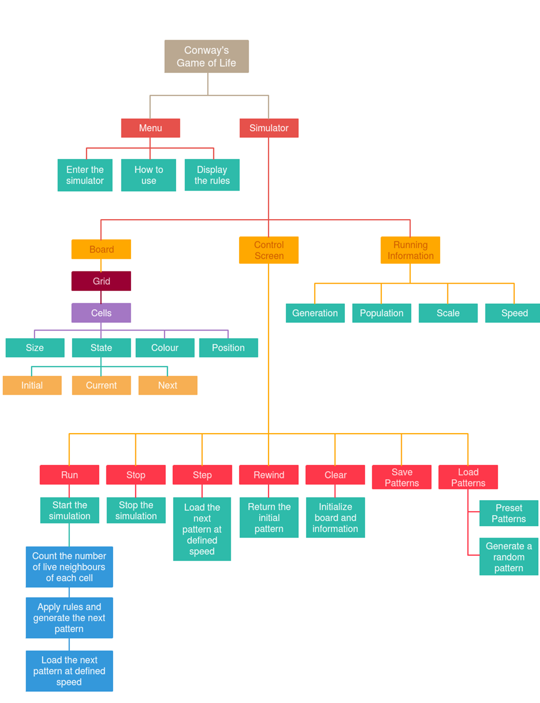

## Data Structure in my project

The data structure used to represent a grid of cells is a 2-dimensional array. The indexes represent the x and y coordinates of a cell. Zero-based indexing is used, for instance, the first element in the array is indexed by 0. (0, 0) represents the cell in the top row and the leftmost column while (grid size -1, grid size -1) represents the cell in the bottom row and the rightmost column. To access every element in the array, two nested for loops are used.

To implement the undo operation, a stack is used. A stack is a Last In First Out (LIFO) structure where the last item entering the stack is removed first. Every time before the grid is updated to the next generation, the current generation is pushed onto the stack. When the undo button is clicked, we popped the stack and the most recently added generation is returned.

## File Structure in My Project

When importing and exporting patterns, text files are used in my program.

When exporting, a message box pops up and requires you to input the file name. My program creates a text file with the input file name and iterates through the array with two nested FOR loops. If the current state of a cell is alive, it writes the column number and the row number with a space in between in a new line into the text file.

When importing, my program iterates through each line within the text file and extract the text before the space as the column number and the text after as the row number. It then accesses the corresponding array and changes the state of the cell into alive.

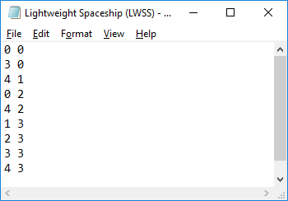

**Figure 2.1.3‑1** an example text file of a LWSS pattern

## Class Definitions

I have defined 3 classes, Cell, Grid and GOLGrid, in my program.

Cell is the most basic element in the simulation. Each cell has a state that can be either alive or dead. Each cell also has their own position on the form, a size and a colour. Cell class defines all these properties of each squared cell. An array of objects is created from this class in the Grid class.

|  |  |  |  |
| --- | --- | --- | --- |
| Cell | | | |
| Private | *Attributes* | *Data Type* | *Description* |
| size | Integer | It stores the width and size of each cell. |
| borderWidth | Integer | It stores the width of the gridlines. |
| positionX | Integer | It stores the position of the cell on the grid on the x-axis. |
| positionY | Integer | It stores the position of the cell on the grid on the y-axis. |
| currentState | Boolean | It stores whether the cell is alive (represented by TRUE) or dead (represented by FALSE) in the current generation, i.e. the state of cell currently displayed on the gird. It is initialised to FALSE. |
| initialState | Boolean | It stores the state of cells before running the simulation. |
| nextState | Boolean | It stores the state of the cells of the next generation. It is initialised to FALSE. |
| undoState | Stack (2.3) | It stores each generation of the grid. |
| cellColour | Colour | It stores the colour of the live cells. |
| deadCellColour | Colour | It stores the colour of the dead cells. |
| Public | *Method* | *Description* | |
| drawCell | It paints a rectangle according to the state, position and size of the cell. | |
| getCellColour: Colour | It returns the colour of the cell according to its state. | |
| changeState | It inverts the state of the cell. | |

Grid Class represents a collection of cells. It is associated with Cell class in a composition relationship. It inherits Picturebox which is a built-in class in VB.NET so that the grid can be painted and displalyed on the form. This class is inherited by GOLGrid and is used when creating the grid displaying the selected pattern on the editing form.

|  |  |  |  |
| --- | --- | --- | --- |
| Grid (Picturebox) | | | |
| Private | *Attributes* | *Data Type* | *Description* |
| myCell(gridSize, gridSize) | ***Cell*** | It is an array which stores the properties of each cell. |
| gridX | Integer | It stores the number of columns of the grid. |
| gridY | Integer | It stores the number of rows of the grid |
| cellSize | Integer | It stores the length and width of each squared cell. |
| borderWidth | Integer | It stores the width of the gridlines. |
| borderColour | Color | It stores the colour of the gridlines. |
| Public | *Method* | *Description* | |
| displayGrid | It paints all the cells onto the grid according to the gridSize. | |
| OnPaint | It overrides the OnPaint method of Picturebox and paint the grid. | |

GOLGrid class defines the properties and methods of a grid in Conway’s Game of Life. It inherits Grid and on top of the methods in its parent class, GOLGrid includes methods to change the state of cell when clicked and move the grid when drag. This class is used to create the grid in the simulator.

|  |  |  |  |
| --- | --- | --- | --- |
| GOLGrid (Grid) | | | |
| Private | *Attributes* | *Data Type* | *Description* |
| gridSize | Integer | It stores the number of columns and rows. The total number of cells is gridSize*gridSize. |
| gridLength | Integer | It stores the number pixels displayed. |
| boundaryCondition | String | It stores the boundary condition. It can be either “Closed Boundaries” or “Toroidal Boundaries”. |
| liveNum | String | It stores the number list of the number of neighbours required for a live cell to survive. |
| bornNum | String | It stores the number list of the number of neighbours required for a dead cell to born. |
| isDragging | Boolean | It stores whether you is dragging the grid. It is initialised to FALSE. TRUE is assigned in a MouseDown Event and FALSE is assigned in a MouseUp event. |
| isClicked | Boolean | It stores whether you clicks on the grid. |
| isSelect | Boolean | It stores whether you tries to select the cells on the grid. |
| selectWidth | Integer | It stores the width of the selected area. |
| selectHeight | Integer | It stores the height of the selected area. |
| startPoint | Point | It stores the point of the mouse on MouseDown. |
| startCellX | Integer | It stores the column number of the top-left cell of the selected region. |
| startCellY | Integer | It stores the row number of the top-left cell of the selected region. |
| endCellX | Integer | It stores the column number of the bottom-right cell of the selected region. |
| endCellY | Integer | It stores the row number of the bottom-right cell of the selected region. |
| Public | *Method* | *Description* | |
| Population: Integer | It stores the total number of live cells on the grid. | |
| displayGrid | It paints all the cells onto the grid according to the gridSize. | |
| clearGrid | It resets all the cells on the grid to dead. | |
| undoGrid | It returns the states of cells of the previous generation. | |
| saveInitial | It stores the initial states of cells. | |
| returnInitial | It returns the initial states of cells | |
| changeStateOnMouseClick | It tracks the position of the mouse and change the state of the clicked cell.  *Algorithm showed in (2.6.1) | |
| countLiveNeighbours | It counts the number of live neighbours of the cells.  *Algorithm showed in (2.6.2) | |
| updateGridToNextState | It changes the states of the cells according to the rules of the game.  *Algorithm showed in (2.6.3) | |
| changeWidth | It changes the width of the gridlines. | |
| changeCellColour | It allows the user to select a colour for the live cells. | |
| changeDeadCellColour | It allows the user to select a colour for the dead cells. | |
| changeBorderColour | It allows the user to select a colour for the gridlines. | |
| SelectCells | It allows the user to select a region on the grid. | |
| OnPaint | It overrides the OnPaint method of Grid and paints the extra selected region. | |
| OnMouseClick | It overrides the OnMouseClick method of Picturebox and changes the state of cell when clicked. | |
| OnMouseDown | It overrides the OnMouseDown method of Picturebox and stores the starting point of the selected region in a variable. | |
| OnMouseMove | It overrides the OnMouseMove method of Picturebox and identifies that the user is trying to move the grid. | |
| OnMouseUp | It overrides the OnMouseUp method of Picturebox and stores the ending point of the selected region in a variable. | |

## My Algorithms

### Change state of cells when clicked

This algorithm is used in the method **changeStateOnMouseClick** of the GOLGrid class.

To change the state of a clicked cell, we need to track the mouse position. The diagrams below show the indexes of the array of cells and their corresponding mouse positions. The size of each cell is 10.

|  |  |  |  |  |  |  |  |  |
| --- | --- | --- | --- | --- | --- | --- | --- | --- |
| (0, 0) | (1, 0) | (2, 0) | (3, 0) |  | (0-9,  0-9) | (10-19, 0-9) | (20-29, 0-9) | (30-39, 0-9) |
| (0, 1) | (1, 1) | (2, 1) | (3, 1) |  | (0-9,  10-19) | (10-19,  10-19) | (20-29,  10-19) | (30-39,  10-19) |
| (0, 2) | (1, 2) | (2, 2) | (3, 2) |  | (0-9,  20-29) | (10-19,  20-29) | (20-29,  20-29) | (30-39,  20-29) |
| Array Index | | | |  | Mouse Positions | | | |

In order to change the cell when it is clicked, we need a function to map the mouse positions to the array indexes.

**Index = mouse position \ the size of cell** ( \ is integer division)

### Counting the number of live neighbours:

In order to update the grid to the next generation, we need to count the number of live neighbours of each cell. A function can be used to return the count when we pass the column number (x) and row number (y) of a cell as parameters. I need to use two different functions for the two boundary conditions respectively.

#### Closed boundaries

The diagram below shows the positions and the indexes of the neighbourhood of a cell.

|  |  |  |
| --- | --- | --- |
| **1** | **2** | **3** |
| **4** |  | **5** |
| **6** | **7** | **8** |

|  |  |  |
| --- | --- | --- |
| **(x-1, y+1)** | **(x, y-1)** | **(x+1, y+1)** |
| **(x-1, y)** | **(x, y)** | **(x+1, y)** |
| **(x-1, y-1)** | **(x, y-1)** | **(x+1, y-1)** |

**Figure 2.7.3‑1** Position of neighbouring cells **Figure 2.7.3‑2** Indexes of neighbouring cells

To find the number of live neighbours, the function has to check the position of the cell to prevent from exceeding the bounds of the array. If the cell is at the top row, it does not have any neighbours at position 1, 2 and 3. If the cell is at the bottom row, it does not have any neighbours at position 6, 7 and 8. If the cell is at the leftmost column, it does not have any neighbours at position 1, 4 and 6. If the cell is at the rightmost column, it does not have any neighbours at position 3, 5 and 8. According to the above conditions, the function has to check whether the current state of the neighbouring cell at each position is true with the corresponding indexes. For example, the neighbouring cell positioned at 1 has coordinates of (x-1, y+1). If yes, the count is incremented by 1.

The following is the Pseudocode of the function:

**Function countLiveNeighbours(x, y)**

**Position 1:**

**IF x is not 0 AND y is not 0 THEN**

**IF current state of Cell(x-1, y-1) is true THEN**

**Increment counter**

**END IF**

**END IF**

**Position 2:**

**IF y is not 0 THEN**

**IF current state of Cell(x, y-1) is true THEN**

**Increment counter**

**END IF**

**END IF**

**Position 3:**

**IF x is not equal to the (grid size -1) AND y is not 0 THEN**

**IF current state of Cell(x+1, y-1) is true THEN**

**Increment counter**

**END IF**

**END IF**

**Position 4:**

**IF x is not 0 THEN**

**IF current state of Cell(x-1, y) is true THEN**

**Increment counter**

**END IF**

**END IF**

**Position 5:**

**IF x is not equal to (grid size -1) THEN**

**IF current state of Cell(x+1, y) is true THEN**

**Increment counter**

**END IF**

**END IF**

**Position 6:**

**IF x is not 0 AND y is not equal to (grid size -1) THEN**

**IF current state of Cell(x-1, y+1) is true THEN**

**Increment counter**

**END IF**

**END IF**

**Position 7:**

**IF y is not equal to (grid size -1) THEN**

**IF current state of Cell(x, y+1) is true THEN**

**Increment counter**

**END IF**

**END IF**

**Position 8:**

**IF x is not equal to (grid size -1) AND y is not equal to (grid size -1) THEN**

**IF current state of Cell(x+1, y+1) is true THEN**

**Increment counter**

**END IF**

**END IF**

**RETURN counter**

**END FUNCTION**

#### Toroidal Boundaries

The diagram below shows the indexes of the neighbourhood of a cell in a toroidal boundary condition.

|  |  |  |
| --- | --- | --- |
| **( (x-1+S) MOD S,**  **(y-1+S) MOD S )** | **( (x-1+S) MOD S,**  **(y )** | **( (x-1+S) MOD S,**  **(y+1+S) MOD S )** |
| **( x,**  **(y-1+S) MOD S )** | **(x, y)** | **( x,**  **(y+1+S) MOD S )** |
| **( (x+1+S) MOD S,**  **(y-1+S) MOD S )** | **( (x-1+S) MOD S,**  **y )** | **( (x+1+S) MOD S,**  **(y+1+S) MOD S )** |

To count the total number of live neighbours in this situation, two nested for loops can be used to count the total number of live cells in this 3x3 region and then subtract 1 if the current cell is alive.

The following is the Pseudocode of the function:

**Function countLiveNeighbours(x, y)**

**For j = 1 To 2**

**For i = 0 to 2**

**IF current state of Cell( *(x-1+S+i) MOD S*, *(y-1+S+j) MOD S*) is true THEN**

**Increment counter**

**END IF**

**NEXT**

**NEXT**

**IF current state of Cell(x, y) is true THEN**

**counter = counter -1**

**END IF**

**RETURN counter**

**END FUNCTION**

### Update the Grid to Next Generation

To update the grid, we need to know the next state of each cells. It can be achieved by applying the rules of the game to each cell on the grid. In my program, I will use two string variables liveNum and bornNum to store the number list of the number of neighbours required for a live cell to survive and the number list of the number of neighbours required for a dead cell to born respectively. In the case of Conway’s Life, liveNum stores “23” and bornNum stores “3”.

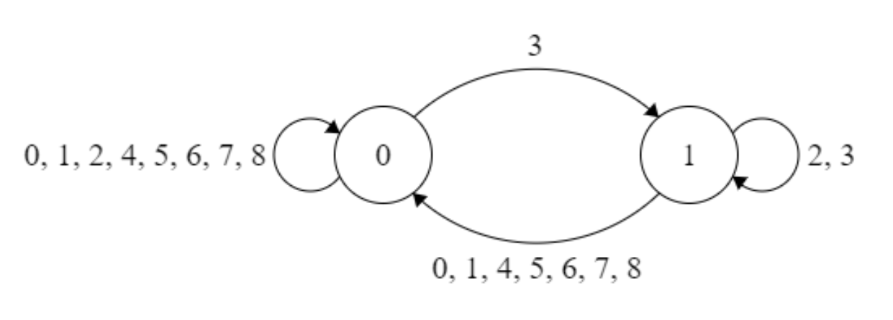

To find out the next state of a cell positioned at (x, y), the program first checks whether the cell is alive or dead. If the cell is alive, it checks whether liveNum contains the value returned by the function countLiveNeighbours(x, y). If the cell is dead, it checks whether bornNum contains the value. If the value is found, the next state of the cell is alive. If not, the next state of it is dead.

To ensure the simulation is running in discrete time steps, we cannot update the current state of the cells directly. This is because the cells that have been accessed by the loop first would have been updated to the new states but the remaining cells would remain in their current states. There is a mixture of current states and new states in the grid, which will cause mistakes in counting live neighbours. Therefore, a temporary variable, nextState, is used to store the state of the next generation.

The following is the Pseudocode of the procedure to update the grid:

**SUB updateGridToNextState()**

**FOR each Cell in the grid**

**IF the current state of Cell is true THEN**

**IF liveNum contains the number of live neighbours of Cell**

**The next state of Cell is true**

**ELSE**

**The next state of Cell is false**

**END IF**

**ELSE**

**IF bornNum contains the number of live neighbours of Cell**

**The next state of Cell is true**

**ELSE**

**The next state of Cell is false**

**END IF**

**END IF**

**END FOR**

**FOR each Cell in the grid**

**The current state of Cell = The next state of Cell**

**END FOR**

**END SUB**

This procedure should be called in the tick event of a timer and in the click event of the STEP button to update the grid at custom speed and on clicked respectively.

### Export Pattern

To export the pattern on the grid, the program has to be able to write text files (refer to 2.4). When the EXPORT button is clicked, an input box is load to ask the user to input a file name. Validation should be carried out to ensure that the user has input a file name.

There are various ways to store the state of cells. For example, the program can store the state of each cell on the grid row by row. If the cell is alive, write 1 to the text file. If the cell is dead, write 0 to the text file. However, this method is inefficient especially when dealing with large grid size. Since each cell only has two states, I decide to store the row number and the column number of live cells instead of storing the state of cells. Furthermore, in order to deal with different grid sizes and make loading the pattern in the centre of the grid in the import stage easier, the program should ignore any rows and columns that do not contain a single live cell. For instance, I only want to store the region of the pattern but not the whole grid. Implementing this method, the same pattern placed at different positions on the grid should always export the same text file. The diagram below shows the difference between the indexes I would like to store and the actual indexes when exporting a glider pattern. A message box is shown to inform the user that it exports the pattern successfully.

|  |  |  |  |  |  |  |
| --- | --- | --- | --- | --- | --- | --- |
| Export Column/ Row No. | 🡪 | / | / | 0 | 1 | 2 |
| 🡫 | Actual Column/ Row No. | 0 | 1 | 2 | 3 | 4 |
| / | 0 |  |  |  |  |  |
| 0 | 1 |  |  |  | 1 0 |  |
| 1 | 2 |  |  |  |  | 2 1 |
| 2 | 3 |  |  | 0 2 | 1 2 | 2 2 |

The wanted text file of a glider pattern is shown below.

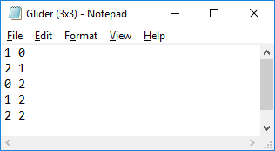

The following is the Pseudocode of the procedure to export a pattern:

**SUB Export()**

**fileName = INPUT**

**IF fileName is empty THEN**

**OUTPUT “You must enter a file name”**

**ELSE**

**Create a text file with the input filename**

**minX = 350**

**minY = 350**

**FOR each Cell in the grid**

**IF current state of Cell is true THEN**

**minX = Min(minX, x index of Cell)**

**minY = Min(minY, y index of Cell)**

**END IF**

**END FOR**

**FOR each Cell in the grid**

**IF current state of Cell is true THEN**

**Write( x index of Cell - minX & “ “ & y index of Cell - minY)**

**END IF**

**END FOR**

**Close file**

**OUTPUT “Export Successfully”**

**END IF**

**END SUB**

### Import Pattern

To import a selected pattern, the program has to be able to read text files (refer to 2.4). When the import button is clicked, an open file dialog will load and ask the user to select the file to be imported onto the grid. If the user did not select a file, the program enters the catch block and a message box will be shown to inform the user that it fails to import a file.

The text file stores the x and y coordinates of live cells in each line with a space as the delimiter. A loop is iterated through each line in the chosen text file. The library function of VB.NET, Split, can be used to separate the x coordinate and the y coordinate. The array returned is stored in a local variable TestArray of length 2. The x coordinate of the cell is the first value in the array while the y coordinate is the second value in the array. The state of the corresponding cell can then be changed to true.

However, if the program changes the cell with the stored indexes to true directly, the pattern will always be placed at the top left corner of the grid. In order to import a pattern in the centre of the grid, I need to know the height and width of the pattern. The starting position to place the pattern is then shown in the following diagram.

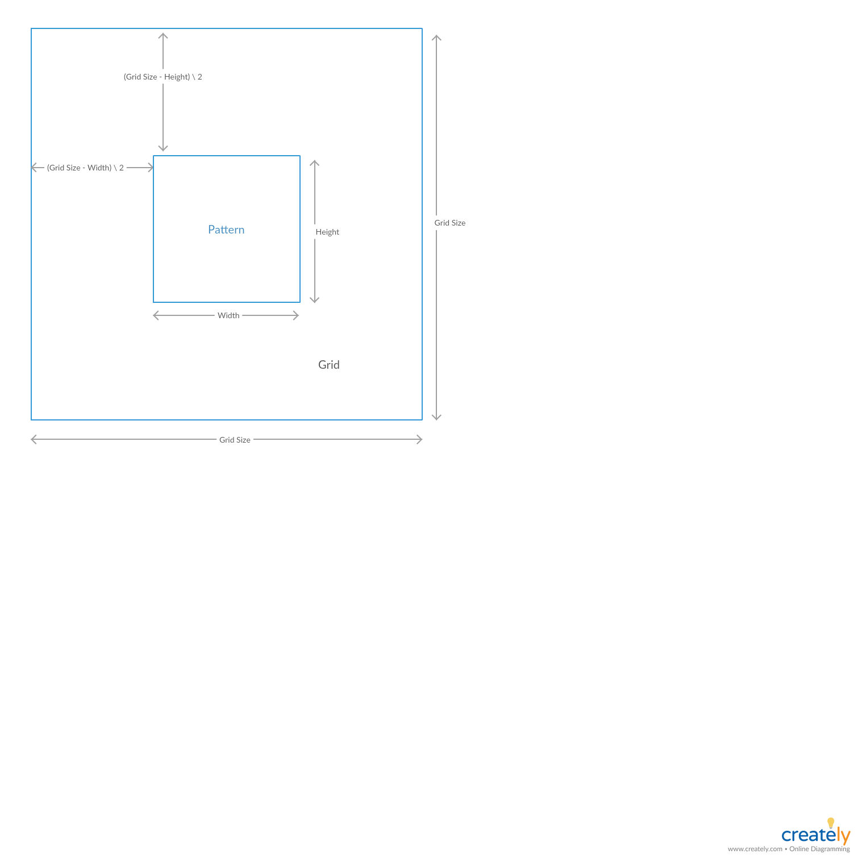

The following is the Pseudocode of the procedure to import a pattern:

**SUB Import()**

**User chooses a text file from the open file dialog**

**Try**

**maxX = 0**

**maxY = 0**

**FOR each Line in the text file**

**Array = Split(Line)**

**x = Array(0)**

**y = Array(1)**

**maxX = Max(maxX, x+1)**

**maxY = Max(maxY, y+1)**

**ADD Array to IndexList**

**END FOR**

**startX = (grid size – maxX) \ 2**

**startY = (grid size – maxY) \ 2**

**FOR each array in the IndexList**

**x = array(0) + startX**

**y = array(1) + startY**

**the current state of Cell(x, y) = true**

**END FOR**

**Catch**

**OUTPUT “Failed to import file”**

**END TRY**

**END SUB**

The following screenshots show that the pattern can be imported into the centre of the grid despite the grid size (20, 50 and 100).

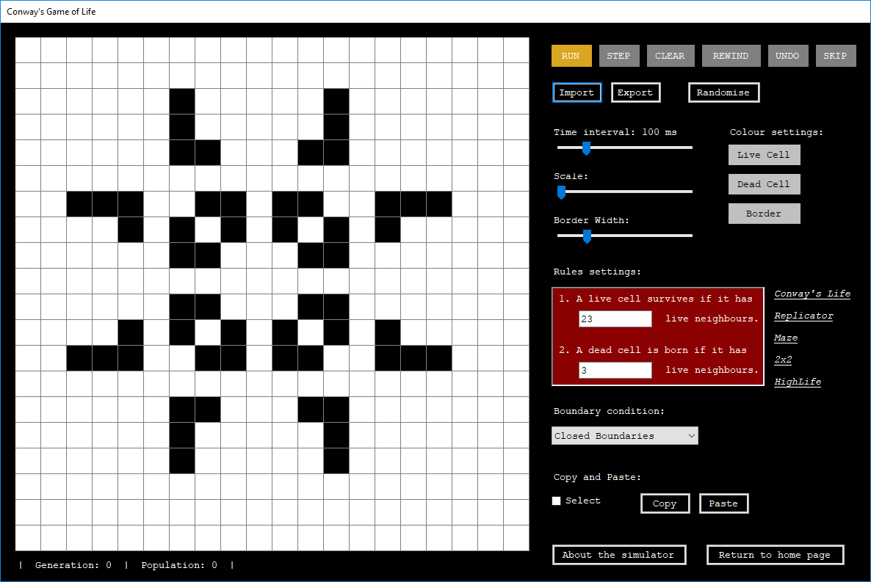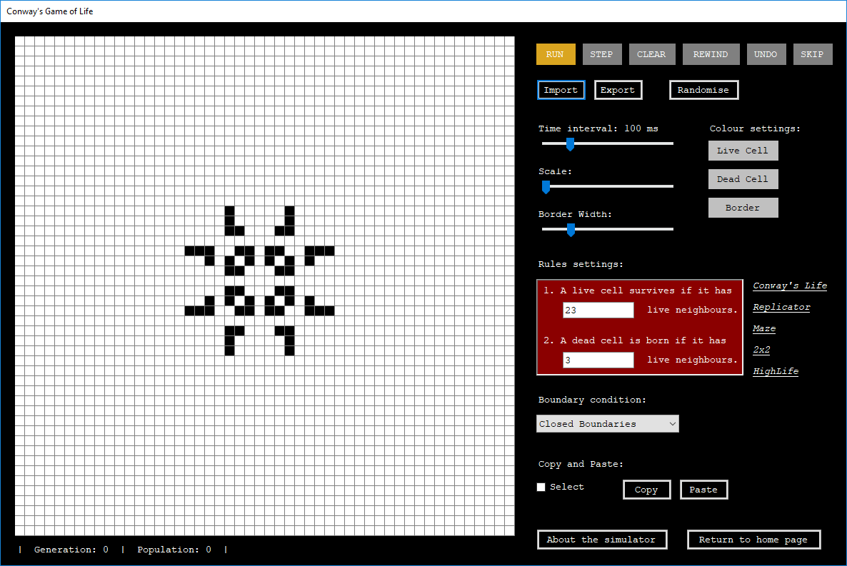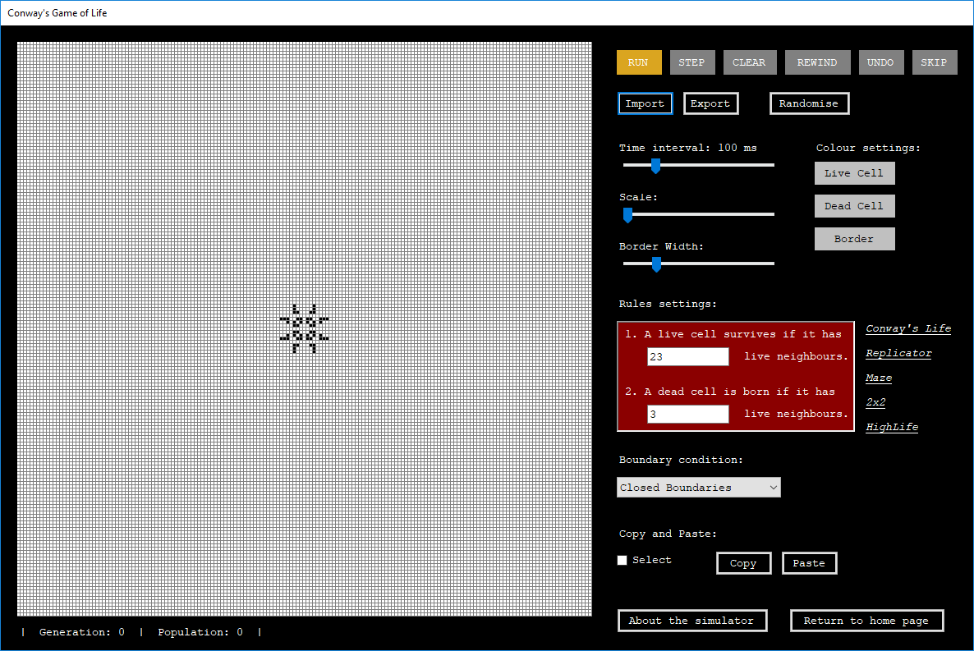

### Undo Operation

In order to allow the user to undo the pattern, an algorithm is needed to store and return the states of cells of the previous generations. Every time the grid is updated, the current generation is pushed onto a stack. When the user clicks the ‘UNDO’ button, the item on top of the stack is popped. The current generation is set to the generation returned from the stack. Every time the ‘UNDO’ button is clicked, we have to check whether the stack is empty because we cannot remove items from an empty stack. If the stack is empty, a message box will pop to tell the user that we cannot undo. The diagrams below show the operation of the stack.

|  |  |  |  |  |  |  |  |
| --- | --- | --- | --- | --- | --- | --- | --- |
| Stack: |  |  |  |  |  |  |  |
|  |  | Related image  t=1 |  |
|  | Related image  t=0 |  | Related image  t=0 |  | Related image  t=0 |
|  |  |  |  |  |  |  |  |
| Grid: | Related image  t=0 |  | Related image  t=1 |  | Related image  t=2 |  | Related image  t=1 |

|  |  |  |  |  |  |  |  |
| --- | --- | --- | --- | --- | --- | --- | --- |
| Description: | The user imports a glider pattern onto the grid. |  | The simulation starts.  The current generation (t=0) is pushed onto the stack and then the grid is updated to the next generation (t=1). |  | The current generation (t=1) is pushed onto the stack and then the grid is updated to the next generation (t=2). |  | When the ‘UNDO’ button is clicked, it pops the stack and returns the item recently added onto the stack. |

### Differentiating Clicking, Dragging and Selecting

The program has to differentiate the click, drag and select events of the grid so that the correct function can be called. It can be achieved using three Boolean variables (isClick, isDrag and isSelect). I assume the user is trying to click at first so isClick is initialised to True and isDrag and isSelect are initialised to False. On Mouse down, isDrag is set to True. Then on Mouse Move, if isDrag is True, isClicked is set to False. It identifies that the user is holding the mouse down and dragging the grid around but not clicking on the cells. Whenever the Select checkbox is checked, isSelect is set to True and vice versa. On Mouse Click, if isClicked is true and isSelect is false, it identifies that the user is trying to click a cell but not selecting. On Mouse Up, isDragging is set back to false and isClicked is set to true. The table below shows when the value of the variables change.

|  |  |  |  |  |  |  |
| --- | --- | --- | --- | --- | --- | --- |
|  | Initial Value | Mouse Down | Mouse Move | Mouse Up | Checked select button | Unchecked select button |
| isClick | True | - | If isDrag is True, isClick is False. | True | - | - |
| isDrag | False | True | - | False | - | - |
| isSelect | False | - | - | - | True | False |

### Selecting Cells

To highlight the selected region, the program needs to be able to draw a rectangle by mouse click and drag. To draw a rectangle in VB.NET, I need to know the coordinate pair as the starting position, a width and a height.

In order to identify the selected region, the program stores the x and y coordinates of the mouse position when mouse down and mouse up as the starting point and ending point respectively. I use the following variables:

|  |  |  |
| --- | --- | --- |
| Identifier | Value | Purpose |
| startPoint | (MouseEventArgs.X, MouseEventArgs.Y )  in MouseDown event | Stores the mouse position when mouse down |
| endpoint | (MouseEventArgs.X, MouseEventArgs.Y )  in MouseUp event | Stores the mouse position when mouse up |
| startCellX | startPoint.X \ cellSize | Stores the x index of the start cell |
| startCellY | startPoint.Y \ cellSize | Stores the y index of the start cell |
| endCellX | endPoint.X \ cellSize | Stores the x index of the end cell |
| endCellY | endPoint.Y \ cellSize | Stores the y index of the end cell |
| height | (endCell – startCellY + 1) * cell size | Stores the height of the selected region |
| width | (endCellX – startCellX + 1) * cell size | Stores the width of the selected region |

However, while mouse position is continuous, the positions of cells have discrete values, as shown in the diagram below.

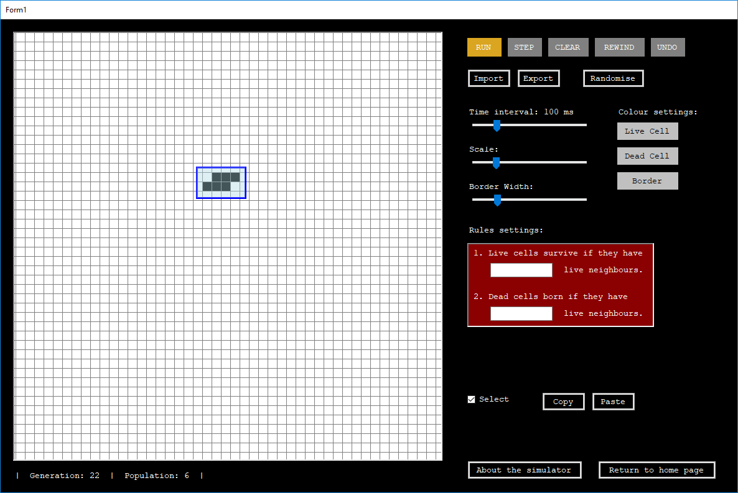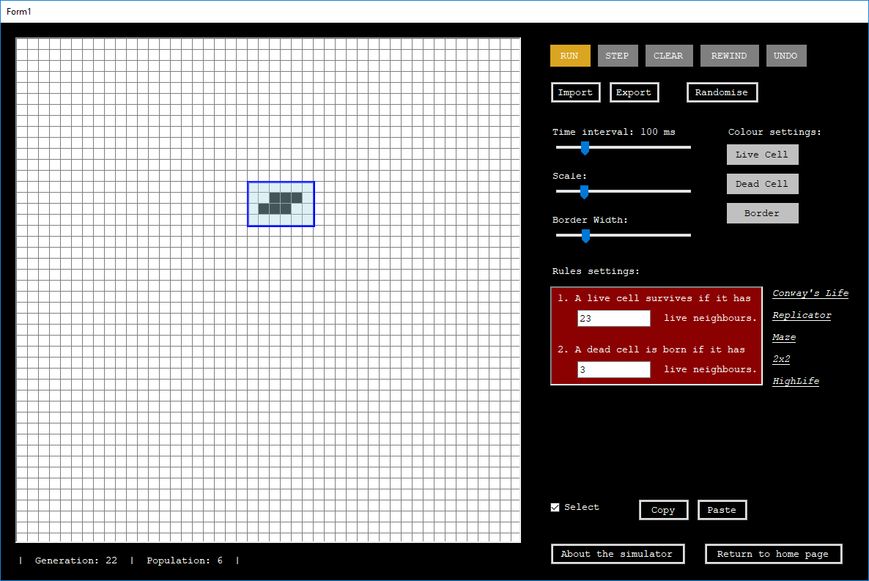

Therefore, the starting point of the selected region should be **( index of cell * cell size )**. I can then draw a rectangle with the discrete starting point and the calculated height and width. The rectangle should be painted in the onPaint event of the GOLGrid and the GOLGrid should be invalidated when MouseMove and when both isDrag and isSelect is true.

## User Interface

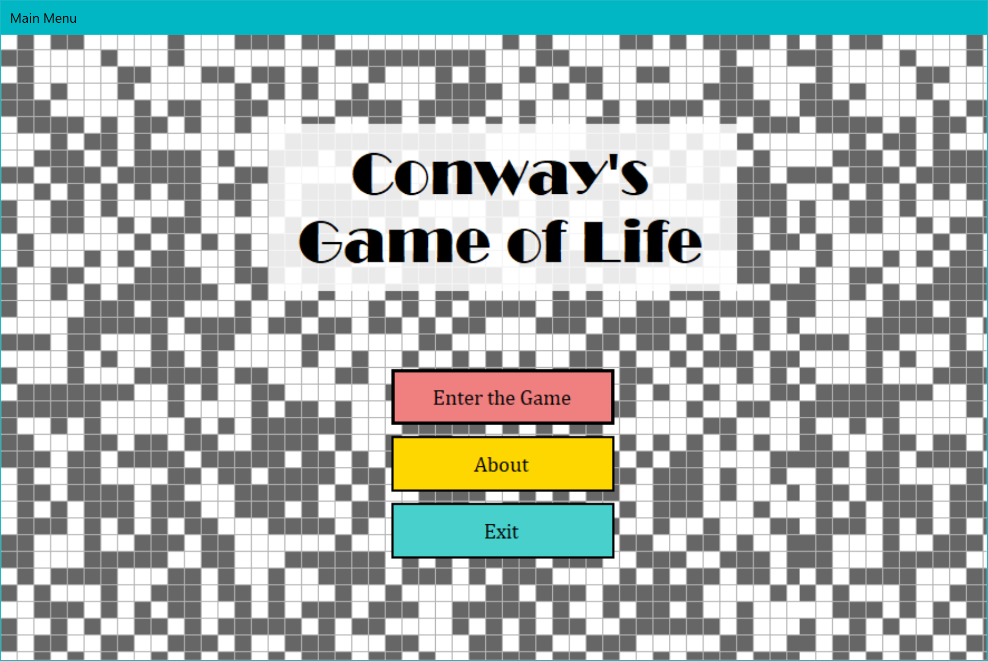

Close the program (All the forms)

Load the user guide

Load the simulator

I have disabled all the control box option so the user can only close the program by clicking the Exit button on this form.

**Figure 2.7.9‑1** Menu Screen

This is the first screen displayed to the user. There is a label control in the centre of the form which displays the name of the simulator ‘Conway’s Game of Life’. There are three buttons below the label.

When the ‘About’ button is clicked, it opens another form which displays how to use the simulator.

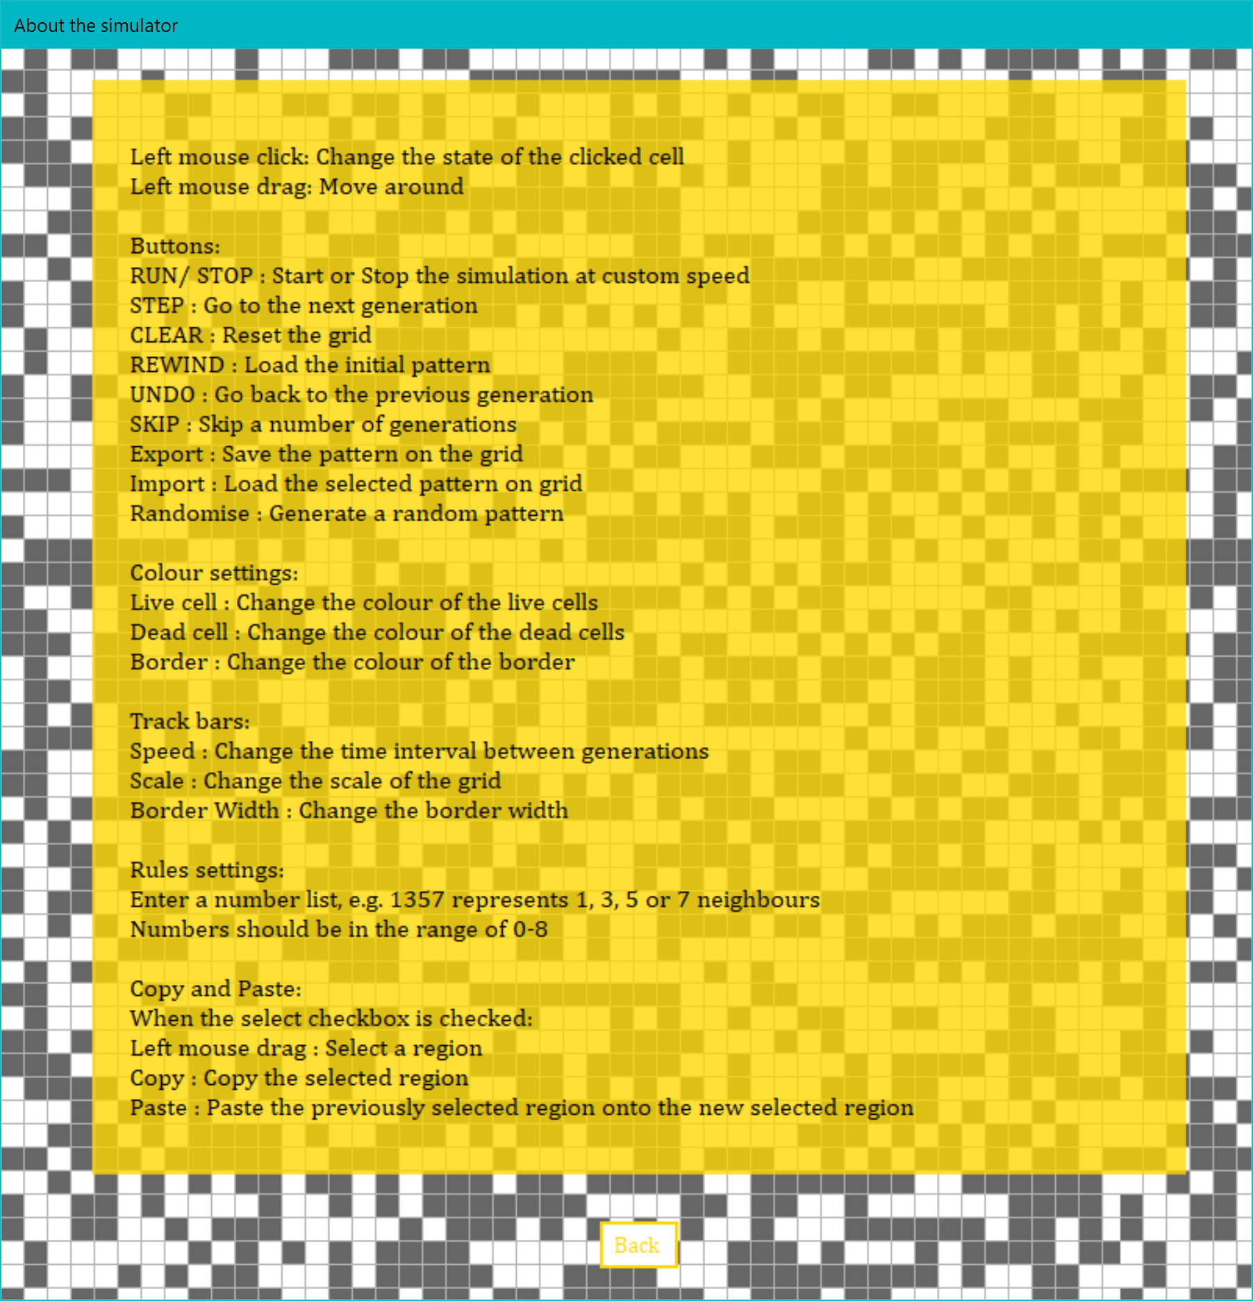

Close this form

**Figure 2.7.9‑2** About the Simulator (User Guide)

This form displays the details of all the controls. There is a “Back” button below which allows the user to exit this form and return to the menu screen.

When the ‘Exit’ button is clicked, the program is closed.

When the ‘Enter the Game’ button is clicked, it opens an input box which ask the user to enter the size of the grid. Input validation is carried out to check the input is an integer and is in the range of 20-350. If the input is invalid, an error message will pop up. If the input is valid, it opens the main form which is the simulator.

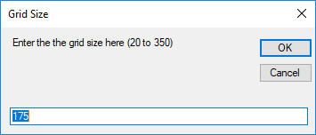

The user can enter the grid size here. The default size is 175 which can import all the preset patterns properly.

If the input is valid, a grid of size input by the user is created from the class GOLGrid.

**Figure 2.7.9‑3** Input Box (Grid Size)

The simulator consists of the grid, the controls and the running information. The user can click on the grid to change the states of the cells and drag the grid to move around.

The smallest size of grid is 20 and the largest is 350. The following are some screenshots of simulators with grid of different sizes:

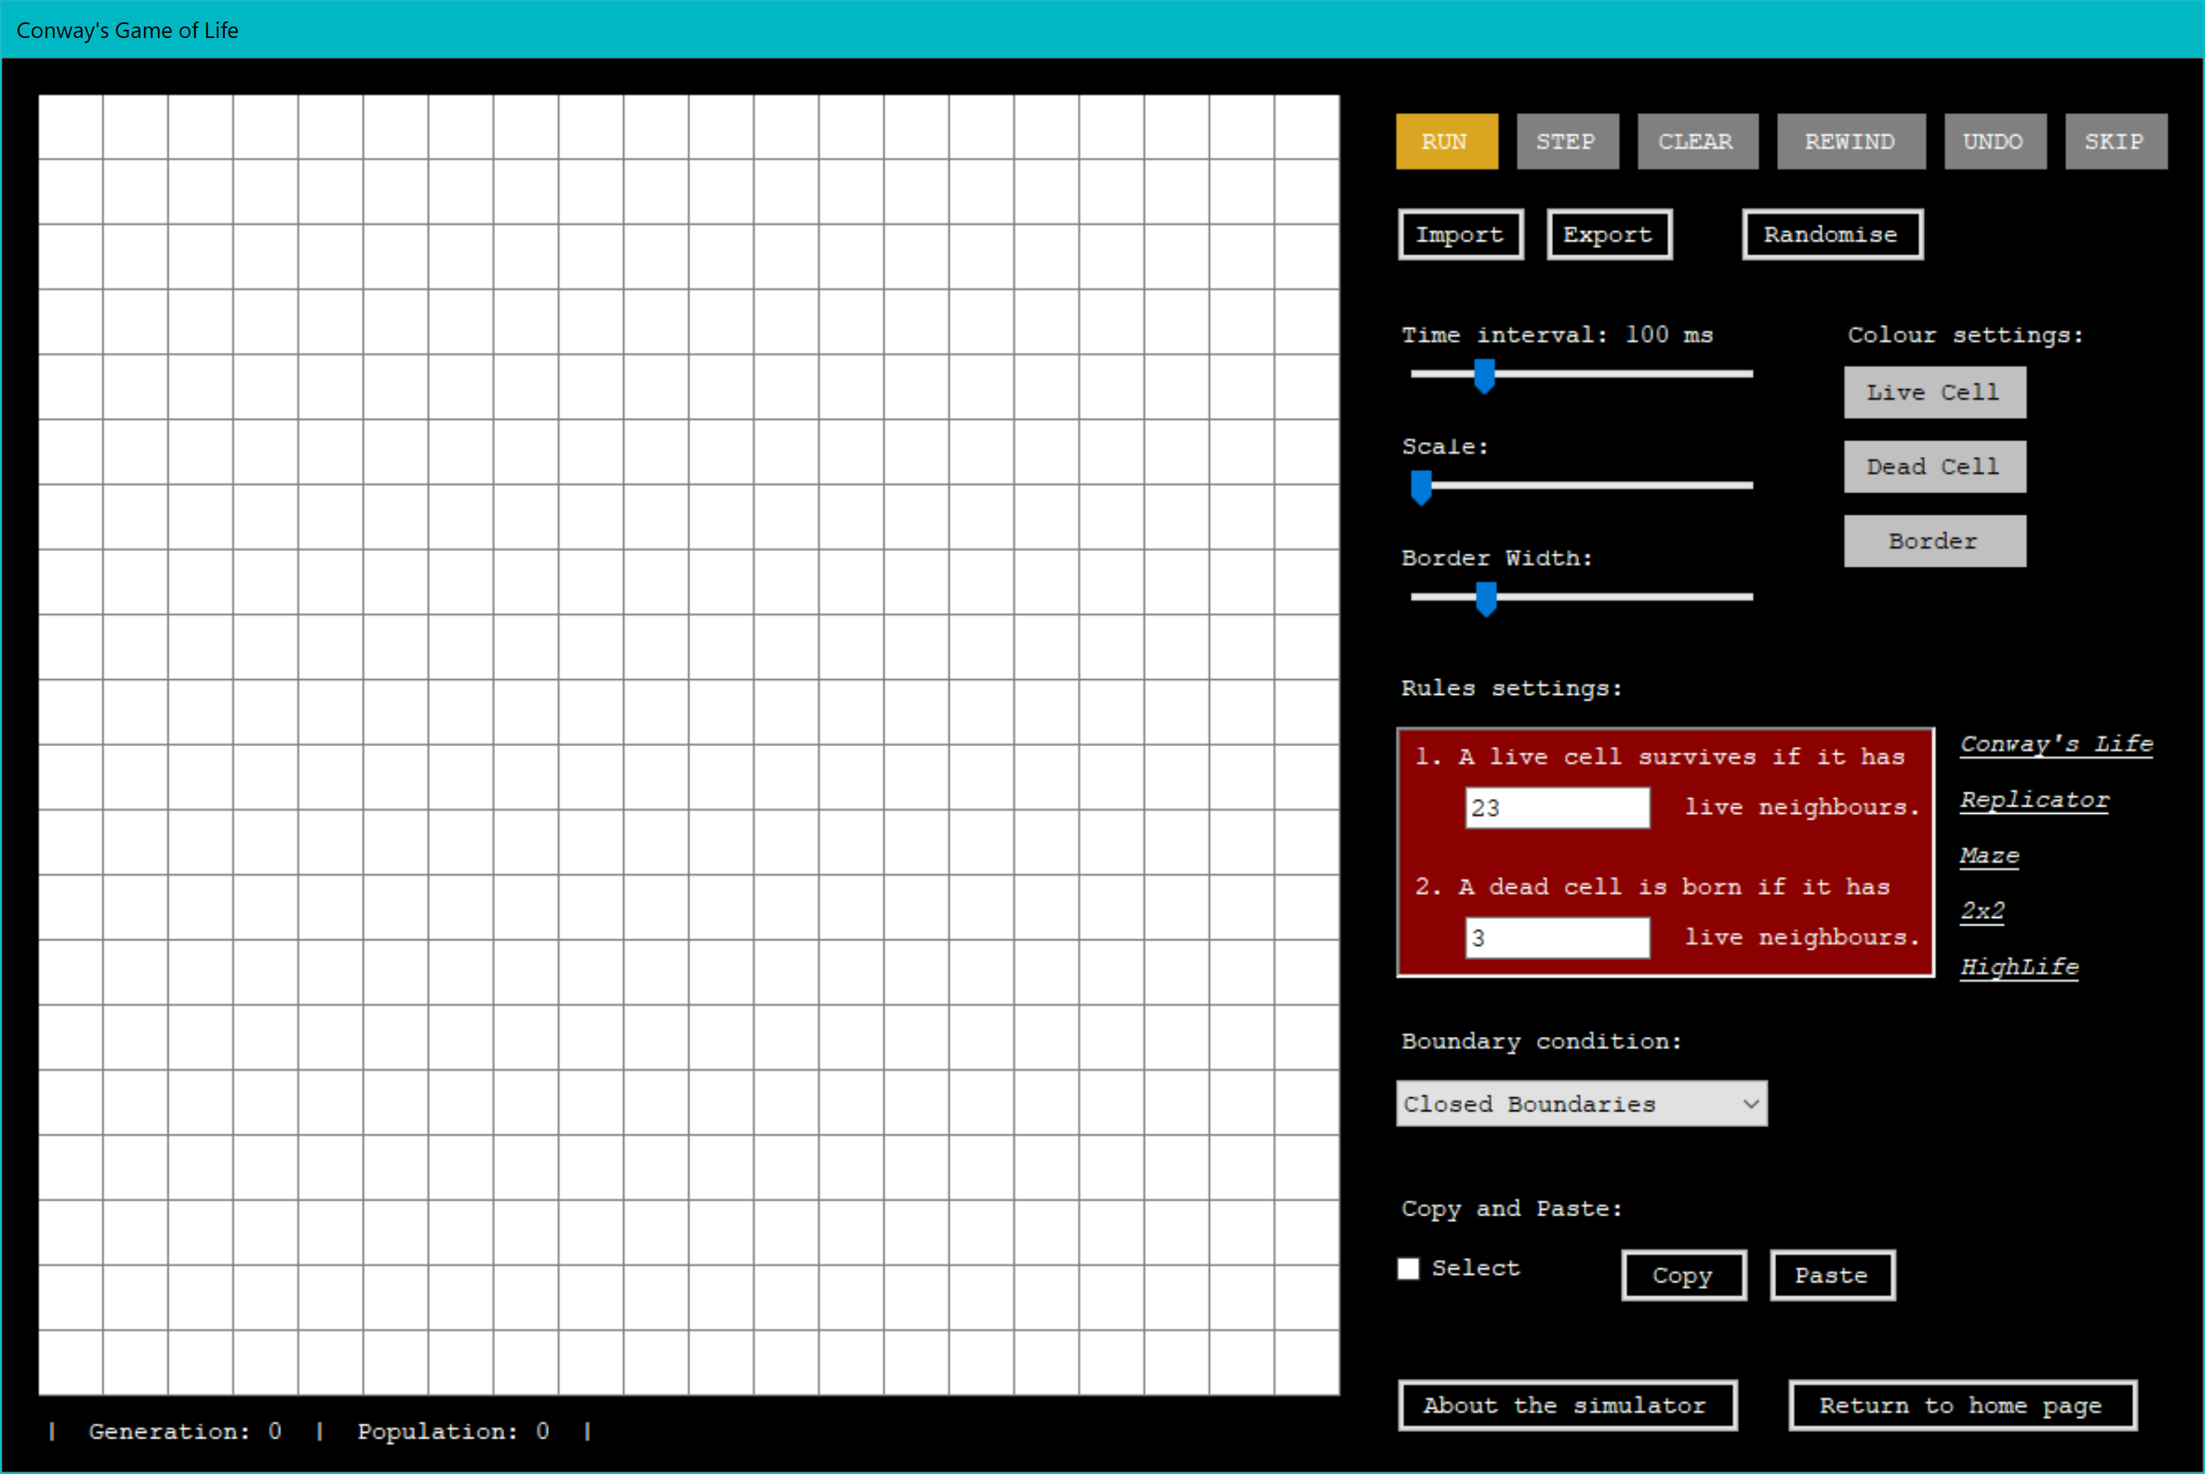

Grid created from the GOLGrid Class.

**Figure 2.7.9‑4** The Simulator (Grid size = 20)

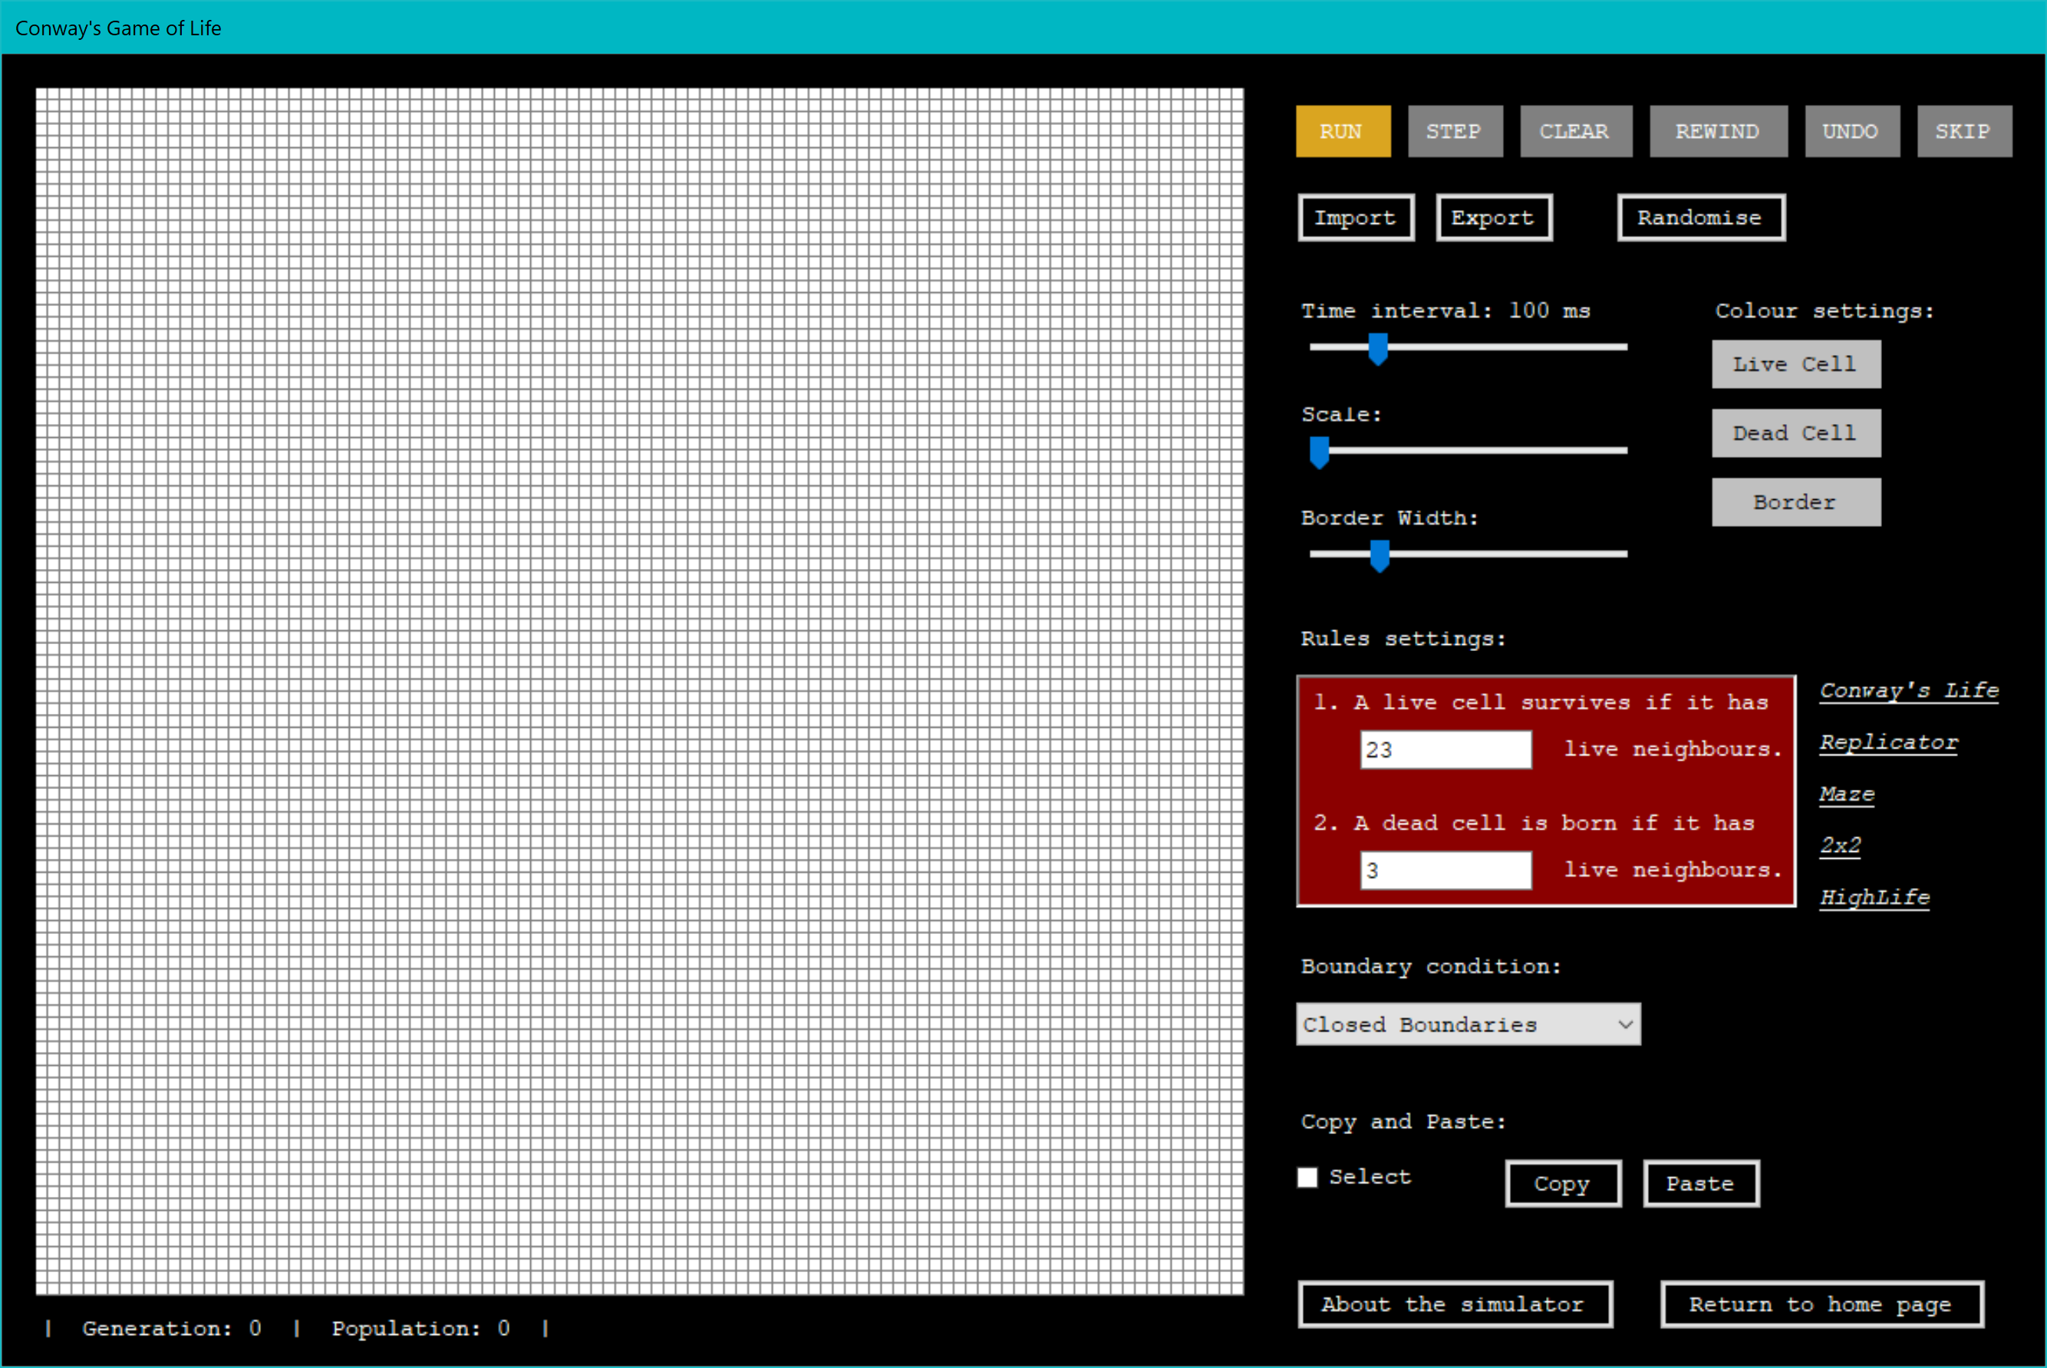

**Figure 2.7.9‑5** The Simulator (Grid size = 100)

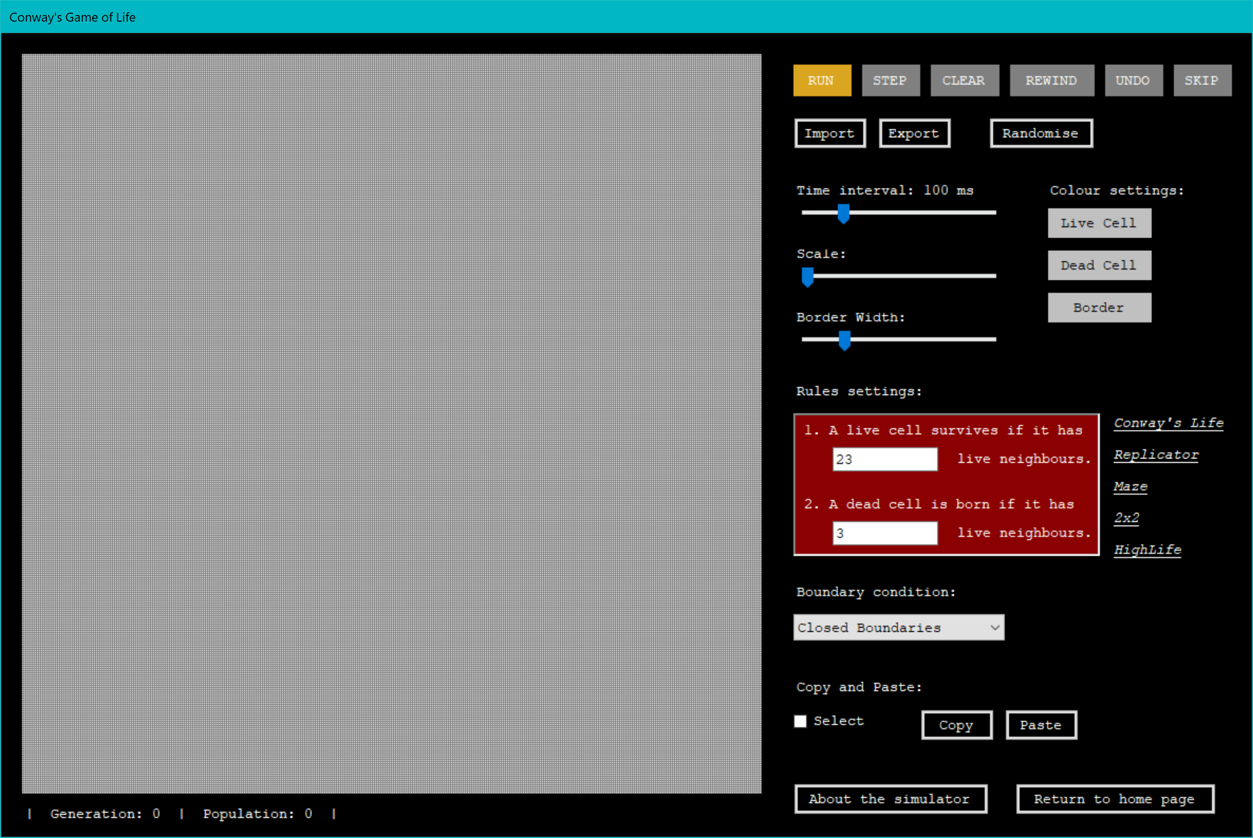

**Figure 2.7.9‑6** The Simulator (Grid size = 350)

Update to the next generation everytime clicked.

Start/ Stop the simulation. (This is a toggle button. When the simulation is running, the text of this button changes to ‘STOP’. It changes back to ‘RUN’ when the simulation stops.)

Reset the grid and the running information.

Load the pattern that was stored before the simulation starts.

Load the previous generation

Opens an input box. Skip the number of generations input by the user.



Drag right to zoom in the grid and vice versa.

A text file will be created.

Drag right to increase the time interval and vice versa.

Open a open file dialog. The user can select a file.

Open a colour dialog. The user can select a colour.

Drag right to increase the border width and vice versa.

Load a random pattern.

**Figure 2.7.9‑7** Control Area

This is the first part of the control area.

When the button ‘Live Cell’, ‘Dead Cell’ or ‘Border’ is clicked, a colour dialog box pops up to allow the user to pick a colour.

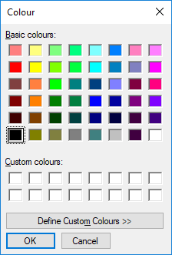 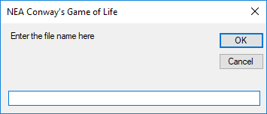

When the button ‘Export’ is clicked, an input box prompts the user to enter a file name. If the file name already exists, an error message pops up.

**Figure 2.7.9‑8** Select Colour **Figure 2.7.9‑9** Export Pattern

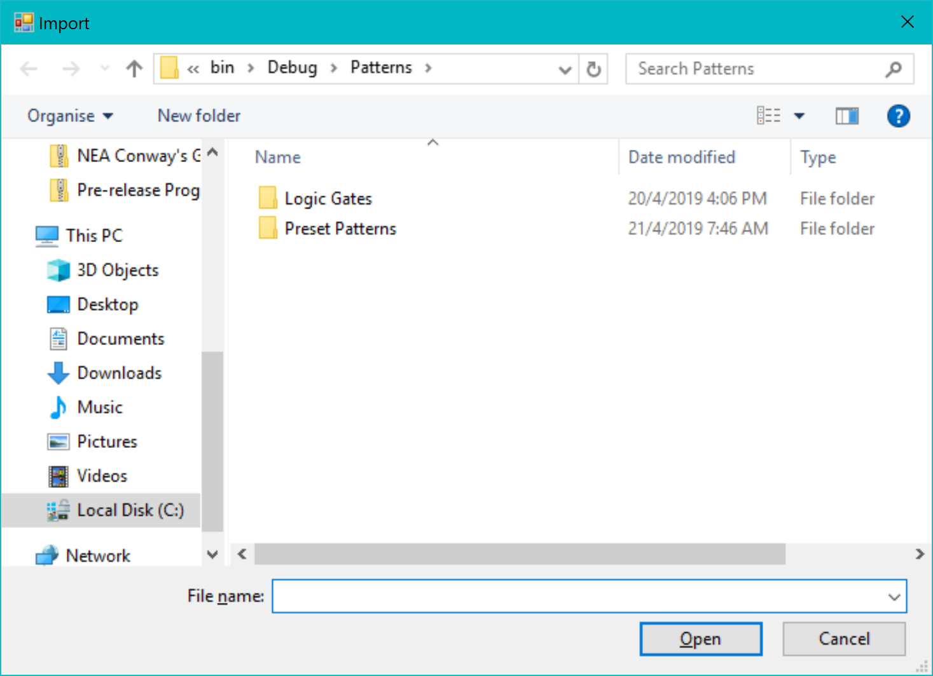

When the button ‘Import’ is clicked, the user is able to browse to select file from the Open File Dialog Box.

**Figure 2.7.9‑10** Import Pattern



Close the simulator and return to the Menu Screen (Figure 2.7.9-1)

Paste the edited pattern into the selced region.

Load the User Guide (Figure 2.7.9-2)

Click to change the rules to the clicked cellular automaton.

The user can select patterns on grid when this box is checked.

Load the editing form

Changing the boundary conditions

The user can change the text in the text boxes to change the rules.

**Figure 2.7.9‑11** Control Area

This is the second part of the control area.



**Figure 2.7.9‑12** Running Information

This is the running information displayed under the grid. These are updated every generation.

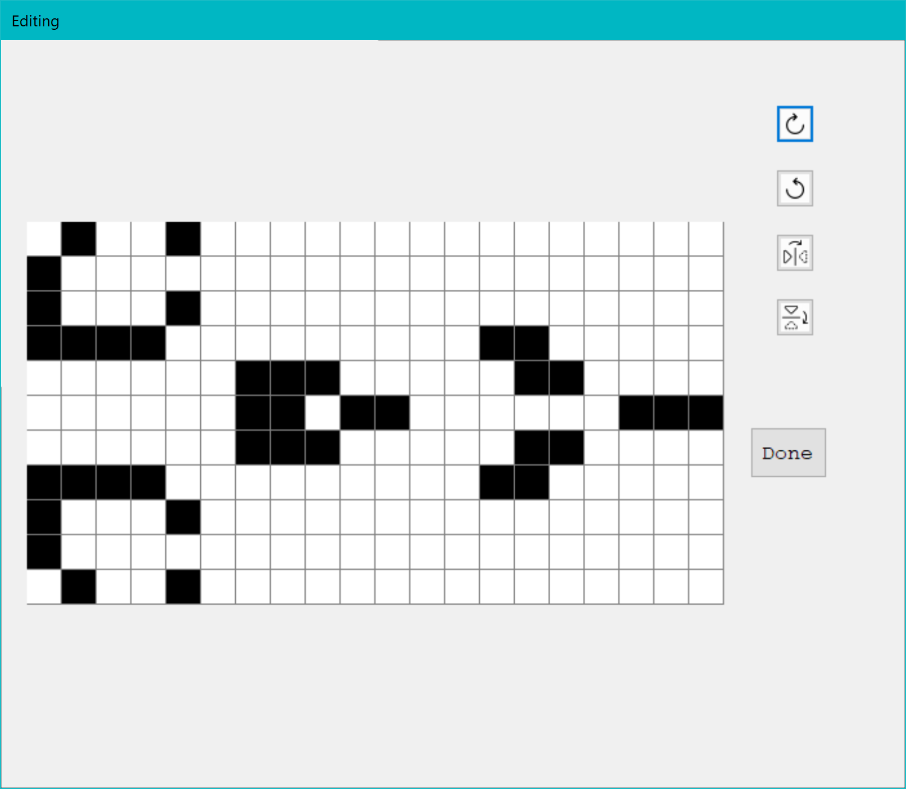

Close this form. Pass the edited pattern back to the simulator.

Flip Vertical

Rotate Anti-clockwise

Flip Horizontal

Rotate Clockwise

Grid created from the Grid Class.

**Figure 2.7.9‑13** Editing Form

This is the editing form which shows the pattern selected by the user. The user can rotate and flip the pattern. When the ‘Done’ button is clicked, this form will be closed and the pattern will be passed back to the simulator.

# Technical solution

## Cell Class

Public Class Cell

Private _size As Integer

Private _borderWidth As Integer

Private _positionX As Integer

Private _positionY As Integer

Private _initialState As Boolean

Private _currentState As Boolean

Private _nextState As Boolean

Private _undoState As New Stack

Private _cellColour As Color = Color.Black

Private _deadCellColour As Color = Color.White

Public Sub New(ByVal size As Integer, ByVal borderWidth As Integer, ByVal x As Integer, ByVal y As Integer)

_size = size

_borderWidth = borderWidth

_positionX = x * _size

_positionY = y * _size

_currentState = False

End Sub

Public Sub changeState()

_currentState = Not _currentState

End Sub

' This method paints a cell at its corresponding position, size and colour

Public Sub drawCell(myGraphics As Graphics)

Dim brushColour As Color = getCellColour(_currentState)

Dim cellSize As Integer = _size - _borderWidth

Using myBrush As SolidBrush = New SolidBrush(brushColour)

myGraphics.FillRectangle(myBrush, _positionX, _positionY, cellSize, cellSize)

End Using

End Sub

' This method returns a colour depending on the state of the cell

Public Function getCellColour(ByVal State As Boolean) As Color

If State Then

Return _cellColour

Else

Return _deadCellColour

End If

End Function

Public Property size As Integer

Get

Return _size

End Get

Set(value As Integer)

_size = value

End Set

End Property

Public Property borderWidth As Integer

Get

Return _borderWidth

End Get

Set(value As Integer)

_borderWidth = value

End Set

End Property

Public Property cellColour As Color

Get

Return _cellColour

End Get

Set(value As Color)

_cellColour = value

End Set

End Property

Public Property deadCellColour As Color

Get

Return _deadcellColour

End Get

Set(value As Color)

_deadcellColour = value

End Set

End Property

Public Property initialState As Boolean

Get

Return _initialState

End Get

Set(value As Boolean)

_initialState = value

End Set

End Property

Public Property currentState As Boolean

Get

Return _currentState

End Get

Set(value As Boolean)

_currentState = value

End Set

End Property

Public Property nextState As Boolean

Get

Return _nextState

End Get

Set(value As Boolean)

_nextState = value

End Set

End Property

Public Property posX As Integer

Get

Return _positionX

End Get

Set(value As Integer)

_positionX = value

End Set

End Property

Public Property posY As Integer

Get

Return _positionY

End Get

Set(value As Integer)

_positionY = value

End Set

End Property

Public Property undoState As Stack

Get

Return _undoState

End Get

Set(value As Stack)

_undoState = value

End Set

End Property

End Class

## Grid Class

Public Class Grid

Inherits PictureBox

Create an array of cells from the Cell class

Protected _gridX As Integer

Protected _gridY As Integer

Protected _myCell(,) As Cell

Protected _cellSize As Integer

Protected _borderWidth As Integer = 1

Protected _borderColour As Color = Color.Gray

Public Sub New()

End Sub

Public Overridable Sub createBoard(ByVal gridX As Integer, ByVal gridY As Integer, ByVal w As Integer, ByVal h As Integer, ByVal cellSize As Integer)

_cellSize = cellSize

renew(gridX, gridY)

Me.Top = (h - Me.Height) \ 2

Me.Left = (w - Me.Width) \ 2

Me.BackColor = _borderColour

End Sub

' Initialise or reset the size of the grid

Public Sub renew(ByVal gridX As Integer, ByVal gridY As Integer)

_gridX = gridX

_gridY = gridY

ReDim _myCell(_gridX - 1, _gridY - 1)

For y = 0 To _gridY - 1

For x = 0 To _gridX - 1

_myCell(x, y) = New Cell(_cellSize, _borderWidth, x, y)

Next

Next

Me.Height = _gridY * _cellSize

Me.Width = _gridX * _cellSize

End Sub

Public Sub displayGrid(myGraphics As Graphics)

' Draw each cell one by one using a nested for loops

For y = 0 To _gridY - 1

For x = 0 To _gridX - 1

_myCell(x, y).drawCell(myGraphics)

Next

Next

End Sub

Protected Overrides Sub OnPaint(e As PaintEventArgs)

MyBase.OnPaint(e)

' Paints the grid

displayGrid(e.Graphics)

End Sub

Public Property myCell(x As Integer, y As Integer) As Cell

Get

Return _myCell(x, y)

End Get

Set(value As Cell)

_myCell(x, y) = value

End Set

End Property

Public Property cellSize As Integer

Get

Return _cellSize

End Get

Set(value As Integer)

_cellSize = value

End Set

End Property

End Class

## GOLGrid Class

Public Class GOLGrid

Inherits Grid

Private _gridSize As Integer ' The number of columns/ rows

Public Property gridSize As Integer

Get

Return _gridSize

End Get

Set(value As Integer)

_gridSize = value

End Set

End Property

Private _gridLength As Integer ' The number of pixels displayed

Private _boundaryCondition As String ' Stores the slected boundary condition

Public Property boundaryCondition() As String

Get

Return _boundaryCondition

End Get

Set(ByVal value As String)

_boundaryCondition = value

End Set

End Property

Private _clickedCell As Rectangle ' Stores the region of the clicked cell

Public Property clickedCell As Rectangle

Get

Return _clickedCell

End Get

Set(value As Rectangle)

_clickedCell = value

End Set

End Property

' Variables to differentiate click, drag and select

Private _isClicked As Boolean = True

Private _isDragging As Boolean = False

Private _isSelect As Boolean = False

Public Property isSelect As Boolean

Get

Return _isSelect

End Get

Set(value As Boolean)

_isSelect = value

End Set

End Property

Private _startPoint As Point ' Stores the point of mouse down

' Stores the column number of the top-left cell of the selected region

Private _startCellX As Integer = 0

Public Property startCellX As Integer

Get

Return _startCellX

End Get

Set(value As Integer)

_startCellX = value

End Set

End Property

' Stores the row number of the top-left cell of the selected region

Private _startCellY As Integer = 0

Public Property startCellY As Integer

Get

Return _startCellY

End Get

Set(value As Integer)

_startCellY = value

End Set

End Property

' Stores the column number of the bottom-right cell of the selected region

Private _endCellX As Integer = 0

Public Property endCellX As Integer

Get

Return _endCellX

End Get

Set(value As Integer)

_endCellX = value

End Set

End Property

' Stores the row number of the bottom-right cell of the selected region

Private _endCellY As Integer = 0

Public Property endCellY As Integer

Get

Return _endCellY

End Get

Set(value As Integer)

_endCellY = value

End Set

End Property

' The number of list that stores the number of neighbours required for a cell to survive

Private _liveNum As String = "23"

Public Property liveNum As String

Get

Return _liveNum

End Get

Set(value As String)

_liveNum = value

End Set

End Property

'The number of list that stores the number of neighbours required for a cell to born

Private _bornNum As String = "3"

Public Property bornNum As String

Get

Return _bornNum

End Get

Set(value As String)

_bornNum = value

End Set

End Property

Public Sub New()

MyBase.New()

End Sub

Public Overrides Sub createBoard(gridX As Integer, gridY As Integer, w As Integer, h As Integer, ByVal cellSize As Integer)

MyBase.createBoard(gridX, gridY, w, h, cellSize)

_gridSize = gridX

_gridLength = h

End Sub

Protected Overrides Sub OnPaint(e As PaintEventArgs)

MyBase.OnPaint(e)

SelectCells(e) ' Paint the highlighted region

End Sub

Public Sub changeScale(ByVal size As Integer)

_cellSize = size

Me.Height = _gridSize * _cellSize

Me.Width = _gridSize * _cellSize

Me.Top = -(Me.Height - _gridLength) / 2

Me.Left = -(Me.Width - _gridLength) / 2

For y = 0 To _gridSize - 1

For x = 0 To _gridSize - 1

_myCell(x, y).posX = x * size

_myCell(x, y).posY = y * size

_myCell(x, y).size = size

Next

Next

End Sub

Public Sub changeWidth(ByVal width As Integer)

_borderWidth = width

For y = 0 To _gridSize - 1

For x = 0 To _gridSize - 1

_myCell(x, y).borderWidth = width

Next

Next

End Sub

Public Sub changeCellColour(ByVal colour As Color)

For y = 0 To _gridSize - 1

For x = 0 To _gridSize - 1

_myCell(x, y).cellColour = colour

Next

Next

End Sub

Public Sub changeDeadCellColour(ByVal colour As Color)

For y = 0 To _gridSize - 1

For x = 0 To _gridSize - 1

_myCell(x, y).deadCellColour = colour

Next

Next

End Sub

Public Sub changeBorderColour(ByVal colour As Color)

Me.BackColor = colour

End Sub

Public Function population() As Integer 'The toatl number of living cells

Dim pop As Integer

For y = 0 To _gridSize - 1

For x = 0 To _gridSize - 1

If _myCell(x, y).currentState Then

pop += 1

End If

Next

Next

Return pop

End Function

Protected Overrides Sub OnMouseClick(e As MouseEventArgs)

MyBase.OnMouseClick(e)

If _isClicked And Not isSelect Then

Call changeStateOnMouseClick(e.X, e.Y)

Me.Invalidate(_clickedCell) ' Only invalidate the selected region to reduce delays

End If

End Sub

Protected Overrides Sub OnMouseDown(ByVal e As MouseEventArgs)

_isDragging = True

_startPoint = New Point(e.X, e.Y)

_startCellX = Int(e.X / _cellSize)

_startCellY = Int(e.Y / _cellSize)

End Sub

Protected Overrides Sub OnMouseMove(ByVal e As MouseEventArgs)

If _isDragging Then

Algorithm 2.6.7

_isClicked = False

If isSelect Then

_endCellX = Int(e.X / _cellSize)

_endCellY = Int(e.Y / _cellSize)

Me.Invalidate()

Else

' Objective 1. c.

'Move the gird when drag

Dim myTop As Integer = Me.Top - _startPoint.Y + e.Y

Dim myLeft As Integer = Me.Left - _startPoint.X + e.X

If myTop <= 0 And myTop >= -Me.Height + _gridLength Then

Me.Top = myTop

End If

If myLeft <= 0 And myLeft >= -Me.Width + _gridLength Then

Me.Left = myLeft

End If

End If

End If

End Sub

Protected Overrides Sub OnMouseUp(ByVal e As MouseEventArgs)

_isDragging = False

_isClicked = True

_endCellX = Int(e.X / _cellSize)

_endCellY = Int(e.Y / _cellSize)

Algorithm 2.6.8 (This method is called in the onPaint method of the same class.)

Me.Invalidate()

End Sub

' Objective 2. f. i.

Public Sub SelectCells(ByVal e As PaintEventArgs)

If isSelect Then

Dim startx As Integer = _startCellX * _cellSize

Dim starty As Integer = _startCellY * _cellSize

Dim w As Integer = (_endCellX - _startCellX + 1) * _cellSize

Dim h As Integer = (_endCellY - _startCellY + 1) * _cellSize

' Highlight the selected region

Dim brushColour As Color = Color.Black

Using myPen As Pen = New Pen(Color.Blue, 3)

e.Graphics.DrawRectangle(myPen, startx, starty, w, h)

End Using

Using myBrush As SolidBrush = New SolidBrush((Color.FromArgb(100, Color.LightBlue)))

e.Graphics.FillRectangle(myBrush, startx, starty, w, h)

End Using

End If

End Sub

Public Sub clearGrid()

For y = 0 To _gridSize - 1

For x = 0 To _gridSize - 1

_myCell(x, y).currentState = False

_myCell(x, y).nextState = False

_myCell(x, y).undoState.Clear()

Next

Next

End Sub

Algorithm 2.6.6

Public Sub undoGrid()

For y = 0 To _gridSize - 1

For x = 0 To _gridSize - 1

_myCell(x, y).currentState = _myCell(x, y).undoState.Pop()

_myCell(x, y).nextState = False

Next

Next

End Sub

Public Sub saveInitial()

For y = 0 To _gridSize - 1

For x = 0 To _gridSize - 1

_myCell(x, y).initialState = _myCell(x, y).currentState

Next

Next

End Sub

Public Sub returnInitial()

For y = 0 To _gridSize - 1

For x = 0 To _gridSize - 1

_myCell(x, y).currentState = _myCell(x, y).initialState

Next

Algorithm 2.6.1 (This method is called in OnMouseClick method of the same class)

Next

End Sub

' Objective 2. a.

Public Sub changeStateOnMouseClick(ByVal x As Integer, ByVal y As Integer)

x = Int(x / _cellSize) ' The x index of the cell

y = Int(y / _cellSize) ' The y index of the cell

_clickedCell = New Rectangle(x * _cellSize, y * _cellSize, _cellSize, _cellSize) 'The area of the clicked cell

_myCell(x, y).changeState()

End Sub

' Objective 3. c.

Public Sub updateGridToNextState()

Algorithm 2.6.3 (This method is called in the myTimer_Tick procedure in Form1)

Dim count As Integer = 0

For y = 0 To _gridSize - 1

For x = 0 To _gridSize - 1

If _boundaryCondition = "Closed Boundaries" Then

count = countLiveNeighbours(x, y)

ElseIf _boundaryCondition = "Toroidal Boundaries" Then

count = countLiveNeighboursWrap(x, y)

End If

If _myCell(x, y).currentState = True Then

If Not _liveNum.Contains(count) Then

_myCell(x, y).nextState = False

Else

_myCell(x, y).nextState = True

End If

Else

If _bornNum.Contains(count) Then

_myCell(x, y).nextState = True

Else

_myCell(x, y).nextState = False

End If

End If

Next

Next

For y = 0 To _gridSize - 1

For x = 0 To _gridSize - 1

_myCell(x, y).undoState.Push(_myCell(x, y).currentState)

_myCell(x, y).currentState = _myCell(x, y).nextState

Next

Next

Algorithm 2.6.2 (This function is called in updateGridToNextState method in the same class)

End Sub

' Objective 3. b.

Public Function countLiveNeighbours(ByVal x As Integer, ByVal y As Integer) As Integer

Dim count As Integer = 0

' Check if the cell is located at the top left

If x <> 0 And y <> 0 Then

If _myCell(x - 1, y - 1).currentState = True Then

count += 1

End If

End If

' Check if the cell is located at the top middle

If y <> 0 Then

If _myCell(x, y - 1).currentState = True Then

count += 1

End If

End If

' Check if the cell is located at the top right

If x <> _gridSize - 1 And y <> 0 Then

If _myCell(x + 1, y - 1).currentState = True Then

count += 1

End If

End If

' Check if the cell is located at the left

If x <> 0 Then

If _myCell(x - 1, y).currentState = True Then

count += 1

End If

End If

' Check if the cell is located at the right

If x <> _gridSize - 1 Then

If _myCell(x + 1, y).currentState = True Then

count += 1

End If

End If

' Check if the cell is located at the bottom left

If x <> 0 And y <> _gridSize - 1 Then

If _myCell(x - 1, y + 1).currentState = True Then

count += 1

End If

End If

' Check if the cell is located at the bottom middle

If y <> _gridSize - 1 Then

If _myCell(x, y + 1).currentState = True Then

count += 1

End If

End If

' Check if the cell is located at the bottom right

If x <> _gridSize - 1 And y <> _gridSize - 1 Then

If _myCell(x + 1, y + 1).currentState = True Then

count += 1

End If

End If

Return count

End Function

Public Function countLiveNeighboursWrap(ByVal x As Integer, ByVal y As Integer) As Integer

Dim count As Integer = 0

For j = 0 To 2

For i = 0 To 2

If _myCell((x - 1 + _gridSize + i) Mod _gridSize, (y - 1 + _gridSize + j) Mod _gridSize).currentState Then

count += 1

End If

Next

Next

If _myCell(x, y).currentState Then

count -= 1

End If

Return count

End Function

End Class

## Menu Form

Public Class Form2

Public main As Form1

Private Sub Form2_Load(sender As Object, e As EventArgs) Handles MyBase.Load

Height = 600

Width = 900

Me.ControlBox = False

Me.Top = (Screen.PrimaryScreen.WorkingArea.Height - Me.Height) / 2

Me.Left = (Screen.PrimaryScreen.WorkingArea.Width - Me.Width) / 2

Me.BackgroundImage = Image.FromFile("bg.png")

Me.Text = "Main Menu"

Dim LabelTitle As New Label

LabelTitle.Text = "Conway's Game of Life"

LabelTitle.BackColor = Color.FromArgb(220, Color.White)

LabelTitle.Width = 420

LabelTitle.Height = 150

LabelTitle.TextAlign = ContentAlignment.MiddleCenter

LabelTitle.Font = New Font("Broadway", 40)

LabelTitle.Location = New Point((Me.Width - LabelTitle.Width) / 2, 80)

Me.Controls.Add(LabelTitle)

Dim ButtonEnter As New Button

ButtonEnter.Text = "Enter the Game"

ButtonEnter.Font = New Font("Cambria", 14)

ButtonEnter.Height = 50

ButtonEnter.Width = 200

ButtonEnter.Location = New Point((Me.Width - ButtonEnter.Width) / 2, 300)

ButtonEnter.BackColor = Color.LightCoral

ButtonEnter.ForeColor = Color.Black

ButtonEnter.FlatStyle = FlatStyle.Flat

ButtonEnter.FlatAppearance.BorderSize = 2

AddHandler ButtonEnter.Click, AddressOf ButtonEnter_Click

Me.Controls.Add(ButtonEnter)

Dim ButtonRules As New Button

ButtonRules.Text = "Rules"

ButtonRules.Font = New Font("Cambria", 14)

ButtonRules.Height = 50

ButtonRules.Width = 200

ButtonRules.Location = New Point((Me.Width - ButtonRules.Width) / 2, 360)

ButtonRules.BackColor = Color.Gold

ButtonRules.ForeColor = Color.Black

ButtonRules.FlatStyle = FlatStyle.Flat

ButtonRules.FlatAppearance.BorderSize = 2

AddHandler ButtonRules.Click, AddressOf ButtonRules_Click

Me.Controls.Add(ButtonRules)

Dim ButtonExit As New Button

ButtonExit.Text = "Exit"

ButtonExit.Font = New Font("Cambria", 14)

ButtonExit.Height = 50

ButtonExit.Width = 200

ButtonExit.Location = New Point((Me.Width - ButtonExit.Width) / 2, 420)

ButtonExit.BackColor = Color.MediumTurquoise

ButtonExit.ForeColor = Color.Black

ButtonExit.FlatStyle = FlatStyle.Flat

ButtonExit.FlatAppearance.BorderSize = 2

AddHandler ButtonExit.Click, AddressOf ButtonExit_Click

Me.Controls.Add(ButtonExit)

End Sub

Protected Sub ButtonEnter_Click(sender As Object, e As EventArgs)

' Objective 1. a.

Dim n As String

' Input validation

n = Trim(InputBox("Enter the the grid size here (20 to 350)", "Grid Size", "175"))

If Not IsNumeric(n) Then

MessageBox.Show("Please enter numbers only.")

ElseIf Not n = Int(n) Then

MessageBox.Show("Please enter integers only.")

ElseIf n < 20 Then

MessageBox.Show("Please enter a number greater than or equal to 20.")

ElseIf n > 350 Then

MessageBox.Show("Pleasee enter a number less than or equal to 350.")

Else

main = New Form1(n) ' Create the simulator

main.Show()

Me.Hide() ' Hide the menu screen

End If

End Sub

Protected Sub ButtonRules_Click(sender As Object, e As EventArgs)

Dim rules As New Form3

rules.Show() ' Open the user guide

Me.Hide()

End Sub

Protected Sub ButtonExit_Click(sender As Object, e As EventArgs)

Me.Close() ' Close the program

End Sub

End Class

## Main Form (The Simulator)

Public Class Form1

Create the grid used for the simulation from the class GOLGrid

Private myGrid As GOLGrid

Private gridSize As Integer = 230

Private gridLength As Integer

Const maxLength As Integer = 700

Private minCellSize As Integer

Private maxCellSize As Integer

Private myPanel As Panel

Private myTimer As Timer

Private isRun As Boolean = False

Private isDrag As Boolean = False

Private generation As Integer = 0

Private infoLabel As Label

Private ButtonRun As Button

Private ButtonStep As New Button

Private ButtonClear As New Button

Private ButtonRewind As New Button

Private ButtonUndo As New Button

Private ButtonSkip As New Button

Private ButtonSelect As New CheckBox

Private ButtonCopy As New Button

Private ButtonPaste As New Button

Private speedTrackbar As TrackBar

Private speedLabel As Label

Private scaleTrackbar As TrackBar

Private scaleLabel As Label

Private borderWidthTrackbar As TrackBar

Private borderWidthLabel As Label

Private colourLabel As Label

Private ButtonCellColour As New Button

Private ButtonDeadCellColour As New Button

Private ButtonBorderColour As New Button

Private rulesPanel As Panel

Private liveTextBox As TextBox

Private bornTextBox As TextBox

Dim rulesLabel As Label

Dim liveLabel1 As Label

Dim liveLabel2 As Label

Dim bornLabel1 As Label

Dim bornLabel2 As Label

Const conwayLiveNum As String = "23"

Const conwayBornNum As String = "3"

Const replicatorLiveNum As String = "1357"

Const replicatorBornNum As String = "1357"

Const mazeLiveNum As String = "12345"

Const mazeBornNum As String = "3"

Const twoLiveNum As String = "125"

Const twoBornNum As String = "36"

Const HLLiveNum As String = "23"

Const HLBornNum As String = "36"

Private conwayLabel As Label

Private replicatorLabel As Label

Private mazeLabel As Label

Private twoLabel As Label

Private HLLabel As Label

Private undoStack As New Stack

Private selected As Boolean = False

Public selectedCells(,) As Boolean

Private myForm4 As Form4

Public Sub New(ByVal Size As Integer)

' This call is required by the designer.

InitializeComponent()

' Add any initialization after the InitializeComponent() call.

gridSize = Size

'gridLength = 700

minCellSize = maxLength \ Size

gridLength = minCellSize * Size

maxCellSize = minCellSize * 10

End Sub

Private Sub Form1_Load(sender As Object, e As EventArgs) Handles MyBase.Load

Height = 800

Width = 1200

Me.FormBorderStyle = FormBorderStyle.FixedSingle

Me.ControlBox = False

Me.Top = (Screen.PrimaryScreen.WorkingArea.Height - Me.Height) / 2

Me.Left = (Screen.PrimaryScreen.WorkingArea.Width - Me.Width) / 2

Me.BackColor = Color.Black

Me.ForeColor = Color.White

Me.DoubleBuffered = True

myPanel = New Panel()

myPanel.Height = gridLength

myPanel.Width = gridLength

myPanel.Top = (maxLength - myPanel.Height) / 2 + 20

myPanel.Left = (maxLength - myPanel.Width) / 2 + 20

myPanel.BorderStyle = BorderStyle.None

Me.Controls.Add(myPanel)

myGrid = New GOLGrid()

myGrid.createBoard(gridSize, gridSize, gridLength, gridLength, minCellSize)

myPanel.Controls.Add(myGrid)

Call createTimer()

Call createBasicControls()

Call CreateRules()

Call createTrackbars()

Call createColourSettings()

Call createSelect

'Display running information

infoLabel = New Label

updateInfo()

infoLabel.Height = 100

infoLabel.Width = 700

infoLabel.Font = New Font(infoLabel.Font.FontFamily, 10)

infoLabel.Location = New Point(20, 730)

Me.Controls.Add(infoLabel)

Dim ButtonExport As New Button

ButtonExport.Text = "Export"

ButtonExport.Height = 30

ButtonExport.Width = 70

ButtonExport.Location = New Point(830, 80)

AddHandler ButtonExport.Click, AddressOf ButtonExport_Click

Me.Controls.Add(ButtonExport)

Dim ButtonImport As New Button

ButtonImport.Text = "Import"

ButtonImport.Height = 30

ButtonImport.Width = 70

ButtonImport.Location = New Point(750, 80)

AddHandler ButtonImport.Click, AddressOf ButtonImport_Click

Me.Controls.Add(ButtonImport)

'Create Random Button

Dim ButtonRandom As New Button

ButtonRandom.Text = "Randomise"

ButtonRandom.Height = 30

ButtonRandom.Width = 100

ButtonRandom.Location = New Point(935, 80)

AddHandler ButtonRandom.Click, AddressOf ButtonRandom_Click

Me.Controls.Add(ButtonRandom)

Dim comboBoxEdge As ComboBox

comboBoxEdge = New ComboBox

comboBoxEdge.Location = New Point(750, 600)

comboBoxEdge.Width = 200

comboBoxEdge.DropDownStyle = ComboBoxStyle.DropDownList

AddHandler comboBoxEdge.SelectedIndexChanged, AddressOf comboBoxEdge_SelectedIndexChanged

Me.Controls.Add(comboBoxEdge)

comboBoxEdge.Items.Add("Closed Boundaries")

comboBoxEdge.Items.Add("Toroidal Boundaries")

comboBoxEdge.SelectedIndex = 0

myGrid.boundaryCondition = "Closed Boundaries"

'Return to home page

Dim ButtonBack As New Button

ButtonBack.Text = "Return to home page"

ButtonBack.BackColor = Color.Black

ButtonBack.ForeColor = Color.White

ButtonBack.Width = 190

ButtonBack.Height = 30

ButtonBack.TextAlign = ContentAlignment.MiddleCenter

ButtonBack.Font = New Font("Cambria", 10)

ButtonBack.Location = New Point(960, 710)

AddHandler ButtonBack.Click, AddressOf ButtonBack_Click

Me.Controls.Add(ButtonBack)

Dim ButtonAbout As New Button

ButtonAbout.Text = "About the simulator"

ButtonAbout.BackColor = Color.Black

ButtonAbout.ForeColor = Color.White

ButtonAbout.Width = 185

ButtonAbout.Height = 30

ButtonAbout.TextAlign = ContentAlignment.MiddleCenter

ButtonAbout.Font = New Font("Cambria", 10)

ButtonAbout.Location = New Point(750, 710)

AddHandler ButtonAbout.Click, AddressOf ButtonAbout_Click

Me.Controls.Add(ButtonAbout)

For Each control In Me.Controls

Dim myFont As New Font("Courier New", 10.5)

control.Font = myFont

Next

conwayLabel.Font = New Font("Courier New", 10.5, FontStyle.Italic Or FontStyle.Underline)

replicatorLabel.Font = New Font("Courier New", 10.5, FontStyle.Italic Or FontStyle.Underline)

mazeLabel.Font = New Font("Courier New", 10.5, FontStyle.Italic Or FontStyle.Underline)

twoLabel.Font = New Font("Courier New", 10.5, FontStyle.Italic Or FontStyle.Underline)

HLLabel.Font = New Font("Courier New", 10.5, FontStyle.Italic Or FontStyle.Underline)

End Sub

Private Sub createTimer()

myTimer = New Timer

myTimer.Interval = 100

AddHandler myTimer.Tick, AddressOf myTimer_Tick

End Sub

Private Sub createBasicControls()

' Create Run Button

ButtonRun = New Button

ButtonRun.Text = "RUN"

ButtonRun.Height = 30

ButtonRun.Width = 55

ButtonRun.Location = New Point(750, 30)

ButtonRun.FlatStyle = False

ButtonRun.BackColor = Color.Goldenrod

ButtonRun.ForeColor = Color.White

ButtonRun.FlatAppearance.BorderSize = 0

AddHandler ButtonRun.Click, AddressOf ButtonRun_Click

Me.Controls.Add(ButtonRun)

' Create Step Button

ButtonStep.Text = "STEP"

ButtonStep.Height = 30

ButtonStep.Width = 55

ButtonStep.Location = New Point(815, 30)

ButtonStep.FlatStyle = False

ButtonStep.BackColor = Color.Gray

ButtonStep.FlatAppearance.BorderSize = 0

AddHandler ButtonStep.Click, AddressOf ButtonStep_Click

Me.Controls.Add(ButtonStep)

'Create Clear Button

ButtonClear.Text = "CLEAR"

ButtonClear.Height = 30

ButtonClear.Width = 65

ButtonClear.Location = New Point(880, 30)

ButtonClear.FlatStyle = False

ButtonClear.BackColor = Color.Gray

ButtonClear.FlatAppearance.BorderSize = 0

AddHandler ButtonClear.Click, AddressOf ButtonClear_Click

Me.Controls.Add(ButtonClear)

' Create Rewind Button

ButtonRewind.Text = "REWIND"

ButtonRewind.Height = 30

ButtonRewind.Width = 80

ButtonRewind.Location = New Point(955, 30)

ButtonRewind.FlatStyle = False

ButtonRewind.BackColor = Color.Gray

ButtonRewind.FlatAppearance.BorderSize = 0

AddHandler ButtonRewind.Click, AddressOf ButtonRewind_Click

Me.Controls.Add(ButtonRewind)

' Create Undo Button

ButtonUndo.Text = "UNDO"

ButtonUndo.Height = 30

ButtonUndo.Width = 55

ButtonUndo.Location = New Point(1045, 30)

ButtonUndo.FlatStyle = False

ButtonUndo.BackColor = Color.Gray

ButtonUndo.FlatAppearance.BorderSize = 0

AddHandler ButtonUndo.Click, AddressOf ButtonUndo_Click

Me.Controls.Add(ButtonUndo)

' Create Skip Button

ButtonSkip.Text = "SKIP"

ButtonSkip.Height = 30

ButtonSkip.Width = 55

ButtonSkip.Location = New Point(1110, 30)

ButtonSkip.FlatStyle = False

ButtonSkip.BackColor = Color.Gray

ButtonSkip.FlatAppearance.BorderSize = 0

AddHandler ButtonSkip.Click, AddressOf Buttonskip_Click

Me.Controls.Add(ButtonSkip)

End Sub

Private Sub createTrackbars()

'Create Speed Trackbar

speedTrackbar = New TrackBar

speedTrackbar.Location = New Point(750, 160)

speedTrackbar.Text = "Speed"

speedTrackbar.Width = 200

speedTrackbar.SmallChange = 20

speedTrackbar.LargeChange = 20

speedTrackbar.TickFrequency = 20

speedTrackbar.TickStyle = TickStyle.None

speedTrackbar.Minimum = 1

speedTrackbar.Maximum = 500

speedTrackbar.Value = 100

AddHandler speedTrackbar.Scroll, AddressOf speedTrackbar_Scroll

Me.Controls.Add(speedTrackbar)

'Speed label

speedLabel = New Label

speedLabel.Width = 200

speedLabel.Text = String.Format("Time interval: {0} ms", speedTrackbar.Value)

speedLabel.Location = New Point(750, 140)

Me.Controls.Add(speedLabel)

'Create Scale Trackbar

scaleTrackbar = New TrackBar

scaleTrackbar.Location = New Point(750, 220)

scaleTrackbar.Text = "Scale"

scaleTrackbar.Width = 200

'scaleTrackbar.LargeChange = 0.1

scaleTrackbar.TickStyle = TickStyle.None

scaleTrackbar.SmallChange = 1

scaleTrackbar.LargeChange = 2

scaleTrackbar.Minimum = minCellSize

scaleTrackbar.Maximum = maxCellSize

scaleTrackbar.Value = minCellSize

AddHandler scaleTrackbar.Scroll, AddressOf scaleTrackbar_Scroll

Me.Controls.Add(scaleTrackbar)

'Scale label

scaleLabel = New Label

scaleLabel.Width = 200

scaleLabel.Text = String.Format("Scale:")

scaleLabel.Location = New Point(750, 200)

Me.Controls.Add(scaleLabel)

'Create borderWidth Trackbar

borderWidthTrackbar = New TrackBar

borderWidthTrackbar.Location = New Point(750, 280)

borderWidthTrackbar.Text = "Border Width"

borderWidthTrackbar.Width = 200

borderWidthTrackbar.TickStyle = TickStyle.None

borderWidthTrackbar.SmallChange = 1

borderWidthTrackbar.LargeChange = 1

borderWidthTrackbar.Minimum = 0

borderWidthTrackbar.Maximum = 5

borderWidthTrackbar.Value = 1

AddHandler borderWidthTrackbar.Scroll, AddressOf borderWidthTrackbar_Scroll

Me.Controls.Add(borderWidthTrackbar)

'borderWidth label

borderWidthLabel = New Label

borderWidthLabel.Width = 200

borderWidthLabel.Text = String.Format("Border Width:")

borderWidthLabel.Location = New Point(750, 260)

Me.Controls.Add(borderWidthLabel)

End Sub

Private Sub createColourSettings()

colourLabel = New Label

colourLabel.Width = 200

colourLabel.Text = String.Format("Colour settings:")

colourLabel.Location = New Point(990, 140)

colourLabel.Font = New Font("Cambria", 10)

Me.Controls.Add(colourLabel)

ButtonCellColour.Text = "Live Cell"

ButtonCellColour.Height = 30

ButtonCellColour.Width = 100

ButtonCellColour.Location = New Point(990, 165)

ButtonCellColour.FlatStyle = False

ButtonCellColour.BackColor = Color.Silver

ButtonCellColour.ForeColor = Color.Black

AddHandler ButtonCellColour.Click, AddressOf ButtonCellColour_Click

Me.Controls.Add(ButtonCellColour)

ButtonDeadCellColour.Text = "Dead Cell"

ButtonDeadCellColour.Height = 30

ButtonDeadCellColour.Width = 100

ButtonDeadCellColour.Location = New Point(990, 205)

ButtonDeadCellColour.FlatStyle = False

ButtonDeadCellColour.BackColor = Color.Silver

ButtonDeadCellColour.ForeColor = Color.Black

AddHandler ButtonDeadCellColour.Click, AddressOf ButtonDeadCellColour_Click

Me.Controls.Add(ButtonDeadCellColour)

ButtonBorderColour.Text = "Border"

ButtonBorderColour.Height = 30

ButtonBorderColour.Width = 100

ButtonBorderColour.Location = New Point(990, 245)

ButtonBorderColour.FlatStyle = False

ButtonBorderColour.BackColor = Color.Silver

ButtonBorderColour.ForeColor = Color.Black

AddHandler ButtonBorderColour.Click, AddressOf ButtonBorderColour_Click

Me.Controls.Add(ButtonBorderColour)

End Sub

Private Sub CreateRules()

rulesLabel = New Label

rulesLabel.Text = "Rules settings:"

rulesLabel.Width = 200

rulesLabel.Location = New Point(750, 330)

Me.Controls.Add(rulesLabel)

rulesPanel = New Panel()

rulesPanel.Height = 135

rulesPanel.Width = 290

rulesPanel.Top = 360

rulesPanel.Left = 750

rulesPanel.BackColor = Color.DarkRed

rulesPanel.BorderStyle = BorderStyle.Fixed3D

Me.Controls.Add(rulesPanel)

liveLabel1 = New Label

liveLabel1.Text = "1. A live cell survives if it has"

liveLabel1.ForeColor = Color.White

liveLabel1.Top = 5

liveLabel1.Left = 5

liveLabel1.Width = 320

liveLabel2 = New Label

liveLabel2.Text = "live neighbours."

liveLabel2.ForeColor = Color.White

liveLabel2.Top = 32

liveLabel2.Left = 150

liveLabel2.Width = 160

liveTextBox = New TextBox

liveTextBox.Top = 30

liveTextBox.Left = 35

liveTextBox.Text = "23"

AddHandler liveTextBox.TextChanged, AddressOf liveTextBox_TextChanged

bornLabel1 = New Label

bornLabel1.Text = "2. A dead cell is born if it has"

bornLabel1.ForeColor = Color.White

bornLabel1.Top = 75

bornLabel1.Left = 5

bornLabel1.Width = 320

bornLabel2 = New Label

bornLabel2.Text = "live neighbours."

bornLabel2.ForeColor = Color.White

bornLabel2.Top = 102

bornLabel2.Left = 150

bornLabel2.Width = 160

bornTextBox = New TextBox

bornTextBox.Top = 100

bornTextBox.Left = 35

bornTextBox.Text = "3"

AddHandler bornTextBox.TextChanged, AddressOf bornTextBox_TextChanged

rulesPanel.Controls.Add(liveLabel1)

rulesPanel.Controls.Add(liveTextBox)

rulesPanel.Controls.Add(liveLabel2)

rulesPanel.Controls.Add(bornLabel1)

rulesPanel.Controls.Add(bornTextBox)

rulesPanel.Controls.Add(bornLabel2)

conwayLabel = New Label

conwayLabel.Text = "Conway's Life"

conwayLabel.Location = New Point(1050, 360)

conwayLabel.Width = 200

AddHandler conwayLabel.Click, AddressOf conwayLabel_Click

replicatorLabel = New Label

replicatorLabel.Text = "Replicator"

replicatorLabel.Location = New Point(1050, 390)

replicatorLabel.Width = 200

AddHandler replicatorLabel.Click, AddressOf replicatorLabel_Click

mazeLabel = New Label

mazeLabel.Text = "Maze"

mazeLabel.Location = New Point(1050, 420)

mazeLabel.Width = 200

AddHandler mazeLabel.Click, AddressOf mazeLabel_Click

twoLabel = New Label

twoLabel.Text = "2x2"

twoLabel.Location = New Point(1050, 450)

twoLabel.Width = 200

AddHandler twoLabel.Click, AddressOf twoLabel_Click

HLLabel = New Label

HLLabel.Text = "HighLife"

HLLabel.Location = New Point(1050, 480)

HLLabel.Width = 200

AddHandler HLLabel.Click, AddressOf HLLabel_Click

Me.Controls.Add(conwayLabel)

Me.Controls.Add(replicatorLabel)

Me.Controls.Add(mazeLabel)

Me.Controls.Add(twoLabel)

Me.Controls.Add(HLLabel)

End Sub

Private Sub createSelect()

ButtonSelect.Text = "Select"

ButtonSelect.Location = New Point(750, 610)

AddHandler ButtonSelect.CheckedChanged, AddressOf ButtonSelect_Checked

Me.Controls.Add(ButtonSelect)

'Copy

ButtonCopy.Text = "Copy"

ButtonCopy.Height = 30

ButtonCopy.Width = 70

ButtonCopy.Location = New Point(870, 640)

AddHandler ButtonCopy.Click, AddressOf ButtonCopy_Click

Me.Controls.Add(ButtonCopy)

'Paste

ButtonPaste.Text = "Paste"

ButtonPaste.Height = 30

ButtonPaste.Width = 70

ButtonPaste.Location = New Point(950, 640)

AddHandler ButtonPaste.Click, AddressOf ButtonPaste_Click

Me.Controls.Add(ButtonPaste)

End Sub

' Update the simulation at discrete time steps

Private Sub myTimer_Tick(ByVal Sender As Object, ByVal e As EventArgs)

myGrid.updateGridToNextState()

generation += 1

updateInfo()

myGrid.Invalidate()

End Sub

' When this checkbox is checked, the user can select patterns on grid

Protected Sub ButtonSelect_Checked(sender As Object, e As EventArgs)

If sender.checked Then

myGrid.isSelect = True

Else

myGrid.isSelect = False

myGrid.Invalidate()

End If

End Sub

Private Sub ButtonRun_Click(sender As Object, e As EventArgs)

isRun = Not isRun

If isRun Then

' Objective 4. a.

ButtonRun.Text = "STOP" 'Change the text of the toggle button

myTimer.Enabled = True

myTimer.Start()

myGrid.saveInitial()

Else

' Objective 4. b.

ButtonRun.Text = "RUN" 'Change the text of the toggle button

myTimer.Enabled = False

myTimer.Stop()

End If

End Sub

' Objective 4. c.

Private Sub ButtonStep_Click(sender As Object, e As EventArgs)

myTimer.Enabled = False

myTimer.Stop()

myGrid.updateGridToNextState()

generation += 1

updateInfo()

myGrid.Invalidate()

End Sub

' Objective 4. d.

Private Sub ButtonClear_Click(sender As Object, e As EventArgs)

myTimer.Enabled = False

myTimer.Stop()

If myGrid.isSelect Then

For y = myGrid.startCellY To myGrid.endCellY

For x = myGrid.startCellX To myGrid.endCellX

myGrid.myCell(x, y).currentState = False

Next

Next

Else

myGrid.clearGrid()

Me.generation = 0

End If

updateInfo()

myGrid.Invalidate()

End Sub

' Objective 4. e.

Private Sub ButtonRewind_Click(sender As Object, e As EventArgs)

myGrid.clearGrid()

myGrid.returnInitial()

myGrid.Invalidate()

Me.generation = 0

updateInfo()

End Sub

' Objective 4. f.

Private Sub ButtonUndo_Click(sender As Object, e As EventArgs)

If myGrid.myCell(0, 0).undoState.Count > 0 Then

myGrid.undoGrid()

myGrid.Invalidate()

generation -= 1

updateInfo()

Else

MessageBox.Show("You cannot undo.")

End If

End Sub

' Objective 4. g.

Private Sub ButtonSkip_Click(sender As Object, e As EventArgs)

Dim num As String

num = Trim(InputBox("Please enter the number of generations you would like to skip. "))

For n = 1 To CInt(num)

myGrid.updateGridToNextState()

Next

myGrid.Invalidate()

generation += CInt(num)

updateInfo()

End Sub

' Load a random pattern

Private Sub ButtonRandom_Click(sender As Object, e As EventArgs)

randomisePattern()

myGrid.Invalidate()

End Sub

' Objective 4. h., 5. c.

Private Sub speedTrackbar_Scroll(sender As Object, e As EventArgs)

speedLabel.Text = String.Format("Time interval: {0} ms", speedTrackbar.Value)

myTimer.Interval = speedTrackbar.Value

End Sub

' Objective 4. i.

Private Sub scaleTrackbar_Scroll(sender As Object, e As EventArgs)

myGrid.changeScale(scaleTrackbar.Value)

myGrid.Invalidate()

End Sub

' Objective 6. b.

Private Sub borderWidthTrackbar_Scroll(sender As Object, e As EventArgs)

myGrid.changeWidth(borderWidthTrackbar.Value)

myGrid.Invalidate()

End Sub

' Objective 6. a.

Private Sub ButtonCellColour_Click(sender As Object, e As EventArgs)

Dim MyDialog As New ColorDialog()

If (MyDialog.ShowDialog() = Windows.Forms.DialogResult.OK) Then

myGrid.changeCellColour(MyDialog.Color)

myGrid.Invalidate()

End If

End Sub

' Objective 6. a.

Private Sub ButtonDeadCellColour_Click(sender As Object, e As EventArgs)

Dim MyDialog As New ColorDialog()

If (MyDialog.ShowDialog() = Windows.Forms.DialogResult.OK) Then

myGrid.changeDeadCellColour(MyDialog.Color)

myGrid.Invalidate()

End If

End Sub

' Objective 6. a.

Private Sub ButtonBorderColour_Click(sender As Object, e As EventArgs)

Dim MyDialog As New ColorDialog()

If (MyDialog.ShowDialog() = Windows.Forms.DialogResult.OK) Then

myGrid.changeBorderColour(MyDialog.Color)

myGrid.Invalidate()

End If

End Sub

' Export pattern on grid

Private Sub ButtonExport_Click(sender As Object, e As EventArgs)

Export()

End Sub

' Import the pattern selected by the user

Private Sub ButtonImport_Click(sender As Object, e As EventArgs)

Import()

End Sub

' Copy the selected pattern

Private Sub ButtonCopy_Click(sender As Object, e As EventArgs)

If myGrid.isSelect = True Then

myForm4 = New Form4(myGrid)

myForm4.Show()

ButtonSelect.CheckState = False

selected = True

Else

MessageBox.Show("You cannot copy without selecting.")

End If

End Sub

' Paste the edited pattern passed from the editing form into the selected region of the grid

Private Sub ButtonPaste_Click(sender As Object, e As EventArgs)

' Objective 2. f. iv.

Dim i As Integer = myGrid.startCellX

Dim j As Integer = myGrid.startCellY

For y = 0 To selectedCells.GetLength(1) - 1

For x = 0 To selectedCells.GetLength(0) - 1

myGrid.myCell(i, j).currentState = selectedCells(x, y)

i += 1

Next

i = myGrid.startCellX

j += 1

Next

myGrid.Invalidate()

End Sub

' Objective 3. d.

Private Sub liveTextBox_TextChanged(sender As Object, e As EventArgs)

myGrid.liveNum = liveTextBox.Text

End Sub

Private Sub bornTextBox_TextChanged(sender As Object, e As EventArgs)

myGrid.bornNum = bornTextBox.Text

End Sub

' Change the rules to Conway's Life

Private Sub conwayLabel_Click(sender As Object, e As EventArgs)

Me.liveTextBox.Text = conwayLiveNum

Me.bornTextBox.Text = conwayBornNum

myGrid.liveNum = conwayLiveNum

myGrid.bornNum = conwayBornNum

End Sub

' Change the rules to Replicator

Private Sub replicatorLabel_Click(sender As Object, e As EventArgs)

Me.liveTextBox.Text = replicatorLiveNum

Me.bornTextBox.Text = replicatorBornNum

myGrid.liveNum = replicatorLiveNum

myGrid.bornNum = replicatorBornNum

End Sub

'Change the rules to Maze

Private Sub mazeLabel_Click(sender As Object, e As EventArgs)

Me.liveTextBox.Text = mazeLiveNum

Me.bornTextBox.Text = mazeBornNum

myGrid.liveNum = mazeLiveNum

myGrid.bornNum = mazeBornNum

End Sub

'Change the rules to 2x2

Private Sub twoLabel_Click(sender As Object, e As EventArgs)

Me.liveTextBox.Text = twoLiveNum

Me.bornTextBox.Text = twoBornNum

myGrid.liveNum = twoLiveNum

myGrid.bornNum = twoBornNum

End Sub

'Change the rules to HighLife

Private Sub HLLabel_Click(sender As Object, e As EventArgs)

Me.liveTextBox.Text = HLLiveNum

Me.bornTextBox.Text = HLBornNum

myGrid.liveNum = HLLiveNum

myGrid.bornNum = HLBornNum

End Sub

' Objective 3. a.

Private Sub comboBoxEdge_SelectedIndexChanged(sender As Object, e As EventArgs)

myGrid.boundaryCondition = sender.selectedItem

End Sub

' Return to the Main Menu

Private Sub ButtonBack_Click(sender As Object, e As EventArgs)

Me.Hide()

Form2.Show()

End Sub

Private Sub ButtonAbout_Click(sender As Object, e As EventArgs)

Dim rules As New Form3

rules.Show() ' Open the user guide

End Sub

' Objective 5. a., 5. b.

Private Sub updateInfo()

infoLabel.Text = String.Format("| Generation: {0} | Population: {1} |", generation, myGrid.population)

End Sub

' Objective 2. b.

Public Sub randomisePattern()

Randomize()

For y = 0 To myGrid.gridSize - 1

For x = 0 To myGrid.gridSize - 1

myGrid.myCell(x, y).currentState = Int(Rnd() * 2)

Next

Next

End Sub

Algorithm 2.6.5

' Objective 2. c., 2. d.

Public Sub Import()

Dim fileReader As System.IO.StreamReader

Dim openFile As OpenFileDialog = New OpenFileDialog()

Dim fileName As String = ""

openFile.Title = "Import"

openFile.InitialDirectory = Application.StartupPath() & "\Patterns"

If openFile.ShowDialog() = DialogResult.OK Then

fileName = openFile.FileName

End If

Try

fileReader = New IO.StreamReader(fileName)

Dim stringReader As String

Dim indexList As New List(Of String())

Dim myArray(1) As String

Dim x As Integer

Dim y As Integer

Dim maxX As Integer = 0

Dim maxY As Integer = 0

Do

stringReader = fileReader.ReadLine()

myArray = Split(stringReader)

x = CInt(myArray(0))

y = CInt(myArray(1))

maxX = Math.Max(maxX, x + 1)

maxY = Math.Max(maxY, y + 1)

indexList.Add(myArray)

Loop Until fileReader.EndOfStream

Dim startX As Integer = Int((gridSize - maxX) / 2)

Dim startY As Integer = Int((gridSize - maxY) / 2)

For n = 0 To indexList.Count - 1

myArray = indexList(n)

x = myArray(0) + startX

y = myArray(1) + startY

myGrid.myCell(x, y).currentState = True

Next

fileReader.Close()

Me.Invalidate()

Catch ex As Exception

MessageBox.Show("Failed to import file.")

End Try

End Sub

' Objective 2. e.

Algorithm 2.6.4

Public Sub Export()

Dim fileWriter As System.IO.StreamWriter

Dim fileName As String = ""

fileName = Trim(InputBox("Enter the file name here"))

If fileName = "" Then

MessageBox.Show("You must input a file name. Please try again.")

Else

fileWriter = New IO.StreamWriter(Application.StartupPath() & "\Patterns\" & fileName & ".txt")

Dim minX As Integer = 350

Dim minY As Integer = 350

For y = 0 To myGrid.gridSize - 1

For x = 0 To myGrid.gridSize - 1

If myGrid.myCell(x, y).currentState Then

minX = Math.Min(minX, x)

minY = Math.Min(minY, y)

End If

Next

Next

For y = 0 To myGrid.gridSize - 1

For x = 0 To myGrid.gridSize - 1

If myGrid.myCell(x, y).currentState Then

fileWriter.WriteLine(x - minX & " " & y - minY)

End If

Next

Next

fileWriter.Close()

MessageBox.Show("Export successfully!")

End If

End Sub

End Class

Create the grid to display the selected pattern from the class Grid

## Editing Form

Public Class Form4

Private selectGrid As GOLGrid ' Stores the grid from the simulator

Private selectBoard As Grid ' Stores the selected

Private temp(,) As Boolean ' Stores the result of editing temporarily

Private lengthX As Integer ' Stores the number of columns selected

Private lengthY As Integer ' Stores the number of rows selected

Private tempX As Integer

Private tempY As Integer

Dim ButtonRotateC As Button

Dim ButtonRotateAC As Button

Dim ButtonFlipH As Button

Dim ButtonFlipV As Button

Dim ButtonDone As Button

Const maxLength As Integer = 540 ' Stores the maximum number of pixels for the grid to display

Public Sub New(ByVal myGrid As GOLGrid)

' This call is required by the designer.

InitializeComponent()

' Add any initialization after the InitializeComponent() call.

selectGrid = myGrid

' Store the length and width of the selected region

lengthX = selectGrid.endCellX - selectGrid.startCellX + 1

lengthY = selectGrid.endCellY - selectGrid.startCellY + 1

' Objective 2. f. ii.

selectBoard = New Grid()

Dim n As Integer = Math.Min(maxLength \ lengthX, maxLength \ lengthY)

selectBoard.createBoard(lengthX, lengthY, maxLength, maxLength, n)

ReDim temp(lengthX - 1, lengthY - 1)

Dim startX As Integer = selectGrid.startCellX ' Stores the column number of the top-left cell of the selected region

Dim startY As Integer = selectGrid.startCellY ' Stores the row number of the top-left cell of the selected region

Dim endX As Integer = selectGrid.endCellX ' Stores the column number of the bottom-right cell of the selected region

Dim endY As Integer = selectGrid.endCellY ' Stores the row number of the bottom-right cell of the selected region

' Stores the state of cells of the selected region

Dim i As Integer = 0

Dim j As Integer = 0

For y = startY To endY

For x = startX To endX

selectBoard.myCell(i, j).currentState = selectGrid.myCell(x, y).currentState

i += 1

Next

i = 0

j += 1

Next

End Sub

Private Sub Form4_Load(sender As Object, e As EventArgs) Handles MyBase.Load

Me.ControlBox = False

Me.ClientSize = New Size(700, 580)

Me.Top = (Screen.PrimaryScreen.WorkingArea.Height - Me.Height) / 2

Me.Left = (Screen.PrimaryScreen.WorkingArea.Width - Me.Width) / 2

selectBoard.Top += 20

selectBoard.Left += 20

Me.Controls.Add(selectBoard)

'Create Rotate Clockwise Button

ButtonRotateC = New Button

ButtonRotateC.BackColor = Color.White

ButtonRotateC.BackgroundImage = Image.FromFile("Icon\rotate clockwise.png")

ButtonRotateC.BackgroundImageLayout = ImageLayout.Stretch

ButtonRotateC.Height = 30

ButtonRotateC.Width = 30

ButtonRotateC.Location = New Point(600, 50)

AddHandler ButtonRotateC.Click, AddressOf ButtonRotateC_Click

Me.Controls.Add(ButtonRotateC)

'Create Rotate Anti-Clockwise Button

ButtonRotateAC = New Button

ButtonRotateAC.BackColor = Color.White

ButtonRotateAC.BackgroundImage = Image.FromFile("Icon\rotate anticlockwise.png")

ButtonRotateAC.BackgroundImageLayout = ImageLayout.Stretch

ButtonRotateAC.Height = 30

ButtonRotateAC.Width = 30

ButtonRotateAC.Location = New Point(600, 100)

AddHandler ButtonRotateAC.Click, AddressOf ButtonRotateAC_Click

Me.Controls.Add(ButtonRotateAC)

'Create Flip Horizontal Button

ButtonFlipH = New Button

ButtonFlipH.BackColor = Color.White

ButtonFlipH.BackgroundImage = Image.FromFile("Icon\flip horizontal.png")

ButtonFlipH.BackgroundImageLayout = ImageLayout.Stretch

ButtonFlipH.Height = 30

ButtonFlipH.Width = 30

ButtonFlipH.Location = New Point(600, 150)

AddHandler ButtonFlipH.Click, AddressOf ButtonFlipH_Click

Me.Controls.Add(ButtonFlipH)

'Create Flip Vertical Button

ButtonFlipV = New Button

ButtonFlipV.BackColor = Color.White

ButtonFlipV.BackgroundImage = Image.FromFile("Icon\flip vertical.png")

ButtonFlipV.BackgroundImageLayout = ImageLayout.Stretch

ButtonFlipV.Height = 30

ButtonFlipV.Width = 30

ButtonFlipV.Location = New Point(600, 200)

AddHandler ButtonFlipV.Click, AddressOf ButtonFlipV_Click

Me.Controls.Add(ButtonFlipV)

'Create Done Button

ButtonDone = New Button

ButtonDone.Text = "Done"

ButtonDone.Height = 40

ButtonDone.Width = 60

ButtonDone.Location = New Point(580, 300)

ButtonDone.Font = New Font("courier new", 12)

AddHandler ButtonDone.Click, AddressOf ButtonDone_Click

Me.Controls.Add(ButtonDone)

End Sub

' Objective 2. f. iii.

' Rotate the pattern clockwise

Private Sub RotateC()

tempX = lengthY

tempY = lengthX

lengthX = tempX

lengthY = tempY

ReDim temp(lengthX - 1, lengthY - 1)

For x = 0 To lengthX - 1

For y = 0 To lengthY - 1

temp(lengthX - 1 - x, y) = selectBoard.myCell(y, x).currentState

Next

Next

selectBoard.renew(lengthX, lengthY)

updateResult()

End Sub

' Rotate the pattern anti-clockwise

Private Sub RotateAC()

tempX = lengthY

tempY = lengthX

lengthX = tempX

lengthY = tempY

ReDim temp(lengthX - 1, lengthY - 1)

For y = 0 To lengthY - 1

For x = 0 To lengthX - 1

temp(x, y) = selectBoard.myCell(lengthY - 1 - y, x).currentState

Next

Next

selectBoard.renew(lengthX, lengthY)

updateResult()

End Sub

' Flip the pattern horizontally

Private Sub flipH()

For y = 0 To lengthY - 1

For x = 0 To lengthX - 1

temp(x, y) = selectBoard.myCell(lengthX - 1 - x, y).currentState

Next

Next

updateResult()

End Sub

' Flip the pattern vertically

Private Sub flipV()

For y = 0 To lengthY - 1

For x = 0 To lengthX - 1

temp(x, y) = selectBoard.myCell(x, lengthY - 1 - y).currentState

Next

Next

updateResult()

End Sub

Private Sub ButtonRotateC_Click(sender As Object, e As EventArgs)

RotateC()

End Sub

Private Sub ButtonRotateAC_Click(sender As Object, e As EventArgs)

RotateAC()

End Sub

Private Sub ButtonFlipH_Click(sender As Object, e As EventArgs)

flipH()

End Sub

Private Sub ButtonFlipV_Click(sender As Object, e As EventArgs)

flipV()

End Sub

Private Sub ButtonDone_Click(sender As Object, e As EventArgs)

' Pass the edited pattern to the simulator

ReDim Form2.main.selectedCells(lengthX, lengthY)

For y = 0 To lengthY - 1

For x = 0 To lengthX - 1

Form2.main.selectedCells(x, y) = selectBoard.myCell(x, y).currentState

Next

Next

Me.Close()

End Sub

' Redraw the grid after editing

Private Sub updateResult()

For y = 0 To lengthY - 1

For x = 0 To lengthX - 1

selectBoard.myCell(x, y).currentState = temp(x, y)

Next

Next

selectBoard.Top = (maxLength - selectBoard.Height) \ 2 + 20

selectBoard.Left = (maxLength - selectBoard.Width) \ 2 + 20

selectBoard.Invalidate()

End Sub

End Class

# Testing

In order to ensure that my program meets all the objectives, testing is done on the final version of my program. I decided to test my program by forms. The Menu Form is first tested, followed by the Main Form, which is the simulator, and then the Editing Form. In order to test the functionalities of the program, different grid sizes and pre-set patterns are used as the test data, depending on the purpose of the test. The following test tables show my test plan and results clearly. I will submit my evidence of testing in the form of video.

Video Link: <https://youtu.be/8dnr1PFR_3U> (Title: NEA Project Testing – Conway’s Game of Life)

QR code of video:



## Menu Form

|  |  |  |  |  |  |
| --- | --- | --- | --- | --- | --- |
| Test No. | Purpose | Description | Test Data | Expected outcome | Actual outcome |
|  | Navigation | Click ‘Exit’ Button | / | Close the program | Program closed  Evidence at 00:00  (Pass) |
|  | Navigation | Click ‘About’ Button | / | Display the guide to use the simulator | The guide form loaded  Evidence at 00:11  (Pass) |
|  | Navigation | Click ‘Enter the Game’ Button | / | An Input Box should appear to prompt the user to enter the grid size | An input box popped up  Evidence at 00:20  (Pass) |
|  | Navigation | Close the input box | / | Return to the main menu | A message box "Please enter numbers only." popped up. It then returned to the menu.  Evidence at 00:27  (Pass) |
|  | Input Validation  (Not numeric) | Enter the grid size into the input box and click ‘OK’ | Grid size = “ABC” | A message should pop up to ask the user to enter numbers only | Correct message shown  Evidence at 00:34  (Pass) |
|  | Input Validation  (Not integer) | Enter the grid size into the input box and click ‘OK’ | Grid size = 20.5 | A message should pop up to ask the user to enter integers only | Correct message shown  Evidence at 00:47  (Pass) |
|  | Input Validation  (Too small) | Enter the grid size into the input box and click ‘OK’ | Grid size = 19 | A message should pop up to show that the grid size should not be less than 20 | Correct message shown  Evidence at 00:57  (Pass) |
|  | Input Validation  (Too large) | Enter the grid size into the input box and click ‘OK’ | Grid size = 351 | A message should pop up to show that the grid size should not be greater than 350 | Correct message shown  Evidence at 01:07  (Pass) |
|  | Input Validation | Enter the grid size into the input box and click ‘OK’ | Grid size = 175 | Load the simulator  And hide the main menu | The simulator loaded and main menu hidden  Evidence at 01:17  (Pass) |

## Main Form (The Simulator)

|  |  |  |  |  |  |
| --- | --- | --- | --- | --- | --- |
| Test No. | Purpose | Description | Test Data | Expected outcome | Actual outcome |
|  | Navigation | Click ‘About the simulator’ button | Any grid size | Display the guide to use the simulator | The correct form loads  Evidence at 01:28  (Pass) |
|  | Navigation | Click ‘Return to home page’ button | Any grid size | Return to the main menu.  Close the simulator. | The simulator is closed.  Returned to the main menu.  Evidence at 01:35  (Pass) |
|  | Creating grid of size defined by the user | Enter the grid size into the input box and click ‘OK’ | Grid size = 20 | The simulator loaded should contain a grid of size 20.  The grid is empty.  The generation and population are both 0. | A simulator with a grid of size 20 is created.  Evidence at 01:42  (Pass) |
|  | Creating grid of size defined by the user | Enter the grid size into the input box and click ‘OK’ | Grid size = 350 | The simulator loaded should contain a grid of size 350.  The grid is empty.  The generation and population are both 0. | A simulator with a grid of a much larger size is created.  It is not possible to count the exact number of cells created on screen so I have checked in the debug mode that 350x350 cells are created.  Evidence at 01:53  (Pass) |
|  | Grid events | Click any cells in the grid | Grid size = 50 | Any clicked cells should turn alive | The clicked cells turn from white to black.  Evidence at 02:06  (Pass) |
|  | Grid events | Click a cell twice | Grid size = 50 | The clicked cell should turn first alive and then dead | The clicked cell toggles between white and black.  Evidence at 02:21  (Pass) |
|  | Controls | Click ‘Randomise’ | Grid size = 50 | Load a random pattern | A random pattern loads.  Evidence at 02:30  (Pass) |
|  | Design settings | Click ‘Live Cell’ button  Select a colour | Grid size = 50, a random pattern | The colour of all the live cells is changed to the selected colour. | The colour of all the white cells changes to the selected colour.  Evidence at 02:42  (Pass) |
|  | Design settings | Click ‘Dead Cell’ button  Select a colour | Grid size = 50, a random pattern | The colour of all the dead cells is changed to the selected colour. | The colour of all the black cells changes to the selected colour.  Evidence at 02:51  (Pass) |
|  | Design settings | Click ‘Border’ button  Select a colour | Grid size = 50, a random pattern | The colour of the borders is changed to the selected colour. | The colour of the borders is changed to the selected colour.  Evidence at 03:01  (Pass) |
|  | Design settings | Drag along the ‘Border Width’ track bar | Grid size = 50, a random pattern | The width of the borders increases when the track bar is dragged to the right and vice versa. | As expected  Evidence at 03:11  (Pass) |
|  | Controls | Drag along the ‘Scale’ track bar | Grid size = 50 | The scale of the grid becomes larger when the track bar is dragged to the right and vice versa. | As expected  Evidence at 03:27  (Pass) |
|  | Grid events | Click and drag the grid | Grid size = 50, zoomed in grid | The user can move around the grid by dragging. | The grid is moved in the opposite direction of the drag.  Evidence at 03:50  (Pass) |
|  | Grid events | Click the four cells at the corners to change them from dead to alive.  Zoom in the grid.  Click and drag the grid to the four corners until the four live cells can be seen. | Grid size = 50 | The user can drag to move the grid until the corner is seen and only until the corner is seen. The user should not be able to move to an area exceeding the grid size. | As expected  Evidence at 04:02  (Pass) |
|  | Grid events | Click and drag the grid | Grid size = 50, grid in the smallest scale | No effect.  The user should not be able to move to an area exceeding the grid size. | As expected  Evidence at 04:41  (Pass) |
|  | Import | Click ‘Import’ button | Any grid size | An open file dialog should pop up. | Dialog popped up.  Evidence at 05:02  (Pass) |
|  | Import | Click ’Import’ button  Close the dialog. | Any grid size | Close the dialog. | A message box saying ‘Failed to import file’ popped up. The dialog is closed.  Evidence at 05:14  (Pass) |
|  | Import | Click ‘Import’ button  Select a pattern that is larger than the grid size | Grid size = 20, Import Glider Gun (36x9).txt | A message box should pop up to inform the user that the program fails to import the file. | A message box saying ‘Failed to import file’ popped up.  Evidence at 05:22  (Pass but the message did not indicate that it fails to import because the selected pattern is larger than the grid size) |
|  | Import | Import the same pattern onto the grid of different sizes. | Grid size = 50, Grid size = 100, Import Glider Gun (36x9).txt | Despite the grid size, load the pattern onto the centre of the grid. | As expected  Evidence at 05:32  (Pass) |
|  | Export | Click ‘Export’ button | Grid size = 100, Glider Gun (36x9).txt imported | An Input Box should appear to prompt the user to enter a file name | An input box “Enter the file name here” popped up.  Evidence at 06:07  (Pass) |
|  | Export | Click ‘Export’ button  Close the input box. | Grid size = 100, Glider Gun (36x9).txt imported | Close the input box. | A message saying “You must input a file name. Please try again” popped up.  Evidence at 06:15  (Pass) |
|  | Export | Click ‘Export’ button  Enter ‘test’ into the input box | Grid size = 100, Glider Gun (36x9).txt imported | A message box should pop up saying export successfully.  A text file with the entered file name is created. | An input box “Export successfully!” popped up  Evidence at 06:26  (Pass) |
|  | Export when file name already exists | Click ‘Export’ button  Enter “test” into the input box | Grid size = 100, Glider Gun (36x9).txt imported | A message box should pop up saying file name already exists. | A message box saying “File name already exist. Please try again” popped up.  Evidence at 06:44  (Pass) |
|  | Import previously exported file | Click ‘Import’ button  Select ‘test’ | Empty grid, Grid size = 100, test.txt | Load the selected pattern onto the centre of the grid. | A glider gun is loaded onto the grid.  Evidence at 06:59  (Pass) |
|  | Controls | Click ‘STEP’ button | Grid size = 20, Glider (3x3).txt imported | The pattern is updated to the next generation.  Generation should be increased by 1.  Movement of glider:  glider game of lifeçåçæå°çµæ  glider game of lifeçåçæå°çµæ | The pattern is updated on click.  Evidence at 07:14  (Pass) |
|  | Controls | Click ‘UNDO’ button | Grid size = 20, Glider (3x3).txt imported | The previous generation of the pattern should be seen.  Generation should be decreased by 1. | The pattern is undone on click.  Evidence at 07:34  (Pass) |
|  | Controls | Click ‘UNDO’ button when generation is 0 | Grid size = 20, Glider (3x3).txt imported | A message box should pop up saying that the user cannot undo. | A message box saying “You cannot undo.” popped up.  Evidence at 07:41  (Pass) |
|  | Controls | Click ‘SKIP’ button | Grid size = 20, Glider (3x3).txt imported | An input box should appear to prompt the user to enter the number of generations to skip. | An input box “Please enter the number of generations you would like to skip.” Popped up.  Evidence at 07:48  (Pass) |
|  | Controls | Click ‘SKIP’ button  Close the input box | Grid size = 20, Glider (3x3).txt imported | Close the input box. | A message saying “Please enter numbers only.” popped up.  Evidence at 07:52  (Pass) |
|  | Controls | Click ‘SKIP’ button  Enter “ABC” | Grid size = 20, Glider (3x3).txt imported | A message should pop up to ask the user to enter numbers only | A message saying “Please enter numbers only.” popped up.  Evidence at 8:00  (Pass) |
|  | Controls | Click ‘SKIP’ button  Enter 0 | Grid size = 20, Glider (3x3).txt imported | A message should pop up to ask the user to enter number that are greater than 0. | A message saying “Please enter numbers greater than 0.” popped up.  Evidence at 08:12  (Pass) |
|  | Controls | Click ‘SKIP’ button  Enter 1.5 | Grid size = 20, Glider (3x3).txt imported | A message should pop up to ask the user to enter integers only. | A message saying “Please enter integers only.” popped up.  Evidence at 08:23  (Pass) |
|  | Controls | Click ‘SKIP’ button  Enter 4 | Grid size = 20, Glider (3x3).txt imported | The pattern is updated to four generations later.  Generation should be increased by 4. | As expected  Evidence at 08:34  (Pass) |
|  | Controls | Click ‘RUN’ button | Grid size = 50, Glider Gun (36x9).txt imported | The pattern is updated to the next generation at a custom speed.  The simulation should behave like the gif shown in the link below.    (Alternatively, search movement of gosper glider gun in game of life)  Generation and population should be updated at discrete time steps.  The text on the ‘RUN’ button should be changed to ‘STOP’. | As expected  Evidence at 08:43  (Pass) |
|  | Controls | Click ‘STOP’ button | Grid size = 50, Glider Gun (36x9).txt imported | Stop the simulation.  The text on the ‘STOP’ button should be changed to ‘RUN’. | The simulation stops.  Evidence at 09:22  (Pass) |
|  | Controls | Click ‘CLEAR’ button | Grid size = 50, Glider Gun (36x9).txt was running and then stopped | The grid, generation and population should be reset. | The grid, generation and population are reset.  Evidence at 09:29  (Pass) |
|  | Controls | Click ‘CLEAR’ button while running the simulation.  Click ‘Randomise’ button afterwards to check that the simulation has stopped. | Grid size = 50, Glider Gun (36x9).txt running | Stop the simulation.  The text on the ‘STOP’ button should be changed to ‘RUN’.  The grid, generation and population should be reset. | The simulation stops and the grid, generation and population are reset.  Evidence at 09:34  (Pass) |
|  | Controls | Run the simulation for a while.  Click ‘REWIND’ button. | Grid size = 50, Glider Gun (36x9).txt imported | Load the initial pattern.  Generation is set to 0.  Population is updated. | As expected  Evidence at 10:00  (Pass) |
|  | Changing the speed | Run the simulation.  Drag along the ‘Time interval’ track bar. | Grid size = 50, Glider Gun (36x9).txt running | The fps decreases when the track bar is dragged to the right and vice versa. | As expected  Evidence at 10:23  (Pass) |
|  | Changing boundary condition | Select ‘Toroidal Boundaries’.  Run the simulation. | Grid size = 50, Glider Gun (36x9).txt running | The stream of gliders wraps around the grid and eventually destroys the glider gun. | As expected  Evidence at 11:19  (Pass) |
|  | Copy without selecting | Click ‘Copy’ button without selecting any pattern. | Grid size = 20, Glider (3x3).txt imported | A message box should pop up saying the user must select a region to copy. | A message box saying “You cannot copy without selecting.” popped up.  Evidence at 11:46  (Pass) |
|  | Paste without selecting | Click ‘Paste’ button without selecting any region. | Grid size = 20, Glider (3x3).txt imported | A message box should pop up saying the user must select a region to paste. | A message box saying “You cannot paste without selecting.” popped up.  Evidence at 12:00  (Pass) |
|  | Selecting a region | Check the ‘Select’ checkbox.  Click and drag over a region on the grid. | Grid size = 20, Glider (3x3).txt imported | The region that the mouse is dragged over is highlighted. | As expected  Evidence at 12:09  (Pass) |
|  | Paste without copying | Select a region on the grid.  Click ‘Paste’ button. | Grid size = 20, Glider (3x3).txt imported | A message box should pop up saying the user must first copy a pattern to paste. | A message box saying “You cannot paste without copying.” popped up.  Evidence at 12:17  (Pass) |
|  | Copy | Select the pattern on the grid.  Click ‘Copy’ button after selecting the pattern. | Grid size = 20, Glider (3x3).txt imported | Load the editing form.  The selected pattern should be shown on the grid. | The editing form loads and the selected pattern is displayed.  Evidence at 12:28  (Pass) |
|  | Paste | Select an empty region on the grid.  Click ‘Paste’ button. | Grid size = 20 | The previously selected pattern should be pasted onto the selected region on the grid. | As expected  Evidence at 12:48  (Pass) |
|  | Paste | Select an empty region on the grid.  Click ‘Paste’ button. | Grid size = 20 | The edited pattern should be pasted onto the selected region on the grid. | As expected  Evidence at 13:08  (Pass) |
|  | Paste | Select a region with live cells on the grid.  Click ‘Paste’ button. | Grid size = 20 | The edited pattern should be pasted onto the selected region on the grid and override the original pattern. | As expected  Evidence at 13:28  (Pass) |
|  | Rules settings | Click ‘Replicator’ | Any grid size | In rules settings, the texts in the first and second text box are changed to “1357” | As expected  Evidence at 13:41  (Pass) |
|  | Rules settings | Click ‘Conway’s Life’ | Any grid size | In rules settings, the text in the first text box is changed to “23” and the text in the second text box is changed to “3”. | As expected  Evidence at 13:58  (Pass) |
|  | Rules settings | Click ‘Maze’ | Any grid size | In rules settings, the text in the first text box is changed to “12345” and the text in the second text box is changed to “3”. | As expected  Evidence at 14:01  (Pass) |
|  | Rules settings | Click ‘2x2’ | Any grid size | In rules settings, the text in the first text box is changed to “125” and the text in the second text box is changed to “36”. | As expected  Evidence at 14:06  (Pass) |
|  | Rules settings | Click ‘HighLife’ | Any grid size | In rules settings, the text in the first text box is changed to “23” and the text in the second text box is changed to “36”. | As expected  Evidence at 14:11  (Pass) |
|  | Rules settings | Run the simulation when the rule is ‘HighLife’ | Grid size = 100, Replicator (5x5).txt imported | The simulation should behave like the gif shown in the link below.    (Alternatively, search replicator in HighLife) | As expected  Evidence at 14:16  (Pass) |
|  | Changing rules by typing | Change the first text box to “23” and the second one to “3” in rules settings.  Run the simulation. | Grid size = 100, Glider (3x3).txt imported | The simulation should behave like using the rule Conway’s Life. | The glider travels diagonally on the grid.  Evidence at 14:51  (Pass) |
|  | Changing rules by typing | Change the first text box to “222333” and the second one to “333” in rules settings.  Run the simulation. | Grid size = 100, Glider (3x3).txt imported | The simulation should behave like using the rule Conway’s Life. | The glider travels diagonally on the grid.  Evidence at 15:20  (Pass) |
|  | Changing rules by typing | Change the first text box to “23ABC” and the second one to “3ABC” in rules settings.  Run the simulation. | Grid size = 100, Glider (3x3).txt imported | The simulation should behave like using the rule Conway’s Life. | The glider travels diagonally on the grid.  Evidence at 15:34  (Pass) |

## Editing Form

|  |  |  |  |  |  |
| --- | --- | --- | --- | --- | --- |
| Test No. | Purpose | Description | Test Data | Expected outcome | Actual outcome |
|  | Creating grid for selected pattern | The editing form loads. | Glider Gun (36x9).txt | The whole selected pattern can be displayed on the form. | The correct pattern displayed.  Evidence at 16:00  (Pass) |
|  | Editing | Click ‘Rotate Clockwise’ button | Glider Gun (36x9).txt | The selected pattern is rotated clockwise.  The whole pattern can be displayed on the form. | As expected  Evidence at 16:27  (Pass) |
|  | Editing | Click ‘Rotate anti-clockwise’ button | Glider Gun (36x9).txt | The selected pattern is rotated anti-clockwise.  The whole pattern can be displayed on the form. | As expected  Evidence at 16:32  (Pass) |
|  | Editing | Click ‘Flip vertical’ button | Glider Gun (36x9).txt | The selected pattern is flipped vertically.  The whole pattern can be displayed on the form. | As expected  Evidence at 16:38  (Pass) |
|  | Editing | Click ‘Flip Horizontal’ button | Glider Gun (36x9).txt | The selected pattern is flipped horizontally.  The whole pattern can be displayed on the form. | As expected  Evidence at 16:43  (Pass) |
|  | Navigation | Click ‘Done’ button | / | Close the editing form.  Return to the simulator. | The editing form is closed.  Evidence at 16:50  (Pass) |

# Evaluation

## Comparison of project performance against general and specific objectives

|  |  |  |
| --- | --- | --- |
| Objectives | Achieved | Comments |
| 1.a. The program should allow the user to set the grid size and the grid size should be in the range of 20 to 350 | Yes | An input box prompts the user to enter the grid size wanted before creating the simulator. |
| 1.b. A grid of 2-dimensional squared cells in the correct size should be created when the form loads | Yes | This is achieved by the creating an object from the class GOLGrid. |
| 1.c. The user is able to move the grid by mouse dragging | Yes | This tracks the mouse position when the mouse is clicked and moving. |
| 2.a. Allow the user to change the state of each cell by clicking the cell. The cell should toggle between live and dead when clicked. | Yes | The program tracks the mouse position when there is a mouse click so the state of the cell at that position changes on click.  Algorithm 2.6.1 |
| 2.b. Allow user to load a randomized pattern onto the grid | Yes | User can do this by clicking the ‘Randomise’ button. |
| 2.c. Provide a range of pre-set patterns, e.g. still life, oscillator and logic gates | Yes | User can load preset patterns and lodic gates by importing text files. |
| 2.d. Allow the user to import patterns by choosing a file. The program should be able to read the file and load the pattern stored in the file onto the grid. The pattern should be loaded in the centre of the grid despite the grid size. | Yes | User can do this by clicking the ‘Import’ button. User can select files from the open file dialog.  Algorithm 2.6.5 |
| 2.e. Allow the user to export patterns. The program should be able to write a file to store the pattern on the grid with a filename entered by the user. | Yes | User can do this by clicking the ‘Export’ button. An input box prompts the user to enter the file name. The corresponding file is then created.  Algorithm 2.6.4 |
| 2.f. Allow the user to copy and paste patterns in the grid for easier input | Yes | User can do this by clicking the ‘Copy’ and ‘Paste’ buttons. |
| 2.f.i. The user is able to select a region of cells by pressing and dragging the cursor over a region which will be highlighted | Yes | User can do this by checking the ‘Select’ checkbox and then click and drag over a region on the grid. |
| 2.f.ii. The user is able to preview the selected pattern | Yes | The selected region will be displayed in the editing form when ‘Copy’ is clicked. |
| 2.f.iii. The user is able to rotate clockwise or anticlockwise, flip vertically or horizontally the selected pattern | Yes | User can do this by clicking corresponding buttons. |
| 2.f.iv. The pattern can be pasted on the grid correctly with the cell selected by the user as the top-left cell of the pattern | Yes | User can do this by selecting a region on the grid and clicking the ‘Paste’ button. |
| 3.a. The user is able choose the boundary condition between closed boundaries and toroidal boundaries | Yes | User can do this by selecting the boundary condition from a combobox. |
| 3.b. The program is able to count the number of live neighbours of each cell depending on the boundary condition | Yes | Algorithm 2.6.2 |
| 3.c. The program is able to update the grid to the next generation using the rules of Conway’s Life (23/3) before any changes to the rules. Each cell is updated to its next state according to its current state and the number of its neighbours | Yes | Algorithm 2.6.3 |
| 3.d. Allows the user to change the rules of the games for investigation. The program is able to update the grid to the next generation using the rules entered by the user | Yes | User can change the rules by changing the number list in the textboxes under the rules settings. |
| 4.a. The user is able to run the simulation at custom speed. The button should be able to toggle between run and stop | Yes | User can do this by clicking the ‘RUN’ button. |
| 4.b. The user is able to stop the simulation | Yes | User can do this by clicking the ‘STOP’ button. |
| 4.c. The user is able to move to the next generation only when the step button is clicked | Yes | User can do this by clicking the ‘STEP’ button. |
| 4.d. The user is able to clear the cells on the grid. All the cells must be set to dead and all the running information must be reset | Yes | User can do this by clicking the ‘CLEAR’ button. |
| 4.e. The user is able to rewind. The program can store and load the initial pattern back onto the grid. The running information should be reset. | Yes | User can do this by clicking the ‘REWIND’ button. |
| 4.f. The user is able to undo the pattern. The program can load the pattern of the previous generation onto the grid. The program should undo the running information as well. | Yes | User can do this by clicking the ‘UNDO’ button.  Algorithm 2.6.6 |
| 4.g. The user is able to skip to the specified generation | Yes | User can do this by clicking the ‘SKIP’ button. |
| 4.h. The user is able to change the speed of the simulation, i.e. the number of generations per second | Yes | User can do this by dragging along the time interval track bar. |
| 4.i. The user is able to zoom in and zoom out the grid. When the scale is the smallest, the user is able to see the full size of the grid | Yes | User can do this by dragging along the scale track bar. |
| 5. The user is able to view running information throughout the simulation. The information should be updated simultaneously with the simulation.  a. Show the population, i.e. the number of live cells, correctly  b. Show the number of generations correctly  c. Show the speed correctly | Yes | Generation and population is displayed below this grid.  The time interval is displayed beside the time interval track bar. |
| 6.a. The user is able to change the colour of the live cells, the dead cells and the gridlines | Yes | User can do this by clicking the ‘Live Cells’, ‘Dead Cells’ and ‘Border’ buttons under the colour settings. |
| 6.b. The user is able to change the width of the gridlines | Yes | User can do this by dragging along the border width track bars. |

My program achieved all the objectives and the requirements of the end user.

## User feedback

I have asked Miss Jaqueline Austin who is the advisor of Tech Club in Epsom College to give me some feedback on my program. She understands the needs of members of Tech Club and can evaluate whether my program is well developed so that Conway’s Game of Life can be investigated using my simulator in Tech Club.

The following is the written feedback I received from Miss Jaqueline Austin:

“In general, the simulation runs smoothly and the controls are easy to use. All the basic controls (Run, Stop, Step, Clear, Changing speed, etc.), which a Game of Life simulator should have, are included. Navigation between forms works fine, and the ‘About the simulator’ form shows me how to use the simulator clearly.

I am pleased to see that some special features are added to support the learning of students in Tech Club, such as the rules settings, the import and export function, as well as the copy and paste function. It is really useful since these features are not commonly found in online simulators. In the rules settings, I can choose between some more popular cellular automata (Replicator, Maze, etc.) to investigate the differences between them, not just Conway’s. I think the import, copy, and paste function works perfectly together. I can always import different patterns and copy and paste them to somewhere else on the grid to create my own pattern. The copy and paste function make input much more convenient and efficient. For example, when creating symmetric or repeating patterns, I do not need to click each cell one by one all over again.

The simulator is very engaging and meets all the needs of the Tech Club students in investigating Conway’s Game of Life. However, there are some minor issues that you could improve or to extend your project with regards to future development.

Firstly, messages are clear when I successfully export my pattern. Error messages concerning the input of grid size and the number of generations to skip are also very clear about what is wrong (not numeric, not integer or exceeding the range). However, sometimes when I am importing a pattern, an error message ‘Failed to Import File’ is displayed, but I am not clear why the program fails to import. Is it because the size of the pattern is too large or the contents of the text file is in the wrong format?

Secondly, when changing the rule settings, I can enter any characters including letters and symbols but I think only numbers from 0 to 8 are allowed. Though this does not affect the simulation, it may sometimes cause confusion.

Lastly, the grid only occupies less than half of my screen. Adding a full screen option may be useful so that I can view the simulation more clearly.

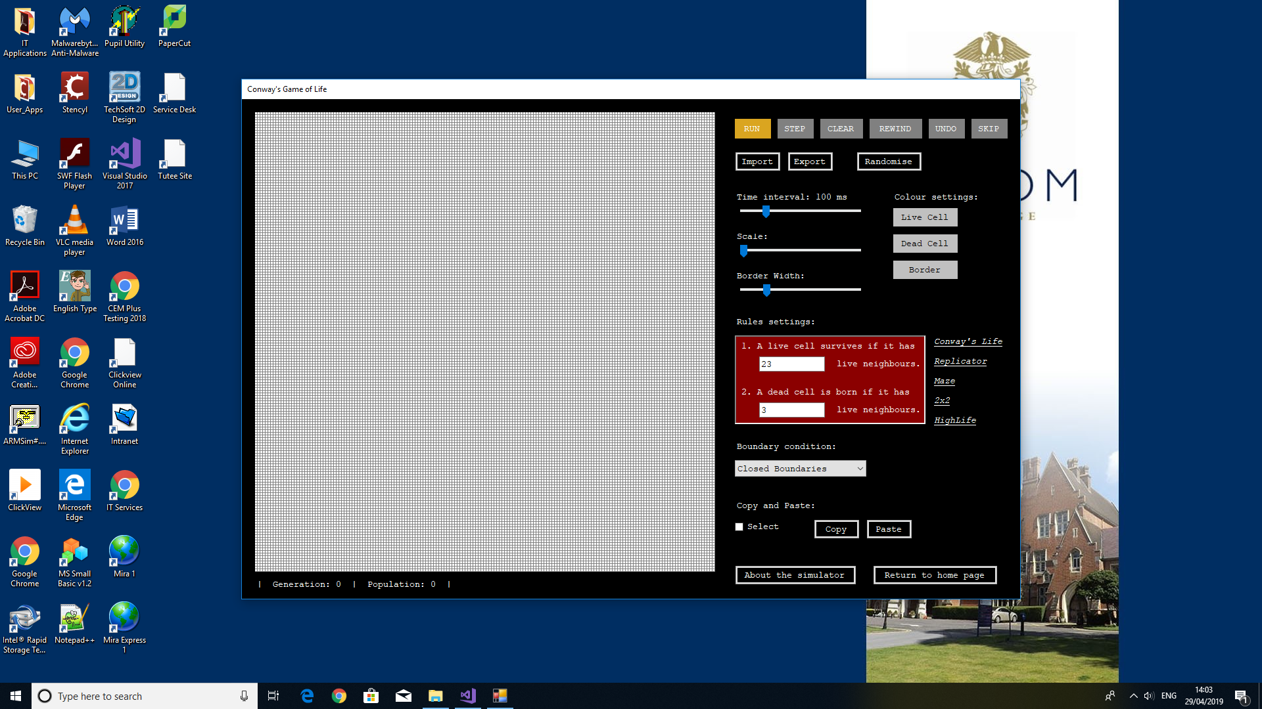

Overall, a well-developed simulation that I look forward to introducing to the students next round. If time had been available, I would have had them using it now before the club time broke up but that’s not possible this term.”

## Analysis of feedback

The feedback I received from Miss Jaqueline Austin is very positive. I am glad to know that the program is ready to be introduced to the Tech Club and the import, export, copy and paste functions are useful to the user. However, I would also like to make the following improvements in the future. Firstly, the error messages could have been more specific when importing patterns so that it is made clear when the grid is too small to import a large pattern. Secondly, concerning the rules settings, the program should only allow the user to enter number from 0 to 8 without repeating digits. A sorting algorithm can also be used to sort the number list so that the information is easier to be understood by the user. Thirdly, I think it is a good idea to allow the user to choose between making the grid full screen and viewing the settings and the grid side by side. Placing the settings and the grid together allows the user to change the settings and view the changes on the pattern simulataneously. On the other hand, making the grid full screen allows the user to focus on the revolution of patterns and hide the settings.

## Future development

Overall, my program has met all the objectives set at the beginning but there are still ways to optimise the simulation. The first improvement that could be made on my program in the future is to increase the size of the grid so that it could simulate larger patterns. At the moment, the size of my grid is limited to 350. Secondly, with a larger grid size, the program will run slower and slower so there is a need to increase the speed of simulation. These two improvements can be done by another approach - using the Hashlife algorithm. This algorithm uses a quad tree to represent the grid instead of using a 2-dimensional array. The quad tree divides the pattern on grid into subpatterns and uses hash tables to store the nodes of the quadtree. Since patterns in Conway’s game of life are always repeated or contain many copies of the same subpatterns such as gliders or spaceships, these identical subpatterns in the tree can be hash to the same address in the hash table and are only needed to be evaluated once. The following shows a quadtree of a pattern:

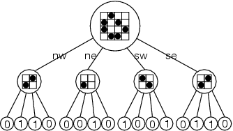

Using the Hashlife algorithm, the simulator can simulate most patterns including extremely large patterns like the Universal Turing Machine which has a population of 252192.

Reference:

<http://www.drdobbs.com/jvm/an-algorithm-for-compressing-space-and-t/184406478>

<https://en.wikipedia.org/wiki/Hashlife>